

Report prepared by:
Rachel Garthe, Ph.D., Doug Smith, Ph.D. & Shawn Freeman, M.B.A.
University of Illinois at Urbana-Champaign
School of Social Work | Center for Prevention Research & Development

Illinois Criminal Justice Information Authority (ICJIA)
Statewide Violence Prevention Plan: 2020-2024
Appendix #4

County Reports

This county report was supported in an interagency agreement between the Illinois Criminal Justice Information Authority and the University of Illinois at Urbana-Champaign.

Suggested citation:
Garthe, R. C., Smith, D. C., & Freeman, S. (2021). Illinois Criminal Justice Authority Statewide Violence Prevention Plan 2020-2024: Review of Programs and Strategies, Needs Assessment of Violence in Illinois & Recommendations for Funding: County Reports. Illinois Criminal Justice Information Authority.

If you would like to request additional data for your county, please email Dr. Garthe at rcgarthe@illinois.edu

Within this appendix, data were pulled from a variety of sources. For more information, please see the full report with citations, or the information provided below:

A. Child Maltreatment data were pulled from:
Children and Family Research Center (CFRC, 2020). Outcome Indicator Tables. Retrieved from
https://cfrc.illinois.edu/outcome-indicator-tables.php?ind=pct_repeat_subreps
Data also provided by the Children and Family Research Center at the University of Illinois at Urbana-Champaign.

B. Youth Violence data were pulled from:
Center for Prevention Research and Development (CPRD; 2018). Illinois Youth Survey, 2018. Center for Prevention Research and Development, University of Illinois at Urbana-Champaign School of Social Work.
For more information on the IYS: https://iys.cprd.illinois.edu/

C. Juvenile Violent Offenses & Weapons-Related Offenses data were pulled from:
Illinois data provided by the Center for Prevention Research and Development, which manages data for the Illinois Juvenile Justice Commission.
More information: https://cprd.illinois.edu/expertise/juvenile-justice-reform-and-prevention/

D. Adult Violent Offenses data were pulled from:
Illinois Criminal Justice Information Authority. (2020). Uniform Crime Report Index Offense Explorer. Retrieved from https://app.icjia.cloud/app/ucr-index-offense-explorer
Data provided by Illinois Criminal Justice Information Authority for differences by race and sex.
Notes about the data:
- Rates by Race: top charge is violent
- Rates by Sex: any charge is violent
- Dashes in the table mean that there is insufficient data or no data for that cell.

E. Adult Intimate Partner Violence and Sexual Violence data pulled from:
Data retrieved from Illinois Criminal Justice Information Authority Research Hub Datasets:
Illinois Uniform Crime Reports (UCR) Domestic Crime Offense (2018).
https://icjia.illinois.gov/researchhub/datasets/illinois-uniform-crime-reports-ucr-domestic-crime-offense

Illinois Uniform Crime Reports (UCR) Index Crime Offense (2018).
https://icjia.illinois.gov/researchhub/datasets/illinois-uniform-crime-reports-ucr-index-crime-offense

F. Gun Violence: Firearm Death Rate data pulled from:
Centers for Disease Control and Prevention (2020). National Center for Health Statistics: Underlying Cause of Death 1999-2019 on CDC WONDER Online Database, released in 2020. Data are from the Multiple Cause of Death Files, 1999-2019, as compiled from data provided by the 57 vital statistics jurisdictions through the Vital Statistics Cooperative Program. Accessed at http://wonder.cdc.gov/ucd-icd10.html
Notes about the tables:
- Dashes in the table mean that there is insufficient data, unreliable data, or no data for that cell.

G. Abuse Among Older Adults data pulled from:
Illinois Criminal Justice Information Authority Research Hub Datasets:
Illinois Department on Aging (2015). https://icjia.illinois.gov/researchhub/datasets/elder-abuse

Table of Contents
Adams County (Rural) vii
Alexander County (Other Urban/Suburban) ix
Bond County (Other Urban/Suburban) xi
Boone County (Other Urban/Suburban) xiii
Brown County (Rural) xv
Bureau County (Rural) xvii
Calhoun County (Other Urban/Suburban) xix
Carroll County (Rural) xx
Cass County (Rural) xxii
Champaign County (Other Urban/Suburban) xxiv
Christian County (Rural) xxvi
Clark County (Rural) xxviii
Clay County (Rural) xxx
Clinton County (Other Urban/Suburban) xxxii
Coles County (Rural) xxxiv
Cook County xxxvi
Crawford County (Other Urban/Suburban) xxxix
Cumberland County (Rural) xli
Dekalb County (Suburban Chicago) xliii
DeWitt County (Other Urban/Suburban) xlv
Douglas County (Rural) xlvii
DuPage County (Suburban Chicago) xlix
Edgar County (Rural) lii
Edwards County (Rural) liv
Effingham County (Rural) lv
Fayette County (Rural) lvii
Ford County (Other Urban/Suburban) lix
Franklin County (Rural) lxi
Fulton County (Rural) lxiii
Gallatin County (Rural) lxv
Greene County (Rural) lxvii
Grundy County (Suburban Chicago) lxix
Hamilton County (Rural) lxxi
Hancock County (Rural) lxxiii
Hardin County (Rural) lxxv
Henderson County (Rural) lxxvii
Henry County (Other Urban/Suburban) lxxix
Iroquois County (Rural) lxxxi
Jackson County (Other Urban/Suburban) lxxxiii
Jasper County (Rural) lxxxv
Jefferson County (Rural) lxxxvii
Jersey County (Other Urban/Suburban) lxxxix
Jo Daviess County (Rural) xci
Johnson County (Rural) xciii
Kane County (Suburban Chicago) xcv
Kankakee County (Other Urban/Suburban) xcvii
Kendall County (Suburban Chicago) xcix
Knox County (Rural) ci
Lake County (Suburban Chicago) ciii
LaSalle County (Rural) cvi
Lawrence County (Rural) cviii
Lee County (Rural) cix
Livingston County (Rural) cxi
Logan County (Rural) cxiii
Macon County (Other Urban/Suburban) cxv
Macoupin County (Other Urban/Suburban) cxvii
Madison County (Other Urban/Suburban) cxix
Marion County (Rural) cxxi
Marshall County (Other Urban/Suburban) cxxiii
Mason County (Rural) cxxv
Massac County (Rural) cxxvii
McDonough County (Rural) cxxix
McHenry County (Suburban Chicago) cxxxi
McLean County (Other Urban/Suburban) cxxxiii
Menard County (Other Urban/Suburban) cxxxv
Mercer County (Other Urban/Suburban) cxxxvii
Monroe County (Other Urban/Suburban) cxxxix
Montgomery County (Rural) cxli
Morgan County (Rural) cxliii
Moultrie County (Rural) cxlv
Ogle County (Rural) cxlvii
Peoria County (Other Urban/Suburban) cxlix
Perry County (Rural) clii
Piatt County (Other Urban/Suburban) cliv
Pike County (Rural) clvi
Pope County (Rural) clviii
Pulaski County (Rural) clix
Putnam County (Rural) clxi
Randolph County (Rural) clxiii
Richland County (Rural) clxv
Rock Island County (Other Urban/Suburban) clxvii
St. Clair County (Other Urban/Suburban) clxix
Saline County (Rural) clxxii
Sangamon County (Other Urban/Suburban) clxxiv
Schuyler County (Rural) clxxvi
Scott County (Rural) clxxviii
Shelby County (Rural) clxxx
Stark County (Other Urban/Suburban) clxxxii
Stephenson County (Rural) clxxxiv
Tazewell County (Other Urban/Suburban) clxxxvi
Union County (Rural) clxxxviii
Vermilion County (Other Urban/Suburban) cxc
Wabash County (Rural) cxcii
Warren County (Rural) cxciv
Washington County (Rural) cxcvi
Wayne County (Rural) cxcviii
White County (Rural) cc
Whiteside County (Rural) ccii
Will County (Suburban Chicago) cciv
Williamson County (Other Urban/Suburban) ccvii
Winnebago County (Other Urban/Suburban) ccix
Woodford County (Other Urban/Suburban) ccxii

A. Child Maltreatment

Adams County (Rural)
During 2018, there were 385 substantiated cases of child maltreatment (which includes reports of physical and other abuse, sexual abuse, neglect, and risk of harm) in Adams County. This number equates to a rate of 25.61 substantiated reports per 1,000 children (which is higher than the state rate: 10.95 substantiated reports per 1,000 children).

These figures illustrate substantiated reports by child’s race and age. A total of 55% of substantiated cases were among female children.

B. Youth Violence
Youth in Adams County reported higher rates of bullying, cyber bullying, physical fighting, and weapon carrying compared to the state average.

Youth reported similar levels of dating violence compared to the state average.

C. Juvenile Violent Offenses
In 2018, there were 132 youth admitted to short-term locked juvenile detention facilities in Adams County. Approximately 16% of detention admissions were for a violent offense (n = 21). This translates to a rate of 3.18 violent offenses per 1,000 youth ages 10-17 in Adams County, which is higher than the rate for the state of Illinois (1.83 violent offense admissions per 1,000 youth ages 10-17).

Black youth had the highest rate of violent offense admissions.

Male and female youth had similar rates of violent offense admissions.
 | Rate per 1,000
Male | 3.3
Female | 3.1

Violent Arrests by Race & Sex (2018)
 | Rate per 1,000
Race/Ethnicity
African American | 28.39
Hispanic/Latinx | -
Other | 3.69
White | 2.86
Sex
Female | 2.15
Male | 6.22
D. Adult Violent Offenses (Arrests)
In 2018, Adams County had a rate of 429.28 violent crimes per 1,000 residents in Illinois. This is higher than the state rate (395.75 violent crimes per 100,000 residents).

African American adults had the highest rates of arrests for violent crimes.

E. Adult Intimate Partner Violence and Sexual Violence
Adams County reported lower rates of domestic violence and higher rates of sexual assault crimes in 2018 compared to the state rate.
 | Rate per 100,000 | State Rate per 100,000
Domestic Violence Crime Offense | 555.6 | 840.39
Sexual Assault | 100.5 | 44.83

F. Gun Violence: Firearm Death Rate
No data or insufficient data for this county.

G. Abuse Among Older Adults
In 2015, Adams County had a rate of 492.3 reports of abuse among older adults (per 100,000) which is higher than the state rate (465.10 reports per 100,000).
A. Child Maltreatment

Alexander County (Other Urban/Suburban)
During 2018, there were 18 substantiated cases of child maltreatment (which includes reports of physical and other abuse, sexual abuse, neglect, and risk of harm) in Alexander County. This number equates to a rate of 11.39 substantiated reports per 1,000 children (which is higher than the state rate: 10.95 substantiated reports per 1,000 children).

These figures illustrate substantiated reports by child’s race and age. 46% of substantiated cases were among female children.

B. Youth Violence
No data or insufficient data for this county.

C. Juvenile Violent Offenses
In 2018, there were 3 youth admitted to short-term locked juvenile detention facilities in Alexander County. None of these admissions were for a violent offense.

Juvenile Weapon-Related Offenses
Alexander county had 1 weapon-related offense in 2018.

D. Adult Violent Offenses (Arrests)
Violent Arrests by Race & Sex (2018)
 | Rate per 1,000
Race/Ethnicity
African American | 12.91
Hispanic/Latinx | -
Other | 3.51
White | 1.72
Sex
Female | -
Male | -
In 2018, Alexander County had a rate of 115.51 violent crimes per 100,000 residents in Illinois. This is lower than the state rate (395.75 violent crimes per 100,000 residents).

African American adults had the highest rates of arrests for violent crimes (per 1,000 residents).

E. Adult Intimate Partner Violence and Sexual Violence
Alexander County reported lower rates of domestic violence crimes in 2018 compared to the state rate.
 | Rate per 100,000 | State Rate per 100,000
Domestic Violence Crime Offense | 181.5 | 840.39

F. Gun Violence: Firearm Death Rate
No data or insufficient data for this county.

G. Abuse Among Older Adults
In 2015, Alexander County had a rate of 1386.7 reports of abuse among older adults (per 100,000) which is higher than the state rate (465.10 reports per 100,000).

A. Child Maltreatment

Bond County (Other Urban/Suburban)
During 2018, there were 83 substantiated cases of child maltreatment (which includes reports of physical and other abuse, sexual abuse, neglect, and risk of harm) in Bond County. This number equates to a rate of 25.90 substantiated reports per 1,000 children (which is higher than the state rate: 10.95 substantiated reports per 1,000 children).

These figures illustrate substantiated reports by child’s race and age. 53% of substantiated cases were among female children.

B. Youth Violence
No data or insufficient data for this county.

C. Juvenile Violent Offenses
Violent Arrests by Race & Sex (2018)
 | Rate per 1,000
Race/Ethnicity
African American | 0.96
Hispanic/Latinx | -
Other | -
White | 2.70
Sex
Female | 1.48
Male | 3.61
In 2018, 5 youth were admitted to short-term locked juvenile detention facilities in Bond County. None of these admissions were for a violent offense.

D. Adult Violent Offenses (Arrests)
In 2018, Bond County had a rate of 96.21 violent crimes per 100,000 residents in Illinois. This is lower than the state rate (395.75 violent crimes per 100,000 residents).

White adults had the highest rates of arrests for violent crimes.

E. Adult Intimate Partner Violence and Sexual Violence
Bond County reported lower rates of domestic violence crimes in 2018 compared to the state rate.

 | Rate per 100,000 | State Rate per 100,000
Domestic Violence Crime Offense | 102.2 | 840.39

F. Gun Violence: Firearm Death Rate
No data or insufficient data for this county.

G. Abuse Among Older Adults
In 2015, Bond County had a rate of 592.3 reports of abuse among older adults (per 100,000) which is higher than the state rate (465.10 reports per 100,000).

A. Child Maltreatment

Boone County (Other Urban/Suburban)
During 2018, there were 111 substantiated cases of child maltreatment (which includes reports of physical and other abuse, sexual abuse, neglect, and risk of harm) in Boone County. This number equates to a rate of 8.10 substantiated reports per 1,000 children (which is lower than the state rate: 10.95 substantiated reports per 1,000 children).

These figures illustrate substantiated reports by child’s race and age. 50% of substantiated cases were among female children.

B. Youth Violence
No data or insufficient data for this county.

C. Juvenile Violent Offenses
In 2018, there were 21 youth admitted to short-term locked juvenile detention facilities in Boone County. Approximately 10% of detention admissions were for a violent offense (n = 2). This translates to a rate of 0.29 violent offenses per 1,000 youth ages 10-17 in Boone County, which is lower than the rate for the state of Illinois (1.83 violent offense admissions per 1,000 youth ages 10-17).

Hispanic and White youth had the similar rates of violent offense admissions.

 | Rate per 1,000
Male | 0.6
Female | 0

Violent Arrests by Race & Sex (2018)
 | Rate per 1,000
Race/Ethnicity
African American | 26.05
Hispanic/Latinx | 2.09
Other | -
White | 2.75
Sex
Female | 1.42
Male | 5.81
D. Adult Violent Offenses (Arrests)
In 2018, Boone County had a rate of 192.25 violent crimes per 100,000 residents in Illinois. This is lower than the state rate (395.75 violent crimes per 100,000 residents).

African American adults had the highest rates of arrests for violent crimes.

E. Adult Intimate Partner Violence and Sexual Violence
Boone County reported lower rates of domestic violence and higher rates of sexual assault crimes in 2018 compared to the state rate.
 | Rate per 100,000 | State Rate per 100,000
Domestic Violence Crime Offense | 513.3 | 840.39
Sexual Assault | 65.3 | 44.83

F. Gun Violence: Firearm Death Rate
No data or insufficient data for this county.

G. Abuse Among Older Adults
In 2015, Boone County had a rate of 251.6 reports of abuse among older adults (per 100,000) which is lower than the state rate (465.10 reports per 100,000).

A. Child Maltreatment

Brown County (Rural)
During 2018, there were 10 substantiated cases of child maltreatment (which includes reports of physical and other abuse, sexual abuse, neglect, and risk of harm) in Brown County. This number equates to a rate of 9.56 substantiated reports per 1,000 children (which is lower than the state rate: 10.95 substantiated reports per 1,000 children).

These figures illustrate substantiated reports by child’s race and age. 50% of substantiated cases were among female children.

B. Youth Violence
No data or insufficient data for this county.

C. Juvenile Violent Offenses
In 2018, there were 0 detention admissions to short-term locked facilities for juveniles.

D. Adult Violent Offenses (Arrests)
In 2018, Brown County had a rate of 61.01 violent crimes per 100,000 residents in Illinois. This is lower than the state rate (395.75 violent crimes per 100,000 residents).

E. Adult Intimate Partner Violence and Sexual Violence
 | Rate per 100,000 | State Rate per 100,000
Domestic Violence Crime Offense | 15.3 | 840.39
Brown County reported lower rates of domestic violence crimes in 2018 compared to the state rate.

F. Gun Violence: Firearm Death Rate
No data or insufficient data for this county.

G. Abuse Among Older Adults
In 2015, Boone County had a rate of 163.1 reports of abuse among older adults (per 100,000) which is lower than the state rate (465.10 reports per 100,000).

A. Child Maltreatment

Bureau County (Rural)
During 2018, there were 118 substantiated cases of child maltreatment (which includes reports of physical and other abuse, sexual abuse, neglect, and risk of harm) in Bureau County. This number equates to a rate of 16.26 substantiated reports per 1,000 children in Illinois (which is higher than the state rate: 10.95 substantiated reports per 1,000 children).

These figures illustrate substantiated reports by child’s race and age. 51% of substantiated cases were among female children.

B. Youth Violence
Youth in Bureau County reported higher rates of all types of youth violence compared to the state average.

C. Juvenile Violent Offenses
In 2018, there were 27 youth admitted to short-term locked juvenile detention facilities in Bureau County. Approximately 15% of detention admissions were for a violent offense (n = 4). This translates to a rate of 1.16 violent offenses per 1,000 youth ages 10-17 in Bureau County, which is lower than the rate for Illinois (1.83 violent offense admissions per 1,000 youth ages 10-17).

Hispanic youth had the highest rate of violent offense admissions, compared to White youth.

 | Rate per 1,000
Male | 2.3
Female | 0

Violent Arrests by Race & Sex (2018)
 | Rate per 1,000
Race/Ethnicity
African American | 70.74
Hispanic/Latinx | 3.01
Other | 1.65
White | 4.90
Sex
Female | 2.66
Male | 8.64
D. Adult Violent Offenses (Arrests)
In 2018, Bureau County had a rate of 157.61 violent crimes per 100,000 residents in Illinois. This is lower than the state rate (395.75 violent crimes per 100,000 residents).

African American adults had the highest rates of arrests for violent crimes.

E. Adult Intimate Partner Violence and Sexual Violence
Bureau County reported lower rates of domestic violence and higher rates of sexual assault crimes in 2018 compared to the state rate.
 | Rate per 100,000 | State Rate per 100,000
Domestic Violence Crime Offense | 666.8 | 840.39
Sexual Assault | 51.5 | 44.83

F. Gun Violence: Firearm Death Rate
No data or insufficient data for this county.

G. Abuse Among Older Adults
In 2015, Bureau County had a rate of 409.9 reports of abuse among older adults (per 100,000) which is lower than the state rate (465.10 reports per 100,000).
A. Child Maltreatment

Calhoun County (Other Urban/Suburban)
During 2018, there were 4 substantiated cases of child maltreatment (which includes reports of physical and other abuse, sexual abuse, neglect, and risk of harm) in Calhoun County. This number equates to a rate of 3.93 substantiated reports per 1,000 children in Illinois (which is lower than the state rate: 10.95 substantiated reports per 1,000 children).

These figures illustrate substantiated reports by child’s race and age. 60% of substantiated cases were among female children.

B. Youth Violence
No data or insufficient data for this county.

C. Juvenile Violent Offenses
In 2018, there were 0 detention admissions to short-term locked facilities for juveniles.

D. Adult Violent Offenses (Arrests)
No data or insufficient data for this county.

E. Adult Intimate Partner Violence and Sexual Violence
No data or insufficient data for this county.

F. Gun Violence: Firearm Death Rate
No data or insufficient data for this county.

G. Abuse Among Older Adults
In 2015, Calhoun County had a rate of 137.1 reports of abuse among older adults (per 100,000) which is lower than the state rate (465.10 reports per 100,000).

A. Child Maltreatment

Carroll County (Rural)
During 2018, there were 51 substantiated cases of child maltreatment (which includes reports of physical and other abuse, sexual abuse, neglect, and risk of harm) in Carroll County. This number equates to a rate of 17.95 substantiated reports per 1,000 children in Illinois (which is higher than the state rate: 10.95 substantiated reports per 1,000 children).

These figures illustrate substantiated reports by child’s race and age. 34% of substantiated cases were among female children.

B. Youth Violence

Youth in Carroll County reported higher rates of bullying, cyber bullying, physical fighting, and weapon carrying compared to the state average.

Youth reported lower rates of dating violence compared to the state average.

C. Juvenile Violent Offenses
In 2018, there were 10 youth admitted to short-term locked juvenile detention facilities in Carroll County. 40% of detention admissions were for a violent offense (n = 4). This translates to a rate of 3.05 violent offenses per 1,000 youth ages 10-17 in Carroll County, which is higher than the rate for the state of Illinois (1.83 violent offense admissions per 1,000 youth ages 10-17).

Hispanic youth had the highest rate of violent offense admissions, compared to White youth.

 | Rate per 1,000
Male | 5.8
Female | 0

Violent Arrests by Race & Sex (2018)
 | Rate per 1,000
Race/Ethnicity
African American | 24.10
Hispanic/Latinx | 3.82
Other | 2.16
White | 4.59
Sex
Female | 3.14
Male | 7.05
D. Adult Violent Offenses (Arrests)
In 2018, Carroll County had a rate of 153.72 violent crimes per 100,000 residents in Illinois. This is lower than the state rate (395.75 violent crimes per 100,000 residents).

African American adults had the highest rates of arrests for violent crimes.

E. Adult Intimate Partner Violence and Sexual Violence
Carroll County reported lower rates of domestic violence and sexual assault crimes in 2018 compared to the state rate.

 | Rate per 100,000 | State Rate per 100,000
Domestic Violence Crime Offense | 48.9 | 840.39
Sexual Assault | 21 | 44.83

F. Gun Violence: Firearm Death Rate
No data or insufficient data for this county.

G. Abuse Among Older Adults
In 2015, Carroll County had a rate of 360.8 reports of abuse among older adults (per 100,000) which is lower than the state rate (465.10 reports per 100,000).
A. Child Maltreatment

Cass County (Rural)
During 2018, there were 80 substantiated cases of child maltreatment (which includes reports of physical and other abuse, sexual abuse, neglect, and risk of harm) in Cass County. This number equates to a rate of 26.20 substantiated reports per 1,000 children in Illinois (which is higher than the state rate: 10.95 substantiated reports per 1,000 children).

These figures illustrate substantiated reports by child’s race and age. 42% of substantiated cases were among female children.

B. Youth Violence

Youth in Cass County reported higher rates of bullying, physical fighting, and weapon carrying compared to the state average.

Youth reported similar or lower levels of cyber bullying and dating violence compared to the state average.

C. Juvenile Violent Offenses
In 2018, there were 3 youth admitted to short-term locked juvenile detention facilities in Cass County. Approximately 67% of detention admissions were for a violent offense (n = 2). This translates to a rate of 1.49 violent offenses per 1,000 youth ages 10-17 in Cass County, which is higher than the rate for the state of Illinois (1.83 violent offense admissions per 1,000 youth ages 10-17).

 | Rate per 1,000
Male | 1.4
Female | 1.6
White youth had a rate of 1.6 detention admissions for a violent offense per 1,000 youth ages 10-17.

Violent Arrests by Race & Sex (2018)
 | Rate per 1,000
Race/Ethnicity
African American | 1.69
Hispanic/Latinx | 0.84
Other | 4.33
White | 1.85
Sex
Female | -
Male | -
D. Adult Violent Offenses (Arrests)
In 2018, Cass County had a rate of 513.87 violent crimes per 100,000 residents in Illinois. This is higher than the state rate (395.75 violent crimes per 100,000 residents).

Adults with “other” race/ethnicity had the highest rates of arrests for violent crimes.

E. Adult Intimate Partner Violence and Sexual Violence
Cass County reported lower rates of domestic violence and sexual assault crimes in 2018 compared to the state rate.

 | Rate per 100,000 | State Rate per 100,000
Domestic Violence Crime Offense | 212.1 | 840.39
Sexual Assault | 16.3 | 44.83

F. Gun Violence: Firearm Death Rate
No data or insufficient data for this county.

G. Abuse Among Older Adults
In 2015, Cass County had a rate of 205.1 reports of abuse among older adults (per 100,000) which is lower than the state rate (465.10 reports per 100,000).

A. Child Maltreatment

Champaign County (Other Urban/Suburban)
During 2018, there were 632 substantiated cases of child maltreatment (which includes reports of physical and other abuse, sexual abuse, neglect, and risk of harm) in Champaign County. This number equates to a rate of 15.98 substantiated reports per 1,000 children in Illinois (which is higher than the state rate: 10.95 substantiated reports per 1,000 children).

These figures illustrate substantiated reports by child’s race and age. 51% of substantiated cases were among female children.

B. Youth Violence

Youth in Champaign County reported higher rates of bullying, cyber bullying, and physical fighting compared to the state average.

Youth reported similar levels of dating violence and weapon carrying compared to the state average.

C. Juvenile Violent Offenses
In 2018, there were 302 youth admitted to short-term locked juvenile detention facilities in Champaign County. About 28% of detention admissions were for a violent offense (N = 84). This translates to a rate of 4.91 violent offenses per 1,000 youth ages 10-17 in Champaign County, which is higher than the rate for the state of Illinois (1.83 violent offense admissions per 1,000 youth ages 10-17).

Black youth had the highest rate of violent offense admissions.

 | Rate per 1,000
Male | 7.2
Female | 2.6

Juvenile Weapon-Related Offenses
Champaign county had 11 weapon-related offenses in 2018.

D. Adult Violent Offenses (Arrests)
Violent Arrests by Race & Sex (2018)
 | Rate per 1,000
Race/Ethnicity
African American | 24.66
Hispanic/Latinx | 3.76
Other | 0.83
White | 2.43
Sex
Female | 3.14
Male | 8.48
In 2018, Champaign County had a rate of 453.85 violent crimes per 100,000 residents in Illinois. This is higher than the state rate (395.75 violent crimes per 100,000 residents).

African American adults had the highest rates of arrests for violent crimes.

E. Adult Intimate Partner Violence and Sexual Violence
Champaign County reported higher rates of domestic violence and sexual assault crimes in 2018 compared to the state rate.
 | Rate per 100,000 | State Rate per 100,000
Domestic Violence Crime Offense | 1430.10 | 840.39
Sexual Assault | 78.1 | 44.83

F. Gun Violence: Firearm Death Rate
No data or insufficient data for this county.

G. Abuse Among Older Adults
In 2015, Champaign County had a rate of 342 reports of abuse among older adults (per 100,000) which is lower than the state rate (465.10 reports per 100,000).

A. Child Maltreatment

Christian County (Rural)
During 2018, there were 204 substantiated cases of child maltreatment (which includes reports of physical and other abuse, sexual abuse, neglect, and risk of harm) in Christian County. This number equates to a rate of 29.81 substantiated reports per 1,000 children in Illinois (which is higher than the state rate: 10.95 substantiated reports per 1,000 children).

These figures illustrate substantiated reports by child’s race and age. 51% of substantiated cases were among female children.

B. Youth Violence
No data or insufficient data for this county.

C. Juvenile Violent Offenses
In 2018, there were 14 youth admitted to short-term locked juvenile detention facilities in Christian County. Approximately 14% of detention admissions were for a violent offense (n = 2). This translates to a rate of 0.63 violent offenses per 1,000 youth ages 10-17 in Christian County, which is lower than the rate for the state of Illinois (1.83 violent offense admissions per 1,000 youth ages 10-17).

White and Hispanic youth had similar rates of being detained for a violent offense.

 | Rate per 1,000
Male | 1.2
Female | 0

Violent Arrests by Race & Sex (2018)
 | Rate per 1,000
Race/Ethnicity
African American | 14.18
Hispanic/Latinx | -
Other | 1.41
White | 3.58
Sex
Female | 1.40
Male | 6.24
D. Adult Violent Offenses (Arrests)
In 2018, Christian County had a rate of 91.85 violent crimes per 100,000 residents in Illinois. This is lower than the state rate (395.75 violent crimes per 100,000 residents).

African American adults had the highest rates of arrests for violent crimes.

E. Adult Intimate Partner Violence and Sexual Violence
Christian County reported lower rates of domestic violence and sexual assault crimes in 2018 compared to the state rate.
 | Rate per 100,000 | State Rate per 100,000
Domestic Violence Crime Offense | 150 | 840.39
Sexual Assault | 9.2 | 44.83

F. Gun Violence: Firearm Death Rate
No data or insufficient data for this county.

G. Abuse Among Older Adults
In 2015, Christian County had a rate of 406.7 reports of abuse among older adults (per 100,000) which is lower than the state rate (465.10 reports per 100,000).
A. Child Maltreatment

Clark County (Rural)
During 2018, there were 68 substantiated cases of child maltreatment (which includes reports of physical and other abuse, sexual abuse, neglect, and risk of harm) in Clark County. This number equates to a rate of 18.68 substantiated reports per 1,000 children in Illinois (which is higher than the state rate: 10.95 substantiated reports per 1,000 children).

These figures illustrate substantiated reports by child’s race and age. 39% of substantiated cases were among female children.

B. Youth Violence

Youth in Clark County reported higher rates of cyber bullying and weapon carrying compared to the state average.

C. Juvenile Violent Offenses
In 2018, there were 2 youth admitted to short-term locked juvenile detention facilities in Clark County. Neither of these admissions were for violent offenses.

Violent Arrests by Race & Sex (2018)
 | Rate per 1,000
Race/Ethnicity
African American | 40.82
Hispanic/Latinx | -
Other | 2.33
White | 4.43
Sex
Female | 2.00
Male | 7.67
D. Adult Violent Offenses (Arrests)
In 2018, Clark County had a rate of 121.83 violent crimes per 100,000 residents in Illinois. This is lower than the state rate (395.75 violent crimes per 100,000 residents).

African American adults had the highest rates of arrests for violent crimes.

E. Adult Intimate Partner Violence and Sexual Violence
Clark County reported lower rates of domestic violence and sexual assault crimes in 2018 compared to the state rate.
 | Rate per 100,000 | State Rate per 100,000
Domestic Violence Crime Offense | 282.1 | 840.39
Sexual Assault | 19.2 | 44.83

F. Gun Violence: Firearm Death Rate
No data or insufficient data for this county.

G. Abuse Among Older Adults
In 2015, Clark County had a rate of 247.6 reports of abuse among older adults (per 100,000) which is lower than the state rate (465.10 reports per 100,000).

A. Child Maltreatment

Clay County (Rural)
During 2018, there were 43 substantiated cases of child maltreatment (which includes reports of physical and other abuse, sexual abuse, neglect, and risk of harm) in Clay County. This number equates to a rate of 14.46 substantiated reports per 1,000 children in Illinois (which is higher than the state rate: 10.95 substantiated reports per 1,000 children).

These figures illustrate substantiated reports by child’s race and age. 51% of substantiated cases were among female children.

B. Youth Violence

Youth in Clay County reported higher rates of bullying, cyber bullying, physical fighting, and weapon carrying compared to the state average.

Youth reported similar levels of dating violence compared to the state average.

C. Juvenile Violent Offenses
In 2018, there were 11 youth admitted to short-term locked juvenile detention facilities in Clay County. None of these admissions were for violent offenses.

D. Adult Violent Offenses (Arrests)
In 2018, Clay County had a rate of 75.45 violent crimes per 100,000 residents in Illinois. This is lower than the state rate (395.75 violent crimes per 100,000 residents).

E. Adult Intimate Partner Violence and Sexual Violence
Clay County reported lower rates of domestic violence crimes in 2018 compared to the state rate.
 | Rate per 100,000 | State Rate per 100,000
Domestic Violence Crime Offense | 362.2 | 840.39

F. Gun Violence: Firearm Death Rate
No data or insufficient data for this county.

G. Abuse Among Older Adults
In 2015, Clay County had a rate of 841.8 reports of abuse among older adults (per 100,000) which is higher than the state rate (465.10 reports per 100,000).

A. Child Maltreatment

Clinton County (Other Urban/Suburban)
During 2018, there were 80 substantiated cases of child maltreatment (which includes reports of physical and other abuse, sexual abuse, neglect, and risk of harm) in Clinton County. This number equates to a rate of 10.01 substantiated reports per 1,000 children in Illinois (which is lower than the state rate: 10.95 substantiated reports per 1,000 children).

These figures illustrate substantiated reports by child’s race and age. 48% of substantiated cases were among female children.

B. Youth Violence

Youth in Clinton County reported higher rates of bullying, cyber bullying, dating violence, physical fighting and weapon carrying compared to the state average.

C. Juvenile Violent Offenses
In 2018, there were 16 youth admitted to short-term locked juvenile detention facilities in Clinton County. None of these admissions were for violent offenses.

D. Adult Violent Offenses (Arrests)
In 2018, Clinton County had a rate of 92.99 violent crimes per 100,000 residents in Illinois. This is lower than the state rate (395.75 violent crimes per 100,000 residents).

E. Adult Intimate Partner Violence and Sexual Violence
Clinton County reported lower rates of domestic violence and sexual assault crimes in 2018 compared to the state rate.
 | Rate per 100,000 | State Rate per 100,000
Domestic Violence Crime Offense | 50.5 | 840.39
Sexual Assault | 21.3 | 44.83

F. Gun Violence: Firearm Death Rate
No data or insufficient data for this county.

G. Abuse Among Older Adults
In 2015, Clinton County had a rate of 358 reports of abuse among older adults (per 100,000) which is lower than the state rate (465.10 reports per 100,000).

A. Child Maltreatment

Coles County (Rural)
During 2018, there were 355 substantiated cases of child maltreatment (which includes reports of physical and other abuse, sexual abuse, neglect, and risk of harm) in Coles County. This number equates to a rate of 37.94 substantiated reports per 1,000 children in Illinois (which is higher than the state rate: 10.95 substantiated reports per 1,000 children).

These figures illustrate substantiated reports by child’s race and age. 52% of substantiated cases were among female children.

B. Youth Violence
Youth in Coles County reported higher rates of bullying, cyber bullying, dating violence and weapon carrying compared to the state average.

Youth reported similar levels of physical fighting compared to the state average.

C. Juvenile Violent Offenses
In 2018, there were 32 youth admitted to short-term locked juvenile detention facilities in Coles County. About 9% of detention admissions were for a violent offense (n = 3). This translates to a rate of 0.72 violent offenses per 1,000 youth ages 10-17 in Coles County, which is lower than the rate for the state of Illinois (1.83 violent offense admissions per 1,000 youth ages 10-17).

Black youth had the highest rate of violent offense admissions.

 | Rate per 1,000
Male | 1.4
Female | 0

African American adults had the highest rates of arrests for violent crimes.

Violent Arrests by Race & Sex (2018)
 | Rate per 1,000
Race/Ethnicity
African American | 33.60
Hispanic/Latinx | 3.88
Other | -
White | 4.23
Sex
Female | 2.66
Male | 8.60
D. Adult Violent Offenses (Arrests)
In 2018, Coles County had a rate of 304.61 violent crimes per 100,000 residents in Illinois. This is lower than the state rate (395.75 violent crimes per 100,000 residents).

E. Adult Intimate Partner Violence and Sexual Violence
Coles County reported lower rates of domestic violence and higher rates of sexual assault crimes in 2018 compared to the state rate.
 | Rate per 100,000 | State Rate per 100,000
Domestic Violence Crime Offense | 395 | 840.39
Sexual Assault | 68.8 | 44.83

F. Gun Violence: Firearm Death Rate
No data or insufficient data for this county.

G. Abuse Among Older Adults
In 2015, Coles County had a rate of 779.6 reports of abuse among older adults (per 100,000) which is higher than the state rate (465.10 reports per 100,000).
A. Child Maltreatment

Cook County
During 2018, there were 9,080 substantiated cases of child maltreatment (which includes reports of physical and other abuse, sexual abuse, neglect, and risk of harm) in Cook County. This number equates to a rate of 7.82 substantiated reports per 1,000 children in Illinois (which is lower than the state rate: 10.95 substantiated reports per 1,000 children).

These figures illustrate substantiated reports by child’s race and age. More than half (51%) of substantiated cases were among female children.

B. Youth Violence

Youth in Cook (Non–Chicago) County reported lower rates of bullying, cyber bullying, dating violence, physical fighting and weapon carrying compared to the state average.

Youth in Cook (Chicago) County reported lower rates of bullying and cyber bullying compared to the state average.

Youth in Cook (Chicago) County reported higher levels of dating violence, physical fighting and weapon carrying compared to the state average.

C. Juvenile Violent Offenses
In 2018, there were 2624 youth admitted to short-term locked juvenile detention facilities in Cook County. About 31% of detention admissions were for a violent offense (n = 804). This translates to a rate of 1.60 violent offenses per 1,000 youth ages 10-17 in Cook County, which is lower than the rate for the state of Illinois (1.83 violent offense admissions per 1,000 youth ages 10-17).

Black youth had the highest rate of violent offense admissions.

 | Rate per 1,000
Male | 2.9
Female | 0.3

Juvenile Weapon-Related Offenses
Cook County had 728 weapon-related offenses in 2018.

D. Adult Violent Offenses (Arrests)
Violent Arrests by Race & Sex (2018)
 | Rate per 1,000
Race/Ethnicity
African American | 14.17
Hispanic/Latinx | 1.44
Other | 0.20
White | 1.58
Sex
Female | 2.25
Male | 9.18
In 2018, Cook County had a rate of 614.94 violent crimes per 100,000 residents in Illinois. This is higher than the state rate (395.75 violent crimes per 100,000 residents).

African American adults had the highest rates of arrests for violent crimes.

E. Adult Intimate Partner Violence and Sexual Violence
Cook County reported higher rates of domestic violence and sexual assault crimes in 2018 compared to the state rate.
 | Rate per 100,000 | State Rate per 100,000
Domestic Violence Crime Offense | 1208.8 | 840.39
Sexual Assault | 48.2 | 44.83

F. Gun Violence: Firearm Death Rate
Cook County reported higher rates of homicides and deaths by firearms than the state rate.

 | Rate per 100,000 | State Rate per 100,000
Homicide by Firearm | 10.9 | 6.2
Suicide by Firearm | 3.2 | 4.5
Total: Death by Firearm | 14.2 | 10.8

G. Abuse Among Older Adults
In 2015, Cook County had a rate of 421.9 reports of abuse among older adults (per 100,000) which is lower than the state rate (465.10 reports per 100,000).

A. Child Maltreatment

Crawford County (Other Urban/Suburban)
During 2018, there were 97 substantiated cases of child maltreatment (which includes reports of physical and other abuse, sexual abuse, neglect, and risk of harm) in Crawford County. This number equates to a rate of 25.54 substantiated reports per 1,000 children in Illinois (which is higher than the state rate: 10.95 substantiated reports per 1,000 children).

These figures illustrate substantiated reports by child’s race and age. 51% of substantiated cases were among female children.

B. Youth Violence
Youth in Crawford County reported higher rates of bullying, cyber bullying, physical fighting, and weapon carrying compared to the state average.

Youth reported similar levels of dating violence compared to the state average.

C. Juvenile Violent Offenses
In 2018, there were 8 youth admitted to short-term locked juvenile detention facilities in Crawford County. About 13% of detention admissions were for a violent offense (n = 1). This translates to a rate of 0.59 violent offenses per 1,000 youth ages 10-17 in Crawford County, which is lower than the rate for the state of Illinois (1.83 violent offense admissions per 1,000 youth ages 10-17).

White youth had a rate of 0.6 violent offense admissions per 1,000 youth ages 10-17.
 | Rate per 1,000
Male | 0
Female | 1.2

Juvenile Weapon-Related Offenses
Crawford county had 1 weapon-related offense in 2018.

Violent Arrests by Race & Sex (2018)
 | Rate per 1,000
Race/Ethnicity
African American | 5.45
Hispanic/Latinx | 1.50
Other | -
White | 4.04
Sex
Female | 2.94
Male | 5.95
D. Adult Violent Offenses (Arrests)
In 2018, Crawford County had a rate of 164.83 violent crimes per 100,000 residents in Illinois. This is lower than the state rate (395.75 violent crimes per 100,000 residents).

African American adults had the highest rates of arrests for violent crimes.

E. Adult Intimate Partner Violence and Sexual Violence
Crawford County reported lower rates of domestic violence and sexual assault crimes in 2018 compared to the state rate.
 | Rate per 100,000 | State Rate per 100,000
Domestic Violence Crime Offense | 170.10 | 840.39
Sexual Assault | 5.30 | 44.83

F. Gun Violence: Firearm Death Rate
No data or insufficient data for this county.

G. Abuse Among Older Adults
In 2015, Crawford County had a rate of 921.5 reports of abuse among older adults (per 100,000) which is higher than the state rate (465.10 reports per 100,000).
A. Child Maltreatment

Cumberland County (Rural)
During 2018, there were 33 substantiated cases of child maltreatment (which includes reports of physical and other abuse, sexual abuse, neglect, and risk of harm) in Cumberland County. This number equates to a rate of 13.30 substantiated reports per 1,000 children in Illinois (which is higher than the state rate: 10.95 substantiated reports per 1,000 children).

These figures illustrate substantiated reports by child’s race and age. 50% of substantiated cases were among female children.

B. Youth Violence
Youth in Cumberland County reported higher rates of bullying, cyber bullying, physical fighting, and weapon carrying compared to the state average.

Youth reported lower levels of dating violence compared to the state average.

C. Juvenile Violent Offenses
In 2018, there were 4 youth admitted to short-term locked juvenile detention facilities in Crawford County. None of these admissions were for violent offenses.

D. Adult Violent Offenses (Arrests)
In 2018, Cumberland County had a rate of 55.51 violent crimes per 100,000 residents in Illinois. This is lower than the state rate (395.75 violent crimes per 100,000 residents).

E. Adult Intimate Partner Violence and Sexual Violence
Cumberland County reported lower rates of domestic violence and sexual assault crimes in 2018 compared to the state rate.
 | Rate per 100,000 | State Rate per 100,000
Domestic Violence Crime Offense | 259.10 | 840.39
Sexual Assault | 9.30 | 44.83

F. Gun Violence: Firearm Death Rate
No data or insufficient data for this county.

G. Abuse Among Older Adults
In 2015, Cumberland County had a rate of 474.3 reports of abuse among older adults (per 100,000) which is higher than the state rate (465.10 reports per 100,000).

A. Child Maltreatment

Dekalb County (Suburban Chicago)
During 2018, there were 226 substantiated cases of child maltreatment (which includes reports of physical and other abuse, sexual abuse, neglect, and risk of harm) in DeKalb County. This number equates to a rate of 10.00 substantiated reports per 1,000 children in Illinois (which is lower than the state rate: 10.95 substantiated reports per 1,000 children).

These figures illustrate substantiated reports by child’s race and age. 50% of substantiated cases were among female children.

B. Youth Violence
Youth in Dekalb County reported higher rates of bullying, cyber bullying, physical fighting and weapon carrying compared to the state average.

Youth reported similar levels of dating violence compared to the state average.

C. Juvenile Violent Offenses
In 2018, there were 52 youth admitted to short-term locked juvenile detention facilities in DeKalb County. About 27% of detention admissions were for a violent offense (n = 14). This translates to a rate of 1.38 violent offenses per 1,000 youth ages 10-17 in DeKalb County, which is lower than the rate for the state of Illinois (1.83 violent offense admissions per 1,000 youth ages 10-17).

Black youth had the highest rate of violent offense admissions.

 | Rate per 1,000
Male | 2.1
Female | 0.6

Juvenile Weapon-Related Offenses
DeKalb County had 3 weapon-related offenses in 2018.

Violent Arrests by Race & Sex (2018)
 | Rate per 1,000
Race/Ethnicity
African American | 42.82
Hispanic/Latinx | 5.60
Other | 0.60
White | 2.70
Sex
Female | 3.65
Male | 9.54
D. Adult Violent Offenses (Arrests)
In 2018, DeKalb County had a rate of 281.34 violent crimes per 100,000 residents in Illinois. This is lower than the state rate (395.75 violent crimes per 100,000 residents).

African American adults had the highest rates of arrests for violent crimes.

E. Adult Intimate Partner Violence and Sexual Violence
DeKalb County reported higher rates of domestic violence and sexual assault crimes in 2018 compared to the state rate.
 | Rate per 100,000 | State Rate per 100,000
Domestic Violence Crime Offense | 1018.8 | 840.39
Sexual Assault | 67.2 | 44.83

F. Gun Violence: Firearm Death Rate
No data or insufficient data for this county.

G. Abuse Among Older Adults
In 2015, DeKalb County had a rate of 770.4 reports of abuse among older adults (per 100,000) which is higher than the state rate (465.10 reports per 100,000).
A. Child Maltreatment

DeWitt County (Other Urban/Suburban)
During 2018, there were 112 substantiated cases of child maltreatment (which includes reports of physical and other abuse, sexual abuse, neglect, and risk of harm) in DeWitt County. This number equates to a rate of 32.02 substantiated reports per 1,000 children in Illinois (which is higher than the state rate: 10.95 substantiated reports per 1,000 children).

These figures illustrate substantiated reports by child’s race and age. 50% of substantiated cases were among female children.

B. Youth Violence
Youth in DeWitt County reported higher rates of bullying, cyber bullying, physical fighting, and weapon carrying compared to the state average.

Youth reported similar levels of dating violence compared to the state average.

C. Juvenile Violent Offenses
In 2018, there were 17 youth admitted to short-term locked juvenile detention facilities in DeWitt County. Approximately 6% of detention admissions were for a violent offense (n = 1). This translates to a rate of 0.61 violent offenses per 1,000 youth ages 10-17 in DeWitt County, which is lower than the rate for the state of Illinois (1.83 violent offense admissions per 1,000 youth ages 10-17).

White youth had a rate of 0.6 violent offense admissions per 1,000 youth ages 10-17.
 | Rate per 1,000
Male | 1.2
Female | 0

Violent Arrests by Race & Sex (2018)
 | Rate per 1,000
Race/Ethnicity
African American | 39.47
Hispanic/Latinx | 6.98
Other | 3.70
White | 3.76
Sex
Female | 1.99
Male | 6.86
D. Adult Violent Offenses (Arrests)
In 2018, DeWitt County had a rate of 57.07 violent crimes per 100,000 residents in Illinois. This is lower than the state rate (395.75 violent crimes per 100,000 residents).

African American adults had the highest rates of arrests for violent crimes.

E. Adult Intimate Partner Violence and Sexual Violence
DeWitt County reported lower rates of domestic violence and higher rates of sexual assault crimes in 2018 compared to the state rate.
 | Rate per 100,000 | State Rate per 100,000
Domestic Violence Crime Offense | 570.7 | 840.39
Sexual Assault | 50.7 | 44.83

F. Gun Violence: Firearm Death Rate
No data or insufficient data for this county.

G. Abuse Among Older Adults
In 2015, DeWitt County had a rate of 271.1 reports of abuse among older adults (per 100,000) which is lower than the state rate (465.10 reports per 100,000).
A. Child Maltreatment

Douglas County (Rural)
During 2018, there were 63 substantiated cases of child maltreatment (which includes reports of physical and other abuse, sexual abuse, neglect, and risk of harm) in Douglas County. This number equates to a rate of 12.70 substantiated reports per 1,000 children in Illinois (which is higher than the state rate: 10.95 substantiated reports per 1,000 children).

These figures illustrate substantiated reports by child’s race and age. 51% of substantiated cases were among female children.

B. Youth Violence
Youth in Douglas County reported higher rates of bullying, cyber bullying, dating violence, and weapon carrying compared to the state average.

Youth reported lower levels of physical fighting compared to the state average.

C. Juvenile Violent Offenses
In 2018, there were 3 youth admitted to short-term locked juvenile detention facilities in Douglas County. None of these admissions were for violent offenses.

Juvenile Weapon-Related Offenses
Douglas county had 1 weapon-related offenses in 2018.

Violent Arrests by Race & Sex (2018)
 | Rate per 1,000
Race/Ethnicity
African American | 47.62
Hispanic/Latinx | 3.51
Other | -
White | 3.00
Sex
Female | 1.71
Male | 5.44
D. Adult Violent Offenses (Arrests)
In 2018, Douglas County had a rate of 220.75 violent crimes per 100,000 residents in Illinois. This is lower than the state rate (395.75 violent crimes per 100,000 residents).

African American adults had the highest rates of arrests for violent crimes.

E. Adult Intimate Partner Violence and Sexual Violence
Douglas County reported lower rates of domestic violence and sexual assault crimes in 2018 compared to the state rate.
 | Rate per 100,000 | State Rate per 100,000
Domestic Violence Crime Offense | 282.4 | 840.39
Sexual Assault | 10.3 | 44.83

F. Gun Violence: Firearm Death Rate
No data or insufficient data for this county.

G. Abuse Among Older Adults
In 2015, Douglas County had a rate of 260.4 reports of abuse among older adults (per 100,000) which is lower than the state rate (465.10 reports per 100,000).

A. Child Maltreatment

DuPage County (Suburban Chicago)
During 2018, there were 845 substantiated cases of child maltreatment (which includes reports of physical and other abuse, sexual abuse, neglect, and risk of harm) in DuPage County. This number equates to a rate of 3.93 substantiated reports per 1,000 children in Illinois (which is lower than the state rate: 10.95 substantiated reports per 1,000 children).

These figures illustrate substantiated reports by child’s race and age. 51% of substantiated cases were among female children.

B. Youth Violence
Youth in DuPage County reported lower rates of bullying, cyber bullying, dating violence, physical fighting, and weapon carrying compared to the state average.

C. Juvenile Violent Offenses
In 2018, there were 370 youth admitted to short-term locked juvenile detention facilities in DuPage County. Approximately 28% of detention admissions were for a violent offense (n = 105). This translates to a rate of 1.07 violent offenses per 1,000 youth ages 10-17 in DuPage County, which is lower than the rate for the state of Illinois (1.83 violent offense admissions per 1,000 youth ages 10-17).

Black youth had the highest rate of violent offense admissions.

 | Rate per 1,000
Male | 1.6
Female | 0.5

Juvenile Weapon-Related Offenses
DuPage County had 10 weapon-related offenses in 2018.

Violent Arrests by Race & Sex (2018)
 | Rate per 1,000
Race/Ethnicity
African American | 12.42
Hispanic/Latinx | 2.61
Other | 0.47
White | 1.22
Sex
Female | 0.94
Male | 3.27
D. Adult Violent Offenses (Arrests)
In 2018, DuPage County had a rate of 90.68 violent crimes per 100,000 residents in Illinois. This is lower than the state rate (395.75 violent crimes per 100,000 residents).

African American adults had the highest rates of arrests for violent crimes.

E. Adult Intimate Partner Violence and Sexual Violence
DuPage County reported lower rates of domestic violence and sexual assault crimes in 2018 compared to the state rate.
 | Rate per 100,000 | State Rate per 100,000
Domestic Violence Crime Offense | 361.6 | 840.39
Sexual Assault | 26.2 | 44.83

F. Gun Violence: Firearm Death Rate
DuPage County reported lower rates of suicides and deaths by firearms than the state rate.

 | Rate per 100,000 | State Rate per 100,000
Homicide by Firearm | - | 6.2
Suicide by Firearm | 2.9 | 4.5
Total: Death by Firearm | 4.2 | 10.8

G. Abuse Among Older Adults
In 2015, DuPage County had a rate of 255.2 reports of abuse among older adults (per 100,000) which is lower than the state rate (465.10 reports per 100,000).

A. Child Maltreatment

Edgar County (Rural)
During 2018, there were 130 substantiated cases of child maltreatment (which includes reports of physical and other abuse, sexual abuse, neglect, and risk of harm) in Edgar County. This number equates to a rate of 35.68 substantiated reports per 1,000 children in Illinois (which is higher than the state rate: 10.95 substantiated reports per 1,000 children).

These figures illustrate substantiated reports by child’s race and age. 51% of substantiated cases were among female children.

B. Youth Violence

Youth in Edgar County reported higher rates of bullying, cyber bullying, dating violence, physical fighting and weapon carrying compared to the state average.

C. Juvenile Violent Offenses
In 2018, there were 13 youth admitted to short-term locked juvenile detention facilities in Edgar County. Approximately 23% of detention admissions were for a violent offense (n = 3). This translates to a rate of 1.76 violent offenses per 1,000 youth ages 10-17 in Edgar County, which is lower than the rate for the state of Illinois (1.83 violent offense admissions per 1,000 youth ages 10-17).

White youth had a rate of 0.6 violent offense admissions per 1,000 youth ages 10-17.
 | Rate per 1,000
Male | 3.5
Female | 0

Violent Arrests by Race & Sex (2018)
 | Rate per 1,000
Race/Ethnicity
African American | 32.79
Hispanic/Latinx | 4.98
Other | 2.89
White | 3.97
Sex
Female | 1.57
Male | 6.85
D. Adult Violent Offenses (Arrests)
In 2018, Edgar County had a rate of 414.75 violent crimes per 100,000 residents in Illinois. This is higher than the state rate (395.75 violent crimes per 100,000 residents).

African American adults had the highest rates of arrests for violent crimes.

E. Adult Intimate Partner Violence and Sexual Violence
Edgar County reported lower rates of domestic violence and higher rates of sexual assault crimes in 2018 compared to the state rate.
 | Rate per 100,000 | State Rate per 100,000
Domestic Violence Crime Offense | 334.1 | 840.39
Sexual Assault | 86.4 | 44.83

F. Gun Violence: Firearm Death Rate
No data or insufficient data for this county.

G. Abuse Among Older Adults
In 2015, Edgar County had a rate of 612.5 reports of abuse among older adults (per 100,000) which is higher than the state rate (465.10 reports per 100,000).

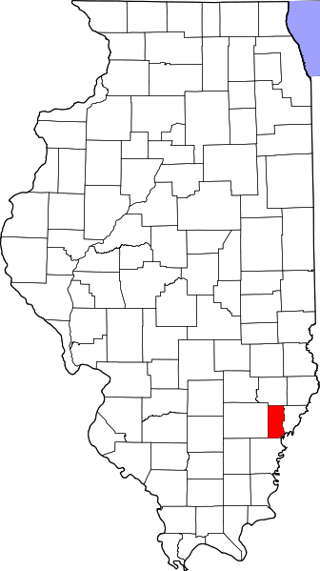
A. Child Maltreatment

Edwards County (Rural)
During 2018, there were 24 substantiated cases of child maltreatment (which includes reports of physical and other abuse, sexual abuse, neglect, and risk of harm) in Edwards County. This number equates to a rate of 15.84 substantiated reports per 1,000 children in Illinois (which is higher than the state rate: 10.95 substantiated reports per 1,000 children).

These figures illustrate substantiated reports by child’s race and age. 50% of substantiated cases were among female children.

B. Youth Violence
No data or insufficient data for this county.

C. Juvenile Violent Offenses
In 2018, there were 4 youth admitted to short-term locked juvenile detention facilities in Edwards County. None of these admissions were for violent offenses.

D. Adult Violent Offenses (Arrests)
In 2018, Edwards County had a rate of 31.29 violent crimes per 100,000 residents in Illinois. This is lower than the state rate (395.75 violent crimes per 100,000 residents).

E. Adult Intimate Partner Violence and Sexual Violence
No data or insufficient data for this county.

F. Gun Violence: Firearm Death Rate
No data or insufficient data for this county.

G. Abuse Among Older Adults
In 2015, Edwards County had a rate of 1,238 reports of abuse among older adults (per 100,000) which is higher than the state rate (465.10 reports per 100,000).

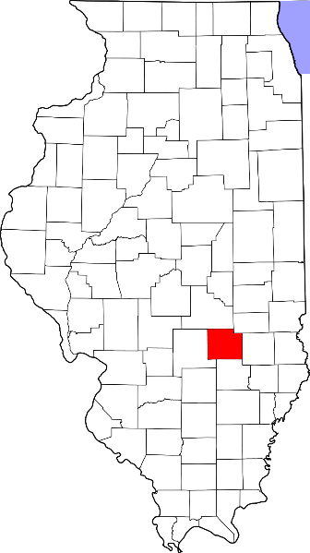
A. Child Maltreatment

Effingham County (Rural)
During 2018, there were 141 substantiated cases of child maltreatment (which includes reports of physical and other abuse, sexual abuse, neglect, and risk of harm) in Effingham County. This number equates to a rate of 17.46 substantiated reports per 1,000 children in Illinois (which is higher than the state rate: 10.95 substantiated reports per 1,000 children).

These figures illustrate substantiated reports by child’s race and age. 50% of substantiated cases were among female children.

B. Youth Violence

Youth in Effingham County reported higher rates of bullying, cyber bullying, dating violence, physical fighting, and weapon carrying compared to the state average.

C. Juvenile Violent Offenses
In 2018, there were 11 youth admitted to short-term locked juvenile detention facilities in Effingham County. Approximately 36% of detention admissions were for a violent offense (n = 4). This translates to a rate of 1.13 violent offenses per 1,000 youth ages 10-17 in Effingham County, which is lower than the rate for the state of Illinois (1.83 violent offense admissions per 1,000 youth ages 10-17).

Hispanic youth had the highest rate of violent offense admissions.

 | Rate per 1,000
Male | 1.1
Female | 1.2

Violent Arrests by Race & Sex (2018)
 | Rate per 1,000
Race/Ethnicity
African American | 50.28
Hispanic/Latinx | 2.92
Other | -
White | 4.27
Sex
Female | 2.21
Male | 7.37
D. Adult Violent Offenses (Arrests)
In 2018, Effingham County had a rate of 172.47 violent crimes per 100,000 residents in Illinois. This is lower than the state rate (395.75 violent crimes per 100,000 residents).

African American adults had the highest rates of arrests for violent crimes.

E. Adult Intimate Partner Violence and Sexual Violence
Effingham County reported lower rates of domestic violence and sexual assault crimes in 2018 compared to the state rate.
 | Rate per 100,000 | State Rate per 100,000
Domestic Violence Crime Offense | 725 | 840.39
Sexual Assault | 40.9 | 44.83

F. Gun Violence: Firearm Death Rate
No data or insufficient data for this county.

G. Abuse Among Older Adults
In 2015, Effingham County had a rate of 887.3 reports of abuse among older adults (per 100,000) which is higher than the state rate (465.10 reports per 100,000).
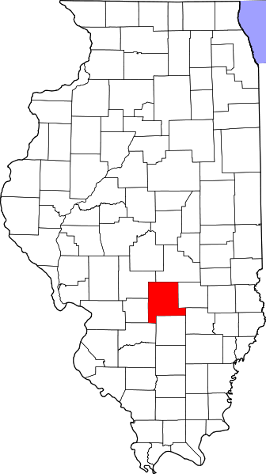
A. Child Maltreatment

Fayette County (Rural)
During 2018, there were 101 substantiated cases of child maltreatment (which includes reports of physical and other abuse, sexual abuse, neglect, and risk of harm) in Fayette County. This number equates to a rate of 22.34 substantiated reports per 1,000 children in Illinois (which is higher than the state rate: 10.95 substantiated reports per 1,000 children).

These figures illustrate substantiated reports by child’s race and age. 47% of substantiated cases were among female children.

B. Youth Violence
No data or insufficient data for this county.

C. Juvenile Violent Offenses
In 2018, there were 32 youth admitted to short-term locked juvenile detention facilities in Fayette County. Approximately 22% of detention admissions were for a violent offense (n = 7). This translates to a rate of 3.35 violent offenses per 1,000 youth ages 10-17 in Fayette County, which is higher than the rate for the state of Illinois (1.83 violent offense admissions per 1,000 youth ages 10-17).

 | Rate per 1,000
Male | 5.7
Female | 1.0

Black youth had the highest rate of violent offense admissions.

Juvenile Weapon-Related Offenses
Fayette County had 1 weapon-related offenses in 2018.

D. Adult Violent Offenses (Arrests)
In 2018, Fayette County had a rate of 154.09 violent crimes per 100,000 residents in Illinois. This is lower than the state rate (395.75 violent crimes per 100,000 residents).

E. Adult Intimate Partner Violence and Sexual Violence
Fayette County reported lower rates of domestic violence and sexual assault crimes in 2018 compared to the state rate.
 | Rate per 100,000 | State Rate per 100,000
Domestic Violence Crime Offense | 112.1 | 840.39
Sexual Assault | 37.4 | 44.83

F. Gun Violence: Firearm Death Rate
No data or insufficient data for this county.

G. Abuse Among Older Adults
In 2015, Fayette County had a rate of 842.6 reports of abuse among older adults (per 100,000) which is higher than the state rate (465.10 reports per 100,000).

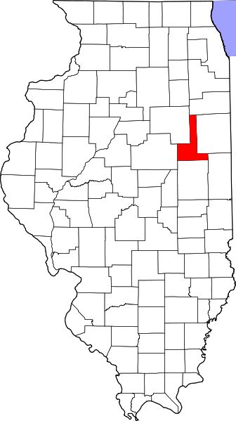
A. Child Maltreatment

Ford County (Other Urban/Suburban)
During 2018, there were 36 substantiated cases of child maltreatment (which includes reports of physical and other abuse, sexual abuse, neglect, and risk of harm) in Ford County. This number equates to a rate of 11.76 substantiated reports per 1,000 children in Illinois (which is higher than the state rate: 10.95 substantiated reports per 1,000 children).

These figures illustrate substantiated reports by child’s race and age. 51% of substantiated cases were among female children.

B. Youth Violence
Youth in Ford County reported higher rates of bullying, cyber bullying, physical fighting, and weapon carrying compared to the state average.

Youth reported similar levels of dating violence compared to the state average.

C. Juvenile Violent Offenses
In 2018, there were 2 youth admitted to short-term locked juvenile detention facilities in Adams County. 50% of detention admissions were for a violent offense (n = 1). This translates to a rate of 0.69 violent offenses per 1,000 youth ages 10-17 in Ford County, which is lower than the rate for the state of Illinois (1.83 violent offense admissions per 1,000 youth ages 10-17).

White youth had a rate of 0.7 violent offense admissions per 1,000 youth ages 10-17.
 | Rate per 1,000
Male | 1.4
Female | 0

Violent Arrests by Race & Sex (2018)
 | Rate per 1,000
Race/Ethnicity
African American | 13.61
Hispanic/Latinx | 2.34
Other | 2.16
White | 2.66
Sex
Female | 1.47
Male | 4.69
D. Adult Violent Offenses (Arrests)
In 2018, Ford County had a rate of 263.87 violent crimes per 100,000 residents in Illinois. This is lower than the state rate (395.75 violent crimes per 100,000 residents).

African American adults had the highest rates of arrests for violent crimes.

E. Adult Intimate Partner Violence and Sexual Violence
Ford County reported lower rates of domestic violence and higher rates of sexual assault crimes in 2018 compared to the state rate.
 | Rate per 100,000 | State Rate per 100,000
Domestic Violence Crime Offense | 723.8 | 840.39
Sexual Assault | 52.8 | 44.83

F. Gun Violence: Firearm Death Rate
No data or insufficient data for this county.

G. Abuse Among Older Adults
In 2015, Ford County had a rate of 501 reports of abuse among older adults (per 100,000) which is higher than the state rate (465.10 reports per 100,000).

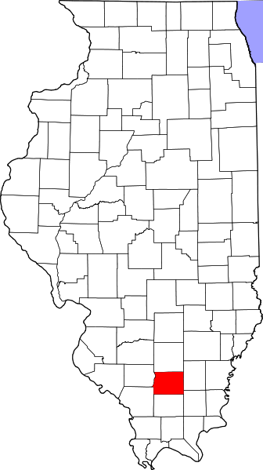
A. Child Maltreatment

Franklin County (Rural)
During 2018, there were 245 substantiated cases of child maltreatment (which includes reports of physical and other abuse, sexual abuse, neglect, and risk of harm) in Franklin County. This number equates to a rate of 28.19 substantiated reports per 1,000 children in Illinois (which is higher than the state rate: 10.95 substantiated reports per 1,000 children).

These figures illustrate substantiated reports by child’s race and age. 51% of substantiated cases were among female children.

B. Youth Violence

Youth in Franklin County reported higher rates of bullying, cyber bullying, dating violence, physical fighting, and weapon carrying compared to the state average.

C. Juvenile Violent Offenses
In 2018, there were 39 youth admitted to short-term locked juvenile detention facilities in Franklin County. Approximately 10% of detention admissions were for a violent offense (n = 4). This translates to a rate of 1.01 violent offenses per 1,000 youth ages 10-17 in Franklin County, which is higher than the rate for the state of Illinois (1.83 violent offense admissions per 1,000 youth ages 10-17).

Black youth had the highest rate of violent offense admissions.

 | Rate per 1,000
Male | 1.0
Female | 1.1

Violent Arrests by Race & Sex (2018)
 | Rate per 1,000
Race/Ethnicity
African American | 30.96
Hispanic/Latinx | -
Other | 1.15
White | 7.12
Sex
Female | 3.93
Male | 11.30
D. Adult Violent Offenses (Arrests)
In 2018, Franklin County had a rate of 77.52 violent crimes per 100,000 residents in Illinois. This is lower than the state rate (395.75 violent crimes per 100,000 residents).

African American adults had the highest rates of arrests for violent crimes.

E. Adult Intimate Partner Violence and Sexual Violence
Franklin County reported lower rates of domestic violence crimes in 2018 compared to the state rate.
 | Rate per 100,000 | State Rate per 100,000
Domestic Violence Crime Offense | 310.1 | 840.39

F. Gun Violence: Firearm Death Rate
No data or insufficient data for this county.

G. Abuse Among Older Adults
In 2015, Franklin County had a rate of 1416.4 reports of abuse among older adults (per 100,000) which is higher than the state rate (465.10 reports per 100,000).

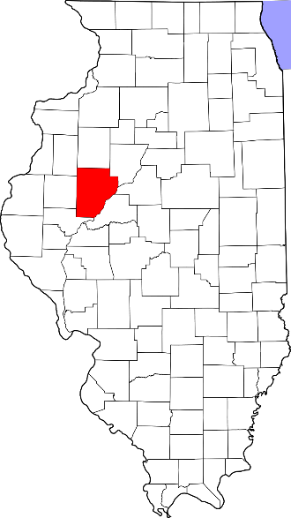
A. Child Maltreatment

Fulton County (Rural)
During 2018, there were 145 substantiated cases of child maltreatment (which includes reports of physical and other abuse, sexual abuse, neglect, and risk of harm) in Fulton County. This number equates to a rate of 20.47 substantiated reports per 1,000 children in Illinois (which is higher than the state rate: 10.95 substantiated reports per 1,000 children).

These figures illustrate substantiated reports by child’s race and age. 48% of substantiated cases were among female children.

B. Youth Violence

Youth in Fulton County reported higher rates of bullying, cyber bullying, dating violence, physical fighting, and weapon carrying compared to the state average.

C. Juvenile Violent Offenses
In 2018, there were 26 youth admitted to short-term locked juvenile detention facilities in Fulton County. Approximately 4% of detention admissions were for a violent offense (n = 1). This translates to a rate of 0.30 violent offenses per 1,000 youth ages 10-17 in Fulton County, which is lower than the rate for the state of Illinois (1.83 violent offense admissions per 1,000 youth ages 10-17).

White youth had a rate of 0.3 violent offense admissions per 1,000 youth ages 10-17.
 | Rate per 1,000
Male | 0.6
Female | 0

Violent Arrests by Race & Sex (2018)
 | Rate per 1,000
Race/Ethnicity
African American | 5.32
Hispanic/Latinx | -
Other | -
White | 3.59
Sex
Female | 2.25
Male | 5.35
D. Adult Violent Offenses (Arrests)
In 2018, Fulton County had a rate of 60.27 violent crimes per 100,000 residents in Illinois. This is lower than the state rate (395.75 violent crimes per 100,000 residents).

African American adults had the highest rates of arrests for violent crimes.

E. Adult Intimate Partner Violence and Sexual Violence
Fulton County reported lower rates of domestic violence and sexual assault crimes in 2018 compared to the state rate.
 | Rate per 100,000 | State Rate per 100,000
Domestic Violence Crime Offense | 106.2 | 840.39
Sexual Assault | 23 | 44.83

F. Gun Violence: Firearm Death Rate
No data or insufficient data for this county.

G. Abuse Among Older Adults
In 2015, Fulton County had a rate of 738.4 reports of abuse among older adults (per 100,000) which is higher than the state rate (465.10 reports per 100,000).

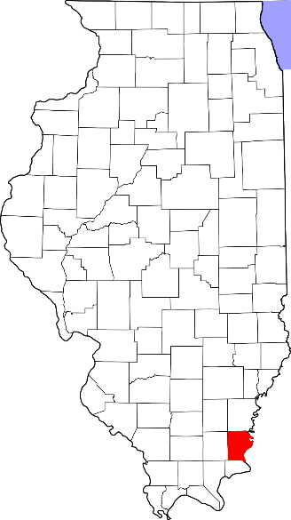
A. Child Maltreatment

Gallatin County (Rural)
During 2018, there were 31 substantiated cases of child maltreatment (which includes reports of physical and other abuse, sexual abuse, neglect, and risk of harm) in Gallatin County. This number equates to a rate of 29.00 substantiated reports per 1,000 children in Illinois (which is higher than the state rate: 10.95 substantiated reports per 1,000 children).

These figures illustrate substantiated reports by child’s race and age. 52% of substantiated cases were among female children.

B. Youth Violence
No data or insufficient data for this county.

C. Juvenile Violent Offenses
In 2018, there were 1 youth admitted to short-term locked juvenile detention facilities in Gallatin County. It was not for a violent offense.

D. Adult Violent Offenses (Arrests)
In 2018, Gallatin County had a rate of 177.94 violent crimes per 100,000 residents in Illinois. This is lower than the state rate (395.75 violent crimes per 100,000 residents).

E. Adult Intimate Partner Violence and Sexual Violence
Gallatin County reported lower rates of domestic violence crimes in 2018 compared to the state rate.
 | Rate per 100,000 | State Rate per 100,000
Domestic Violence Crime Offense | 59.3 | 840.39

F. Gun Violence: Firearm Death Rate
No data or insufficient data for this county.

G. Abuse Among Older Adults
In 2015, Gallatin County had a rate of 592.9 reports of abuse among older adults (per 100,000) which is higher than the state rate (465.10 reports per 100,000).

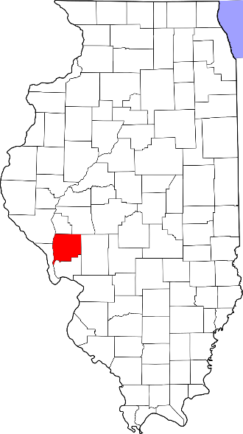
A. Child Maltreatment

Greene County (Rural)
During 2018, there were 59 substantiated cases of child maltreatment (which includes reports of physical and other abuse, sexual abuse, neglect, and risk of harm) in Greene County. This number equates to a rate of 21.22 substantiated reports per 1,000 children in Illinois (which is higher than the state rate: 10.95 substantiated reports per 1,000 children).

These figures illustrate substantiated reports by child’s race and age. 50% of substantiated cases were among female children.

B. Youth Violence
Youth in Greene County reported higher rates of bullying, cyber bullying, physical fighting, and weapon carrying compared to the state average.

Youth reported slightly lower levels of dating violence compared to the state average.

C. Juvenile Violent Offenses
No data or insufficient data for this county.

Violent Arrests by Race & Sex (2018)
 | Rate per 1,000
Race/Ethnicity
African American | 15.46
Hispanic/Latinx | 23.26
Other | -
White | 4.76
Sex
Female | 2.75
Male | 8.70
D. Adult Violent Offenses (Arrests)
In 2018, Greene County had a rate of 306.65 violent crimes per 100,000 residents in Illinois. This is lower than the state rate (395.75 violent crimes per 100,000 residents).

Hispanic/Latinx adults had the highest rates of arrests for violent crimes.

E. Adult Intimate Partner Violence and Sexual Violence
Greene County reported lower rates of domestic violence and sexual assault crimes in 2018 compared to the state rate.
 | Rate per 100,000 | State Rate per 100,000
Domestic Violence Crime Offense | 260.7 | 840.39
Sexual Assault | 30.7 | 44.83

F. Gun Violence: Firearm Death Rate
No data or insufficient data for this county.

G. Abuse Among Older Adults
In 2015, Greene County had a rate of 1438.6 reports of abuse among older adults (per 100,000) which is higher than the state rate (465.10 reports per 100,000).

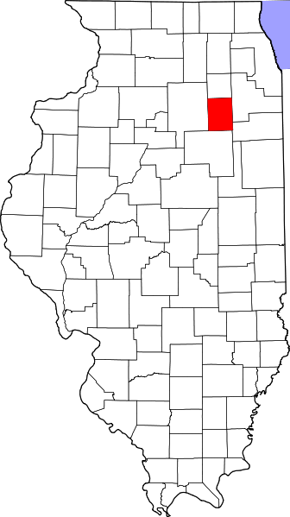
A. Child Maltreatment

Grundy County (Suburban Chicago)
During 2018, there were 107 substantiated cases of child maltreatment (which includes reports of physical and other abuse, sexual abuse, neglect, and risk of harm) in Grundy County. This number equates to a rate of 8.27 substantiated reports per 1,000 children in Illinois (which is lower than the state rate: 10.95 substantiated reports per 1,000 children).

These figures illustrate substantiated reports by child’s race and age. 50% of substantiated cases were among female children.

B. Youth Violence
Youth in Grundy County reported higher rates of cyber bullying, dating violence, and weapon carrying compared to the state average.

Youth reported lower levels of bullying and physical fighting compared to the state average.

C. Juvenile Violent Offenses
In 2018, there were 26 youth admitted to short-term locked juvenile detention facilities in Grundy County. Approximately 27% of detention admissions were for a violent offense (n = 7). This translates to a rate of 1.12 violent offenses per 1,000 youth ages 10-17 in Grundy County, which is lower than the rate for the state of Illinois (1.83 violent offense admissions per 1,000 youth ages 10-17).

Black youth had the highest rate of violent offense admissions.

 | Rate per 1,000
Male | 0.9
Female | 1.3

Juvenile Weapon-Related Offenses
Violent Arrests by Race & Sex (2018)
 | Rate per 1,000
Race/Ethnicity
African American | 20.41
Hispanic/Latinx | 1.23
Other | 0.41
White | 2.43
Sex
Female | 1.15
Male | 4.32
Grundy County had 1 weapon-related offenses in 2018.

D. Adult Violent Offenses (Arrests)
In 2018, Grundy County had a rate of 76.51 violent crimes per 100,000 residents in Illinois. This is lower than the state rate (395.75 violent crimes per 100,000 residents).

African American adults had the highest rates of arrests for violent crimes.

E. Adult Intimate Partner Violence and Sexual Violence
Grundy County reported lower rates of domestic violence and sexual assault crimes in 2018 compared to the state rate.
 | Rate per 100,000 | State Rate per 100,000
Domestic Violence Crime Offense | 190.3 | 840.39
Sexual Assault | 17.7 | 44.83

F. Gun Violence: Firearm Death Rate
No data or insufficient data for this county.

G. Abuse Among Older Adults
In 2015, Grundy County had a rate of 343.8 reports of abuse among older adults (per 100,000) which is lower than the state rate (465.10 reports per 100,000).
A. Child Maltreatment

Hamilton County (Rural)
During 2018, there were 25 substantiated cases of child maltreatment (which includes reports of physical and other abuse, sexual abuse, neglect, and risk of harm) in Hamilton County. This number equates to a rate of 13.71 substantiated reports per 1,000 children in Illinois (which is higher than the state rate: 10.95 substantiated reports per 1,000 children).

These figures illustrate substantiated reports by child’s race and age. 51% of substantiated cases were among female children.

B. Youth Violence
No data or insufficient data for this county.

C. Juvenile Violent Offenses
In 2018, there were 7 youth admitted to short-term locked juvenile detention facilities in Hamilton County. Approximately 43% of detention admissions were for a violent offense (n = 3). This translates to a rate of 3.45 violent offenses per 1,000 youth ages 10-17 in Hamilton County, which is higher than the rate for the state of Illinois (1.83 violent offense admissions per 1,000 youth ages 10-17).

White youth had a rate of 3.6 violent offense admissions per 1,000 youth ages 10-17.
 | Rate per 1,000
Male | 6.9
Female | 0

D. Adult Violent Offenses (Arrests)
No data or insufficient data for this county.

E. Adult Intimate Partner Violence and Sexual Violence
No data or insufficient data for this county.

F. Gun Violence: Firearm Death Rate
No data or insufficient data for this county.

G. Abuse Among Older Adults
In 2015, Hamilton County had a rate of 566 reports of abuse among older adults (per 100,000) which is higher than the state rate (465.10 reports per 100,000).

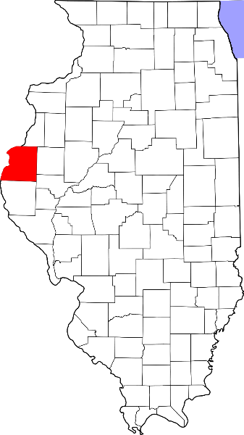
A. Child Maltreatment

Hancock County (Rural)
During 2018, there were 110 substantiated cases of child maltreatment (which includes reports of physical and other abuse, sexual abuse, neglect, and risk of harm) in Hancock County. This number equates to a rate of 29.06 substantiated reports per 1,000 children in Illinois (which is higher than the state rate: 10.95 substantiated reports per 1,000 children).

These figures illustrate substantiated reports by child’s race and age. 50% of substantiated cases were among female children.

B. Youth Violence
No data or insufficient data for this county.

C. Juvenile Violent Offenses
In 2018, there were 11 youth admitted to short-term locked juvenile detention facilities in Hancock County. Approximately 36% of detention admissions were for a violent offense (n = 4). This translates to a rate of 2.27 violent offenses per 1,000 youth ages 10-17 in Hancock County, which is higher than the rate for the state of Illinois (1.83 violent offense admissions per 1,000 youth ages 10-17).

White youth had a rate of 1.8 violent offense admissions per 1,000 youth ages 10-17.
 | Rate per 1,000
Male | 3.4
Female | 1.1

D. Adult Violent Offenses (Arrests)
Violent Arrests by Race & Sex (2018)
 | Rate per 1,000
Race/Ethnicity
African American | 6.76
Hispanic/Latinx | -
Other | -
White | 2.72
Sex
Female | 1.98
Male | 3.55
In 2018, Hancock County had a rate of 56.04 violent crimes per 100,000 residents in Illinois. This is lower than the state rate (395.75 violent crimes per 100,000 residents).

African American adults had the highest rates of arrests for violent crimes.

E. Adult Intimate Partner Violence and Sexual Violence
Hancock County reported lower rates of domestic violence and sexual assault crimes in 2018 compared to the state rate.
 | Rate per 100,000 | State Rate per 100,000
Domestic Violence Crime Offense | 134.5 | 840.39
Sexual Assault | 11.2 | 44.83

F. Gun Violence: Firearm Death Rate
No data or insufficient data for this county.

G. Abuse Among Older Adults
In 2015, Hancock County had a rate of 277 reports of abuse among older adults (per 100,000) which is lower than the state rate (465.10 reports per 100,000).

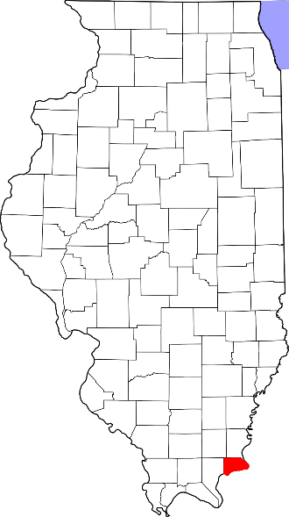
A. Child Maltreatment

Hardin County (Rural)
During 2018, there were 3 substantiated cases of child maltreatment (which includes reports of physical and other abuse, sexual abuse, neglect, and risk of harm) in Hardin County. This number equates to a rate of 4.24 substantiated reports per 1,000 children in Illinois (which is lower than the state rate: 10.95 substantiated reports per 1,000 children).

These figures illustrate substantiated reports by child’s race and age. 51% of substantiated cases were among female children.

B. Youth Violence
No data or insufficient data for this county.

C. Juvenile Violent Offenses
No data or insufficient data for this county.

D. Adult Violent Offenses (Arrests)
In 2018, Hardin County had a rate of 230.18 violent crimes per 100,000 residents in Illinois. This is lower than the state rate (395.75 violent crimes per 100,000 residents).

E. Adult Intimate Partner Violence and Sexual Violence
Hardin County reported lower rates of domestic violence and sexual assault crimes in 2018 compared to the state rate.
 | Rate per 100,000 | State Rate per 100,000
Domestic Violence Crime Offense | 230.2 | 840.39
Sexual Assault | 25.6 | 44.83

F. Gun Violence: Firearm Death Rate
No data or insufficient data for this county.

G. Abuse Among Older Adults
In 2015, Hardin County had a rate of 809.4 reports of abuse among older adults (per 100,000) which is higher than the state rate (465.10 reports per 100,000).

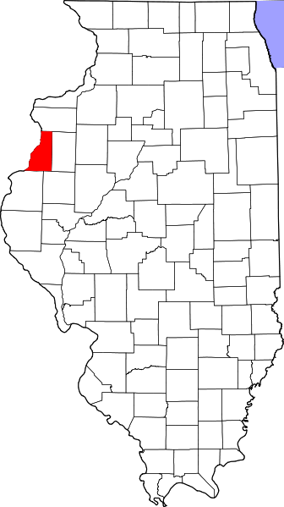
A. Child Maltreatment

Henderson County (Rural)
During 2018, there were 9 substantiated cases of child maltreatment (which includes reports of physical and other abuse, sexual abuse, neglect, and risk of harm) in Henderson County. This number equates to a rate of 7.09 substantiated reports per 1,000 children in Illinois (which is lower than the state rate: 10.95 substantiated reports per 1,000 children).

These figures illustrate substantiated reports by child’s race and age. 47% of substantiated cases were among female children.

B. Youth Violence
No data or insufficient data for this county.

C. Juvenile Violent Offenses
In 2018, there were 12 youth admitted to short-term locked juvenile detention facilities in Henderson County. Approximately 17% of detention admissions were for a violent offense (n = 2). This translates to a rate of 3.64 violent offenses per 1,000 youth ages 10-17 in Henderson County, which is higher than the rate for the state of Illinois (1.83 violent offense admissions per 1,000 youth ages 10-17).

White youth had a rate of 3.8 violent offense admissions per 1,000 youth ages 10-17.
 | Rate per 1,000
Male | 7.5
Female | 0

D. Adult Violent Offenses (Arrests)
In 2018, Henderson County had a rate of 14.91 violent crimes per 100,000 residents in Illinois. This is lower than the state rate (395.75 violent crimes per 100,000 residents).

E. Adult Intimate Partner Violence and Sexual Violence
No data or insufficient data for this county.

F. Gun Violence: Firearm Death Rate
No data or insufficient data for this county.

G. Abuse Among Older Adults
In 2015, Henderson County had a rate of 359.2 reports of abuse among older adults (per 100,000) which is lower than the state rate (465.10 reports per 100,000).

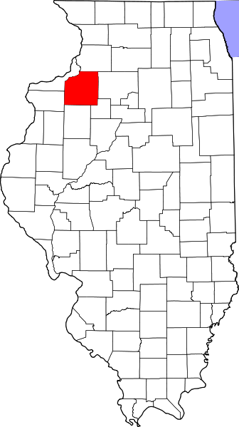
A. Child Maltreatment

Henry County (Other Urban/Suburban)
During 2018, there were 173 substantiated cases of child maltreatment (which includes reports of physical and other abuse, sexual abuse, neglect, and risk of harm) in Henry County. This number equates to a rate of 15.57 substantiated reports per 1,000 children in Illinois (which is higher than the state rate: 10.95 substantiated reports per 1,000 children).

These figures illustrate substantiated reports by child’s race and age. 50% of substantiated cases were among female children.

B. Youth Violence
Youth in Henry County reported higher rates of bullying, cyber bullying, physical fighting, and weapon carrying compared to the state average.

Youth reported lower levels of dating violence compared to the state average.

C. Juvenile Violent Offenses
In 2018, there were 11 youth admitted to short-term locked juvenile detention facilities in Henry County. None of these admissions were for a violent offense.

Violent Arrests by Race & Sex (2018)
 | Rate per 1,000
Race/Ethnicity
African American | 18.69
Hispanic/Latinx | 0.36
Other | 1.44
White | 1.70
Sex
Female | 0.88
Male | 3.55
D. Adult Violent Offenses (Arrests)
In 2018, Henry County had a rate of 89.63 violent crimes per 100,000 residents in Illinois. This is lower than the state rate (395.75 violent crimes per 100,000 residents).

African American adults had the highest rates of arrests for violent crimes.

E. Adult Intimate Partner Violence and Sexual Violence
Henry County reported lower rates of domestic violence and sexual assault crimes in 2018 compared to the state rate.
 | Rate per 100,000 | State Rate per 100,000
Domestic Violence Crime Offense | 73.3 | 840.39
Sexual Assault | 14.3 | 44.83

F. Gun Violence: Firearm Death Rate
No data or insufficient data for this county.

G. Abuse Among Older Adults
In 2015, Henry County had a rate of 463.3 reports of abuse among older adults (per 100,000) which is slightly lower than the state rate (465.10 reports per 100,000).

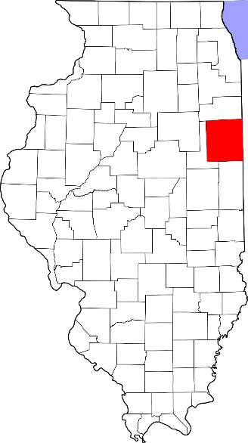
A. Child Maltreatment

Iroquois County (Rural)
During 2018, there were 60 substantiated cases of child maltreatment (which includes reports of physical and other abuse, sexual abuse, neglect, and risk of harm) in Iroquois County. This number equates to a rate of 9.73 substantiated reports per 1,000 children in Illinois (which is lower than the state rate: 10.95 substantiated reports per 1,000 children).

These figures illustrate substantiated reports by child’s race and age. 51% of substantiated cases were among female children.

B. Youth Violence
Youth in Iroquois County reported higher rates of bullying, cyber bullying, dating violence, physical fighting, and weapon carrying compared to the state average.

C. Juvenile Violent Offenses
In 2018, there were 10 youth admitted to short-term locked juvenile detention facilities in Iroquois County. Approximately 40.00% of detention admissions were for a violent offense (n = 4). This translates to a rate of 1.39 violent offenses per 1,000 youth ages 10-17 in Iroquois County, which is higher than the rate for the state of Illinois (1.83 violent offense admissions per 1,000 youth ages 10-17).

Black youth had the highest rate of violent offense admissions.

 | Rate per 1,000
Male | 2.7
Female | 0

Violent Arrests by Race & Sex (2018)
 | Rate per 1,000
Race/Ethnicity
African American | 41.38
Hispanic/Latinx | 0.52
Other | 1.73
White | 2.52
Sex
Female | 1.18
Male | 5.24
D. Adult Violent Offenses (Arrests)
In 2018, Iroquois County had a rate of 83.32 violent crimes per 100,000 residents in Illinois. This is lower than the state rate (395.75 violent crimes per 100,000 residents).

African American adults had the highest rates of arrests for violent crimes.

E. Adult Intimate Partner Violence and Sexual Violence
Iroquois County reported lower rates of domestic violence and sexual assault crimes in 2018 compared to the state rate.
 | Rate per 100,000 | State Rate per 100,000
Domestic Violence Crime Offense | 275.3 | 840.39
Sexual Assault | 18.1 | 44.83

F. Gun Violence: Firearm Death Rate
No data or insufficient data for this county.

G. Abuse Among Older Adults
In 2015, Iroquois County had a rate of 679.3 reports of abuse among older adults (per 100,000) which is higher than the state rate (465.10 reports per 100,000).
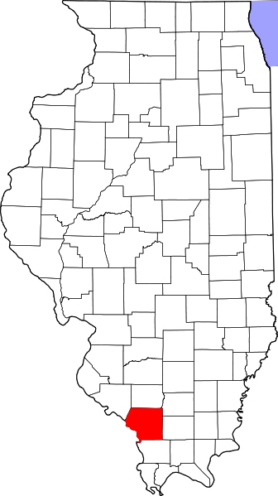
A. Child Maltreatment

Jackson County (Other Urban/Suburban)
During 2018, there were 235 substantiated cases of child maltreatment (which includes reports of physical and other abuse, sexual abuse, neglect, and risk of harm) in Jackson County. This number equates to a rate of 22.07 substantiated reports per 1,000 children in Illinois (which is higher than the state rate: 10.95 substantiated reports per 1,000 children).

These figures illustrate substantiated reports by child’s race and age. 50% of substantiated cases were among female children.

B. Youth Violence
Youth in Jackson County reported higher rates of bullying, cyber bullying, physical fighting/ and weapon carrying compared to the state average.

Youth reported lower levels of dating violence compared to the state average.

C. Juvenile Violent Offenses
In 2018, there were 46 youth admitted to short-term locked juvenile detention facilities in Jackson County. Approximately 22% of detention admissions were for a violent offense (n = 10). This translates to a rate of 2.23 violent offenses per 1,000 youth ages 10-17 in Jackson County, which is higher than the rate for the state of Illinois (1.83 violent offense admissions per 1,000 youth ages 10-17).

Black youth had the highest rate of violent offense admissions.

 | Rate per 1,000
Male | 3.5
Female | 0.9

Juvenile Weapon-Related Offenses
Jackson county had 2 weapon-related offenses in 2018.

Violent Arrests by Race & Sex (2018)
 | Rate per 1,000
Race/Ethnicity
African American | 19.42
Hispanic/Latinx | 4.74
Other | 1.22
White | 3.34
Sex
Female | 3.01
Male | 9.35
D. Adult Violent Offenses (Arrests)
In 2018, Jackson County had a rate of 351.80 violent crimes per 100,000 residents in Illinois. This is lower than the state rate (395.75 violent crimes per 100,000 residents).

African American adults had the highest rates of arrests for violent crimes.

E. Adult Intimate Partner Violence and Sexual Violence
Jackson County reported higher rates of domestic violence and sexual assault crimes in 2018 compared to the state rate.
 | Rate per 100,000 | State Rate per 100,000
Domestic Violence Crime Offense | 1165.1 | 840.39
Sexual Assault | 78.4 | 44.83

F. Gun Violence: Firearm Death Rate
No data or insufficient data for this county.

G. Abuse Among Older Adults
In 2015, Jackson County had a rate of 1176.3 reports of abuse among older adults (per 100,000) which is higher than the state rate (465.10 reports per 100,000).
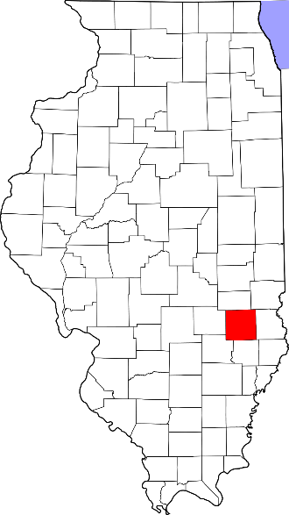
A. Child Maltreatment

Jasper County (Rural)
During 2018, there were 49 substantiated cases of child maltreatment (which includes reports of physical and other abuse, sexual abuse, neglect, and risk of harm) in Jasper County. This number equates to a rate of 22.20 substantiated reports per 1,000 children in Illinois (which is higher than the state rate: 10.95 substantiated reports per 1,000 children).

These figures illustrate substantiated reports by child’s race and age. 50% of substantiated cases were among female children.

B. Youth Violence
No data or insufficient data for this county.

C. Juvenile Violent Offenses
No data or insufficient data for this county.

Violent Arrests by Race & Sex (2018)
 | Rate per 1,000
Race/Ethnicity
African American | 10.31
Hispanic/Latinx | -
Other | -
White | 4.81
Sex
Female | 2.92
Male | 7.49
D. Adult Violent Offenses (Arrests)
In 2018, Jasper County had a rate of 62.43 violent crimes per 100,000 residents in Illinois. This is lower than the state rate (395.75 violent crimes per 100,000 residents).

African American adults had the highest rates of arrests for violent crimes.

E. Adult Intimate Partner Violence and Sexual Violence
Jasper County reported lower rates of domestic violence and sexual assault crimes in 2018 compared to the state rate.
 | Rate per 100,000 | State Rate per 100,000
Domestic Violence Crime Offense | 145.7 | 840.39
Sexual Assault | 20.8 | 44.83

F. Gun Violence: Firearm Death Rate
No data or insufficient data for this county.

G. Abuse Among Older Adults
In 2015, Jasper County had a rate of 852.3 reports of abuse among older adults (per 100,000) which is higher than the state rate (465.10 reports per 100,000).

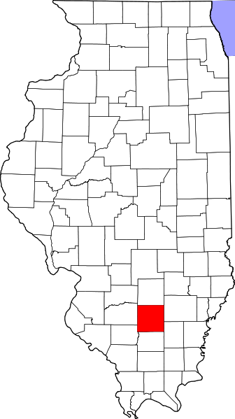
A. Child Maltreatment

Jefferson County (Rural)
During 2018, there were 323 substantiated cases of child maltreatment (which includes reports of physical and other abuse, sexual abuse, neglect, and risk of harm) in Jefferson County. This number equates to a rate of 38.24 substantiated reports per 1,000 children in Illinois (which is higher than the state rate: 10.95 substantiated reports per 1,000 children).

These figures illustrate substantiated reports by child’s race and age. 49% of substantiated cases were among female children.

B. Youth Violence
Youth in Jefferson County reported higher rates of bullying, cyber bullying, physical fighting, and weapon carrying compared to the state average.

Youth reported lower levels of dating violence compared to the state average.

C. Juvenile Violent Offenses
In 2018, there were 66 youth admitted to short-term locked juvenile detention facilities in Jefferson County. Approximately 18% of detention admissions were for a violent offense (n = 12). This translates to a rate of 3.33 violent offenses per 1,000 youth ages 10-17 in Jefferson County, which is higher than the rate for the state of Illinois (1.83 violent offense admissions per 1,000 youth ages 10-17).

Black youth had the highest rate of violent offense admissions.

 | Rate per 1,000
Male | 4.3
Female | 2.3

Violent Arrests by Race & Sex (2018)
 | Rate per 1,000
Race/Ethnicity
African American | 17.18
Hispanic/Latinx | 5.16
Other | 3.29
White | 4.16
Sex
Female | 2.42
Male | 8.69

D. Adult Violent Offenses (Arrests)
In 2018, Jefferson County had a rate of 764.15 violent crimes per 100,000 residents in Illinois. This is higher than the state rate (395.75 violent crimes per 100,000 residents).

African American adults had the highest rates of arrests for violent crimes.

E. Adult Intimate Partner Violence and Sexual Violence
Jefferson County reported higher rates of domestic violence and sexual assault crimes in 2018 compared to the state rate.
 | Rate per 100,000 | State Rate per 100,000
Domestic Violence Crime Offense | 1015.3 | 840.39
Sexual Assault | 79.3 | 44.83

F. Gun Violence: Firearm Death Rate
No data or insufficient data for this county.

G. Abuse Among Older Adults
In 2015, Jefferson County had a rate of 824.1 reports of abuse among older adults (per 100,000) which is higher than the state rate (465.10 reports per 100,000).
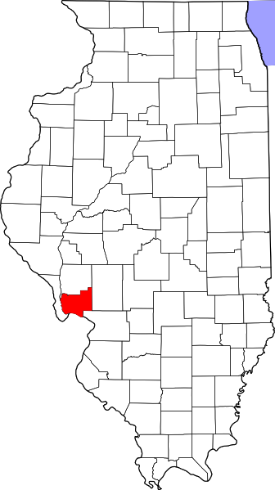
A. Child Maltreatment

Jersey County (Other Urban/Suburban)
During 2018, there were 101 substantiated cases of child maltreatment (which includes reports of physical and other abuse, sexual abuse, neglect, and risk of harm) in Jersey County. This number equates to a rate of 21.81 substantiated reports per 1,000 children in Illinois (which is higher than the state rate: 10.95 substantiated reports per 1,000 children).

These figures illustrate substantiated reports by child’s race and age. 51% of substantiated cases were among female children.

B. Youth Violence
No data or insufficient data for this county.

C. Juvenile Violent Offenses
In 2018, there were 10 youth admitted to short-term locked juvenile detention facilities in Jersey County. Approximately 10% of detention admissions were for a violent offense (n = 1). This translates to a rate of 0.46 violent offenses per 1,000 youth ages 10-17 in Jersey County, which is lower than the rate for the state of Illinois (1.83 violent offense admissions per 1,000 youth ages 10-17).

White youth had a rate of 0.5 violent offense admissions per 1,000 youth ages 10-17.
 | Rate per 1,000
Male | 0.9
Female | 0

D. Adult Violent Offenses (Arrests)
Violent Arrests by Race & Sex (2018)
 | Rate per 1,000
Race/Ethnicity
African American | 19.05
Hispanic/Latinx | -
Other | -
White | 3.42
Sex
Female | 1.16
Male | 6.55
In 2018, Jersey County had a rate of 151.05 violent crimes per 100,000 residents in Illinois. This is lower than the state rate (395.75 violent crimes per 100,000 residents).

African American adults had the highest rates of arrests for violent crimes.

E. Adult Intimate Partner Violence and Sexual Violence
Jersey County reported lower rates of domestic violence and higher rates of sexual assault crimes in 2018 compared to the state rate.
 | Rate per 100,000 | State Rate per 100,000
Domestic Violence Crime Offense | 357 | 840.39
Sexual Assault | 50.4 | 44.83

F. Gun Violence: Firearm Death Rate
No data or insufficient data for this county.

G. Abuse Among Older Adults
In 2015, Jersey County had a rate of 441.3 reports of abuse among older adults (per 100,000) which is lower than the state rate (465.10 reports per 100,000).

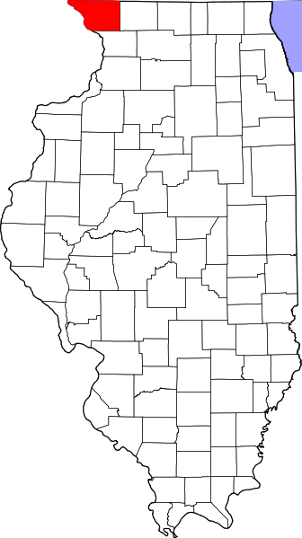
A. Child Maltreatment

Jo Daviess County (Rural)
During 2018, there were 81 substantiated cases of child maltreatment (which includes reports of physical and other abuse, sexual abuse, neglect, and risk of harm) in Jo Daviess County. This number equates to a rate of 19.28 substantiated reports per 1,000 children in Illinois (which is higher than the state rate: 10.95 substantiated reports per 1,000 children).

These figures illustrate substantiated reports by child’s race and age. 50% of substantiated cases were among female children.

B. Youth Violence
Youth in Jo Daviess County reported higher rates of bullying, cyber bullying and physical fighting compared to the state average.

Youth reported similar levels of dating violence and weapon carrying compared to the state average.

C. Juvenile Violent Offenses
In 2018, there were 5 youth admitted to short-term locked juvenile detention facilities in Jo Daviess County. Approximately 20% of detention admissions were for a violent offense (n = 1). This translates to a rate of 0.50 violent offenses per 1,000 youth ages 10-17 in Jo Daviess County, which is lower than the rate for the state of Illinois (1.83 violent offense admissions per 1,000 youth ages 10-17).

Black youth had a rate of 21.3 violent offense admissions per 1,000 youth ages 10-17.

 | Rate per 1,000
Male | 0.9
Female | 0

Violent Arrests by Race & Sex (2018)
 | Rate per 1,000
Race/Ethnicity
African American | 109.09
Hispanic/Latinx | 6.17
Other | -
White | 2.97
Sex
Female | 2.02
Male | 5.57
D. Adult Violent Offenses (Arrests)
In 2018, Jo Daviess County had a rate of 98.29 violent crimes per 100,000 residents in Illinois. This is lower than the state rate (395.75 violent crimes per 100,000 residents).

African American adults had the highest rates of arrests for violent crimes.

E. Adult Intimate Partner Violence and Sexual Violence
Jo Daviess County reported lower rates of domestic violence and sexual assault crimes in 2018 compared to the state rate.
 | Rate per 100,000 | State Rate per 100,000
Domestic Violence Crime Offense | 205.9 | 840.39
Sexual Assault | 23.4 | 44.83

F. Gun Violence: Firearm Death Rate
No data or insufficient data for this county.

G. Abuse Among Older Adults
In 2015, Jo Daviess County had a rate of 80.7 reports of abuse among older adults (per 100,000) which is lower than the state rate (465.10 reports per 100,000).

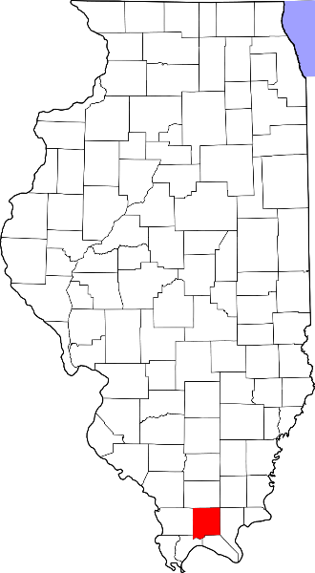
A. Child Maltreatment

Johnson County (Rural)
During 2018, there were 22 substantiated cases of child maltreatment (which includes reports of physical and other abuse, sexual abuse, neglect, and risk of harm) in Johnson County. This number equates to a rate of 9.45 substantiated reports per 1,000 children in Illinois (which is lower than the state rate: 10.95 substantiated reports per 1,000 children).

These figures illustrate substantiated reports by child’s race and age. 44% of substantiated cases were among female children.

B. Youth Violence
Youth in Johnson County reported higher rates of cyber bullying, dating violence, physical fighting and weapon carrying compared to the state average.

Youth reported similar levels of bullying compared to the state average.

C. Juvenile Violent Offenses
No data or insufficient data for this county.

D. Adult Violent Offenses (Arrests)
Violent Arrests by Race & Sex (2018)
 | Rate per 1,000
Race/Ethnicity
African American | 0.67
Hispanic/Latinx | -
Other | 29.13
White | 2.27
Sex
Female | -
Male | -
In 2018, Johnson County had a rate of 136.48 violent crimes per 100,000 residents in Illinois. This is lower than the state rate (395.75 violent crimes per 100,000 residents).

Adults with “other” race/ethnicity had the highest rates of arrests for violent crimes.

E. Adult Intimate Partner Violence and Sexual Violence
Johnson County reported lower rates of sexual assault crimes in 2018 compared to the state rate.

 | Rate per 100,000 | State Rate per 100,000
Sexual Assault | 16.1 | 44.83

F. Gun Violence: Firearm Death Rate
No data or insufficient data for this county.

G. Abuse Among Older Adults
In 2015, Johnson County had a rate of 867.5 reports of abuse among older adults (per 100,000) which is higher than the state rate (465.10 reports per 100,000).

A. Child Maltreatment

Kane County (Suburban Chicago)
During 2018, there were 923 substantiated cases of child maltreatment (which includes reports of physical and other abuse, sexual abuse, neglect, and risk of harm) in Kane County. This number equates to a rate of 6.60 substantiated reports per 1,000 children in Illinois (which is lower than the state rate: 10.95 substantiated reports per 1,000 children).

These figures illustrate substantiated reports by child’s race and age. 50% of substantiated cases were among female children.

B. Youth Violence
Youth in Kane County reported lower and/or similar rates of bullying, cyber bullying, dating violence, physical fighting and weapon carrying compared to the state average.

C. Juvenile Violent Offenses
In 2018, there were 288 youth admitted to short-term locked juvenile detention facilities in Kane County. Approximately 33% of detention admissions were for a violent offense (n = 96). This translates to a rate of 1.46 violent offenses per 1,000 youth ages 10-17 in Kane County, which is lower than the rate for the state of Illinois (1.83 violent offense admissions per 1,000 youth ages 10-17).

Black youth had the highest rate of violent offense admissions.

 | Rate per 1,000
Male | 2.2
Female | 0.7

Juvenile Weapon-Related Offenses
Kane County had 25 weapon-related offenses in 2018.

Violent Arrests by Race & Sex (2018)
 | Rate per 1,000
Race/Ethnicity
African American | 21.46
Hispanic/Latinx | 2.70
Other | 0.68
White | 2.04
Sex
Female | 1.81
Male | 5.82
D. Adult Violent Offenses (Arrests)
In 2018, Kane County had a rate of 181.76 violent crimes per 100,000 residents in Illinois. This is lower than the state rate (395.75 violent crimes per 100,000 residents).

African American adults had the highest rates of arrests for violent crimes.

E. Adult Intimate Partner Violence and Sexual Violence
Kane County reported lower rates of domestic violence and sexual assault crimes in 2018 compared to the state rate.
 | Rate per 100,000 | State Rate per 100,000
Domestic Violence Crime Offense | 314.7 | 840.39
Sexual Assault | 33.3 | 44.83

F. Gun Violence: Firearm Death Rate
Kane County reported 5.2 deaths by a firearm (per 100,000 people), which is lower than the state rate (10.8 per 100,000 people).

G. Abuse Among Older Adults
In 2015, Kane County had a rate of 257.8 reports of abuse among older adults (per 100,000) which is lower than the state rate (465.10 reports per 100,000).

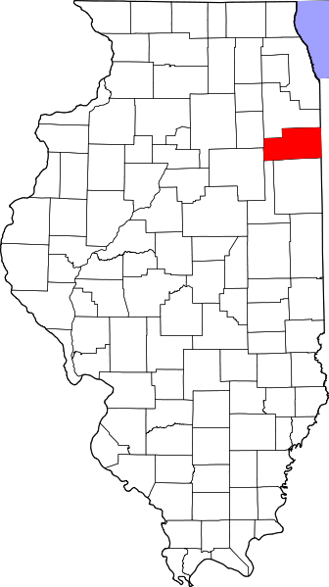
A. Child Maltreatment

Kankakee County (Other Urban/Suburban)
During 2018, there were 219 substantiated cases of child maltreatment (which includes reports of physical and other abuse, sexual abuse, neglect, and risk of harm) in Kankakee County. This number equates to a rate of 8.44 substantiated reports per 1,000 children in Illinois (which is lower than the state rate: 10.95 substantiated reports per 1,000 children).

These figures illustrate substantiated reports by child’s race and age. 51% of substantiated cases were among female children.

B. Youth Violence
Youth in Kankakee County reported higher rates of bullying, cyber-bullying, dating violence, physical fighting, and weapon carrying compared to the state average.

C. Juvenile Violent Offenses
In 2018, there were 148 youth admitted to short-term locked juvenile detention facilities in Kankakee County. Approximately 20% of detention admissions were for a violent offense (n = 30). This translates to a rate of 2.52 violent offenses per 1,000 youth ages 10-17 in Kankakee County, which is higher than the rate for the state of Illinois (1.83 violent offense admissions per 1,000 youth ages 10-17).

Black youth had the highest rate of violent offense admissions.

 | Rate per 1,000
Male | 3.3
Female | 1.7

Juvenile Weapon-Related Offenses
Violent Arrests by Race & Sex (2018)
 | Rate per 1,000
Race/Ethnicity
African American | 15.85
Hispanic/Latinx | 0.44
Other | 6.39
White | 3.08
Sex
Female | 2.60
Male | 8.57
Kankakee county had 2 weapon-related offenses in 2018.

D. Adult Violent Offenses (Arrests)
In 2018, Kankakee County had a rate of 316.29 violent crimes per 100,000 residents in Illinois. This is lower than the state rate (395.75 violent crimes per 100,000 residents).

African American adults had the highest rates of arrests for violent crimes.

E. Adult Intimate Partner Violence and Sexual Violence
Kankakee County reported lower rates of domestic violence and higher rates of sexual assault crimes in 2018 compared to the state rate.
 | Rate per 100,000 | State Rate per 100,000
Domestic Violence Crime Offense | 226.3 | 840.39
Sexual Assault | 58.2 | 44.83

F. Gun Violence: Firearm Death Rate
No data or insufficient data for this county.

G. Abuse Among Older Adults
In 2015, Kankakee County had a rate of 447.5 reports of abuse among older adults (per 100,000) which is lower than the state rate (465.10 reports per 100,000).
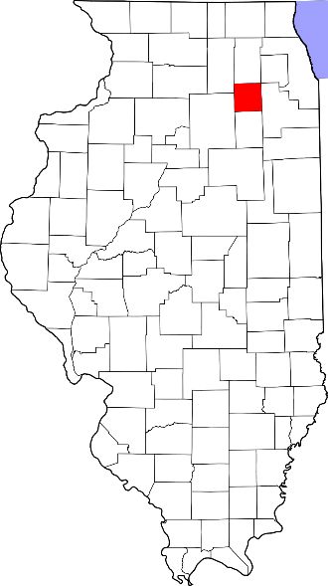
A. Child Maltreatment

Kendall County (Suburban Chicago)
During 2018, there were 117 substantiated cases of child maltreatment (which includes reports of physical and other abuse, sexual abuse, neglect, and risk of harm) in Kendall County. This number equates to a rate of 3.22 substantiated reports per 1,000 children in Illinois (which is lower than the state rate: 10.95 substantiated reports per 1,000 children).

These figures illustrate substantiated reports by child’s race and age. 50% of substantiated cases were among female children.

B. Youth Violence
Youth in Kendall County reported lower rates of bullying, cyber bullying, dating violence, physical fighting, and weapon carrying compared to the state average.

C. Juvenile Violent Offenses
In 2018, there were 92 youth admitted to short-term locked juvenile detention facilities in Kendall County. Approximately 17% of detention admissions were for a violent offense (n =16). This translates to a rate of 0.91 violent offenses per 1,000 youth ages 10-17 in Kendall County, which is lower than the rate for the state of Illinois (1.83 violent offense admissions per 1,000 youth ages 10-17).

Black youth had the highest rate of violent offense admissions.

 | Rate per 1,000
Male | 1.2
Female | 0.6

Juvenile Weapon-Related Offenses
Kendall County had 13 weapon-related offenses in 2018.

Violent Arrests by Race & Sex (2018)
 | Rate per 1,000
Race/Ethnicity
African American | 5.36
Hispanic/Latinx | 0.53
Other | 0.15
White | 1.82
Sex
Female | 1.22
Male | 2.96
D. Adult Violent Offenses (Arrests)
In 2018, Kendall County had a rate of 89.90 violent crimes per 100,000 residents in Illinois. This is lower than the state rate (395.75 violent crimes per 100,000 residents).

African American adults had the highest rates of arrests for violent crimes.

E. Adult Intimate Partner Violence and Sexual Violence
Kendall County reported lower rates of domestic violence and sexual assault crimes in 2018 compared to the state rate.
 | Rate per 100,000 | State Rate per 100,000
Domestic Violence Crime Offense | 522.2 | 840.39
Sexual Assault | 30.5 | 44.83

F. Gun Violence: Firearm Death Rate
No data or insufficient data for this county.

G. Abuse Among Older Adults
In 2015, Kendall County had a rate of 355.9 reports of abuse among older adults (per 100,000) which is lower than the state rate (465.10 reports per 100,000).
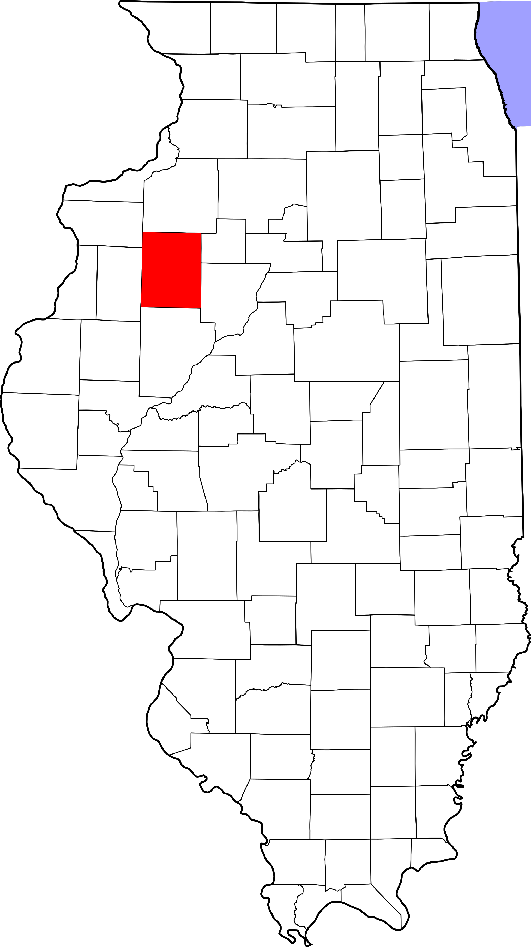
A. Child Maltreatment

Knox County (Rural)
During 2018, there were 164 substantiated cases of child maltreatment (which includes reports of physical and other abuse, sexual abuse, neglect, and risk of harm) in Knox County. This number equates to a rate of 16.31 substantiated reports per 1,000 children in Illinois (which is higher than the state rate: 10.95 substantiated reports per 1,000 children).

These figures illustrate substantiated reports by child’s race and age. 50% of substantiated cases were among female children.

B. Youth Violence
Youth in Knox County reported higher rates of bullying, cyber bullying, dating violence, physical fighting, and weapon carrying compared to the state average.

C. Juvenile Violent Offenses
In 2018, there were 75 youth admitted to short-term locked juvenile detention facilities in Knox County. Approximately 33% of detention admissions were for a violent offense (n = 25). This translates to a rate of 5.63 violent offenses per 1,000 youth ages 10-17 in Knox County, which is higher than the rate for the state of Illinois (1.83 violent offense admissions per 1,000 youth ages 10-17).

Black youth had the highest rate of violent offense admissions.

 | Rate per 1,000
Male | 8.8
Female | 2.3

Juvenile Weapon-Related Offenses
Knox County had 6 weapon-related offenses in 2018.

Violent Arrests by Race & Sex (2018)
 | Rate per 1,000
Race/Ethnicity
African American | 30.63
Hispanic/Latinx | 4.17
Other | 0.77
White | 6.23
Sex
Female | 4.79
Male | 13.17
D. Adult Violent Offenses (Arrests)
In 2018, Knox County had a rate of 365.18 violent crimes per 100,000 residents in Illinois. This is lower than the state rate (395.75 violent crimes per 100,000 residents).

African American adults had the highest rates of arrests for violent crimes.

E. Adult Intimate Partner Violence and Sexual Violence
Knox County reported higher rates of domestic violence and sexual assault crimes in 2018 compared to the state rate.
 | Rate per 100,000 | State Rate per 100,000
Domestic Violence Crime Offense | 1103.5 | 840.39
Sexual Assault | 63.9 | 44.83

F. Gun Violence: Firearm Death Rate
No data or insufficient data for this county.

G. Abuse Among Older Adults
In 2015, Knox County had a rate of 848.7 reports of abuse among older adults (per 100,000) which is higher than the state rate (465.10 reports per 100,000).
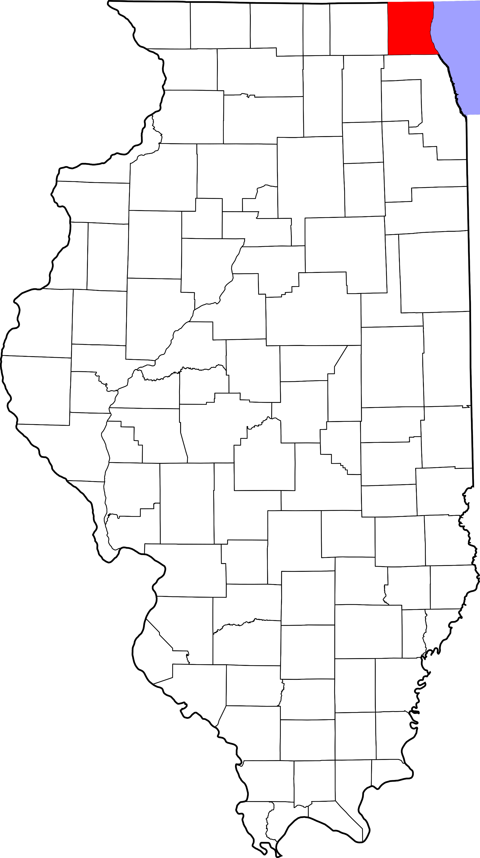
A. Child Maltreatment

Lake County (Suburban Chicago)
During 2018, there were 1,567 substantiated cases of child maltreatment (which includes reports of physical and other abuse, sexual abuse, neglect, and risk of harm) in Lake County. This number equates to a rate of 9.00 substantiated reports per 1,000 children in Illinois (which is lower than the state rate: 10.95 substantiated reports per 1,000 children).

These figures illustrate substantiated reports by child’s race and age. 50% of substantiated cases were among female children.

B. Youth Violence
Youth in Lake County reported lower rates of bullying, cyber bullying, dating violence, physical fighting, and weapon carrying compared to the state average.

C. Juvenile Violent Offenses
In 2018, there were 409 youth admitted to short-term locked juvenile detention facilities in Lake County. Approximately 26% of detention admissions were for a violent offense (n = 108). This translates to a rate of 1.30 violent offenses per 1,000 youth ages 10-17 in Lake County, which is lower than the rate for the state of Illinois (1.83 violent offense admissions per 1,000 youth ages 10-17).

Black youth had the highest rate of violent offense admissions.

 | Rate per 1,000
Male | 1.5
Female | 1.1

Juvenile Weapon-Related Offenses
Lake County had 13 weapon-related offenses in 2018.

Violent Arrests by Race & Sex (2018)
 | Rate per 1,000
Race/Ethnicity
African American | 13.25
Hispanic/Latinx | 2.16
Other | 0.44
White | 1.07
Sex
Female | 0.95
Male | 3.79
D. Adult Violent Offenses (Arrests)
In 2018, Lake County had a rate of 129.42 violent crimes per 100,000 residents in Illinois. This is lower than the state rate (395.75 violent crimes per 100,000 residents).

African American adults had the highest rates of arrests for violent crimes.

E. Adult Intimate Partner Violence and Sexual Violence
Lake County reported lower rates of domestic violence and sexual assault crimes in 2018 compared to the state rate.
 | Rate per 100,000 | State Rate per 100,000
Domestic Violence Crime Offense | 179.5 | 840.39
Sexual Assault | 23.5 | 44.83

F. Gun Violence: Firearm Death Rate
Lake County reported lower rates of suicides and deaths by firearms than the state rate.

 | Rate per 100,000 | State Rate per 100,000
Homicide by Firearm | - | 6.2
Suicide by Firearm | 3.4 | 4.5
Total: Death by Firearm | 5.7 | 10.8

G. Abuse Among Older Adults
In 2015, Lake County had a rate of 234.7 reports of abuse among older adults (per 100,000) which is lower than the state rate (465.10 reports per 100,000).

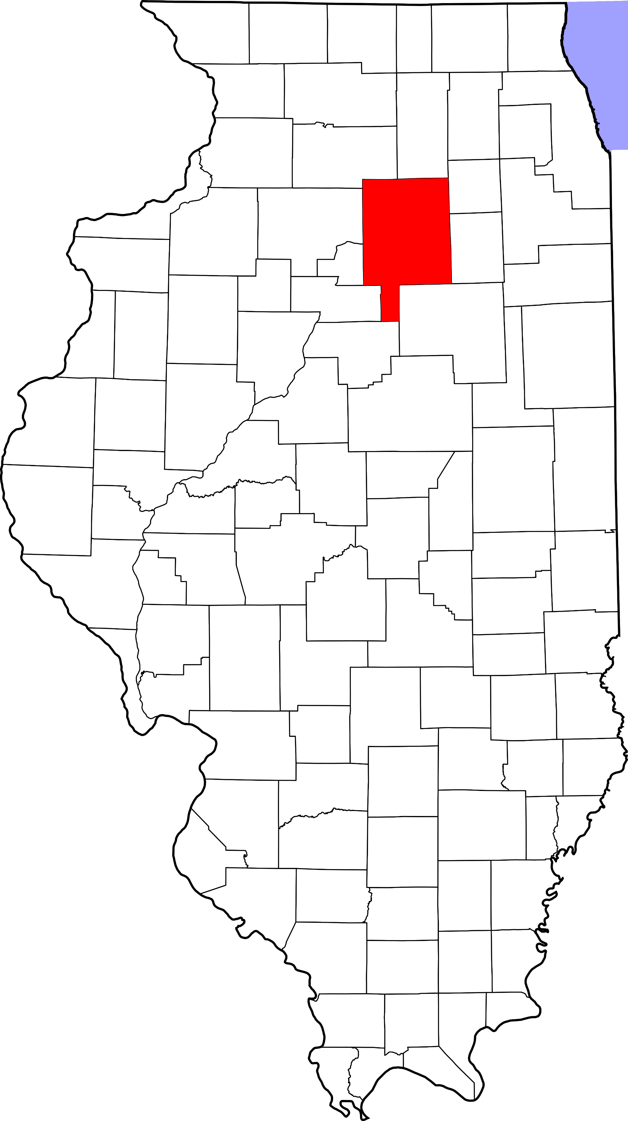
A. Child Maltreatment

LaSalle County (Rural)
During 2018, there were 375 substantiated cases of child maltreatment (which includes reports of physical and other abuse, sexual abuse, neglect, and risk of harm) in La Salle County. This number equates to a rate of 15.60 substantiated reports per 1,000 children in Illinois (which is higher than the state rate: 10.95 substantiated reports per 1,000 children).

These figures illustrate substantiated reports by child’s race and age. 50% of substantiated cases were among female children.

B. Youth Violence
Youth in La Salle County reported higher rates of bullying, cyber bullying, physical fighting, and weapon carrying compared to the state average.

Youth reported similar levels of dating violence compared to the state average.

C. Juvenile Violent Offenses
In 2018, there were 128 youth admitted to short-term locked juvenile detention facilities in LaSalle County. Approximately 28% of detention admissions were for a violent offense (n = 36). This translates to a rate of 3.23 violent offenses per 1,000 youth ages 10-17 in LaSalle County, which is higher than the rate for the state of Illinois (1.83 violent offense admissions per 1,000 youth ages 10-17).

Black youth had the highest rate of violent offense admissions.

 | Rate per 1,000
Male | 5.9
Female | 0.5

Violent Arrests by Race & Sex (2018)
 | Rate per 1,000
Race/Ethnicity
African American | 23.68
Hispanic/Latinx | 0.76
Other | 1.07
White | 3.26
Sex
Female | 1.96
Male | 5.63
D. Adult Violent Offenses (Arrests)
In 2018, LaSalle County had a rate of 110.57 violent crimes per 100,000 residents in Illinois. This is lower than the state rate (395.75 violent crimes per 100,000 residents).

African American adults had the highest rates of arrests for violent crimes.

E. Adult Intimate Partner Violence and Sexual Violence
LaSalle County reported lower rates of domestic violence and sexual assault crimes in 2018 compared to the state rate.
 | Rate per 100,000 | State Rate per 100,000
Domestic Violence Crime Offense | 402.1 | 840.39
Sexual Assault | 42.9 | 44.83

F. Gun Violence: Firearm Death Rate
No data or insufficient data for this county.

G. Abuse Among Older Adults
In 2015, LaSalle County had a rate of 539.7 reports of abuse among older adults (per 100,000) which is higher than the state rate (465.10 reports per 100,000).
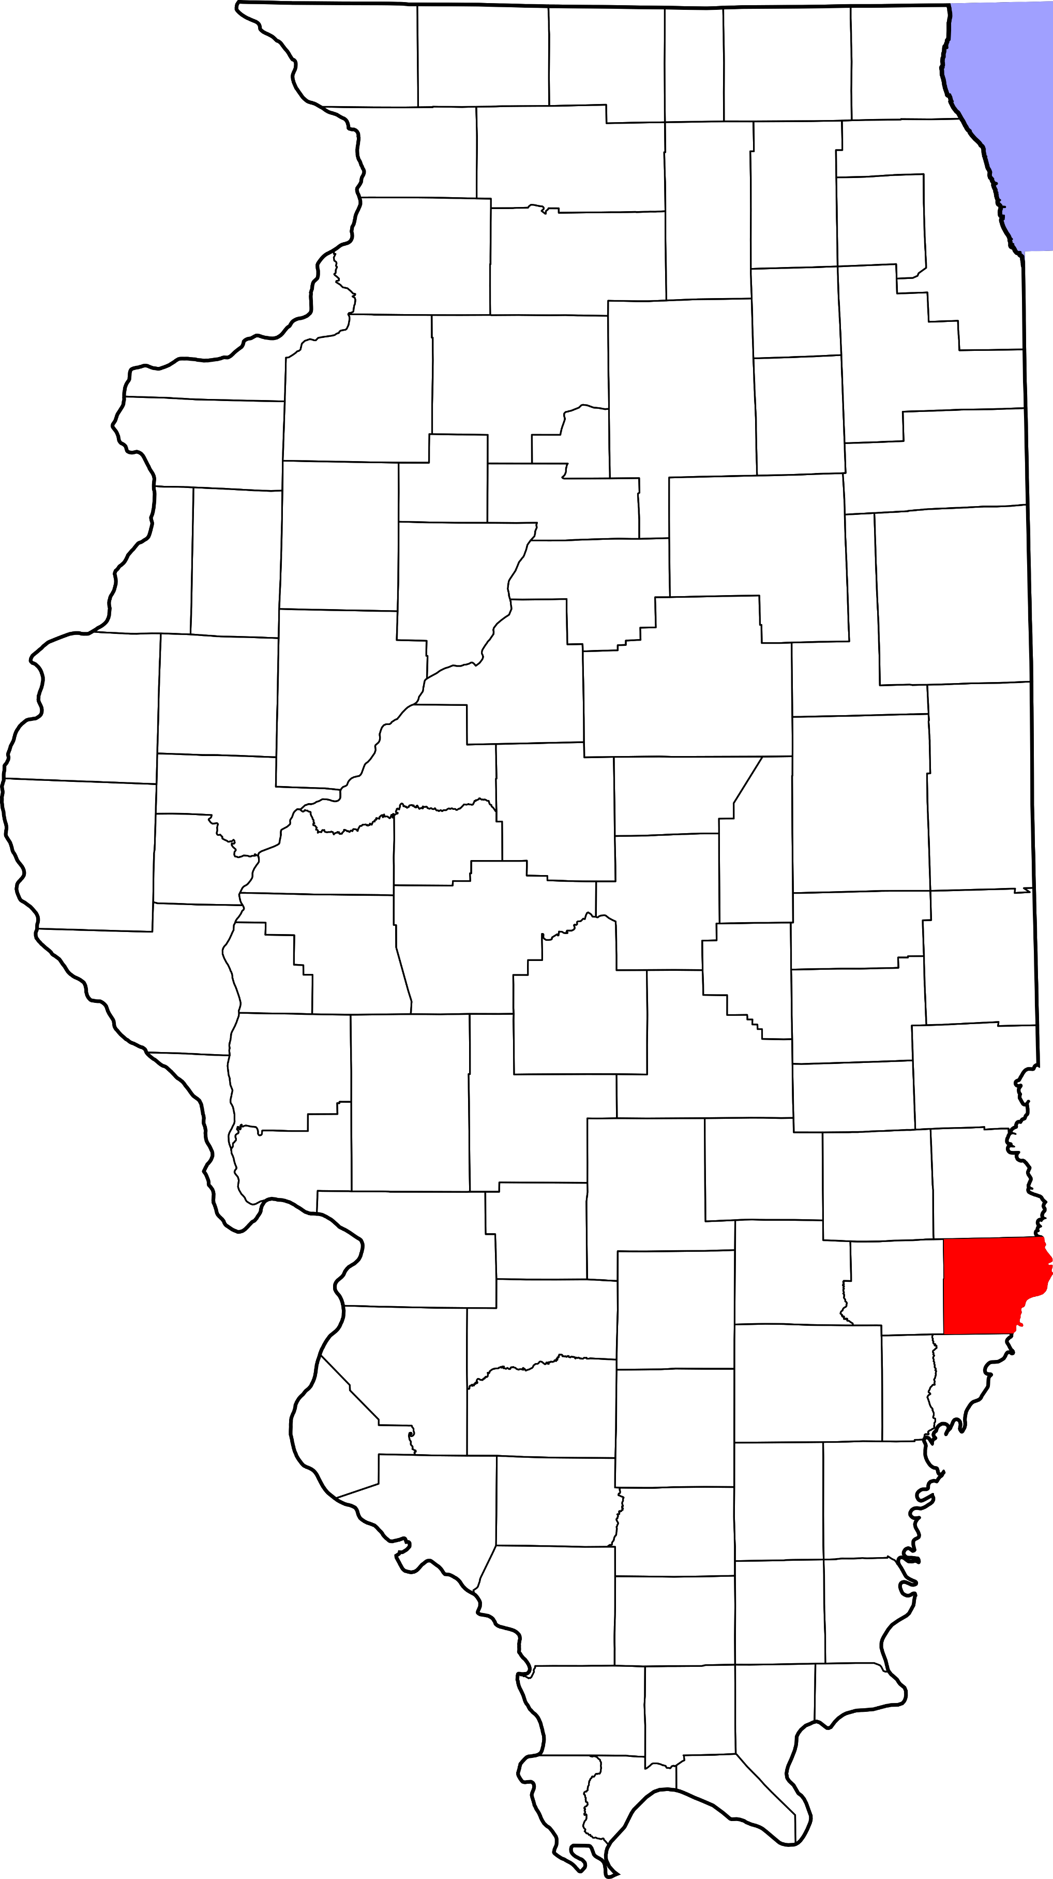
A. Child Maltreatment

Lawrence County (Rural)
During 2018, there were 87 substantiated cases of child maltreatment (which includes reports of physical and other abuse, sexual abuse, neglect, and risk of harm) in Lawrence County. This number equates to a rate of 27.68 substantiated reports per 1,000 children in Illinois (which is higher than the state rate: 10.95 substantiated reports per 1,000 children).

These figures illustrate substantiated reports by child’s race and age. 45% of substantiated cases were among female children.

B. Youth Violence
No data or insufficient data for this county.

C. Juvenile Violent Offenses
No data or insufficient data for this county.

D. Adult Violent Offenses (Arrests)
No data or insufficient data for this county.

E. Adult Intimate Partner Violence and Sexual Violence
No data or insufficient data for this county.

F. Gun Violence: Firearm Death Rate
No data or insufficient data for this county.

G. Abuse Among Older Adults
In 2015, Lawrence County had a rate of 821.8 reports of abuse among older adults (per 100,000) which is higher than the state rate (465.10 reports per 100,000).
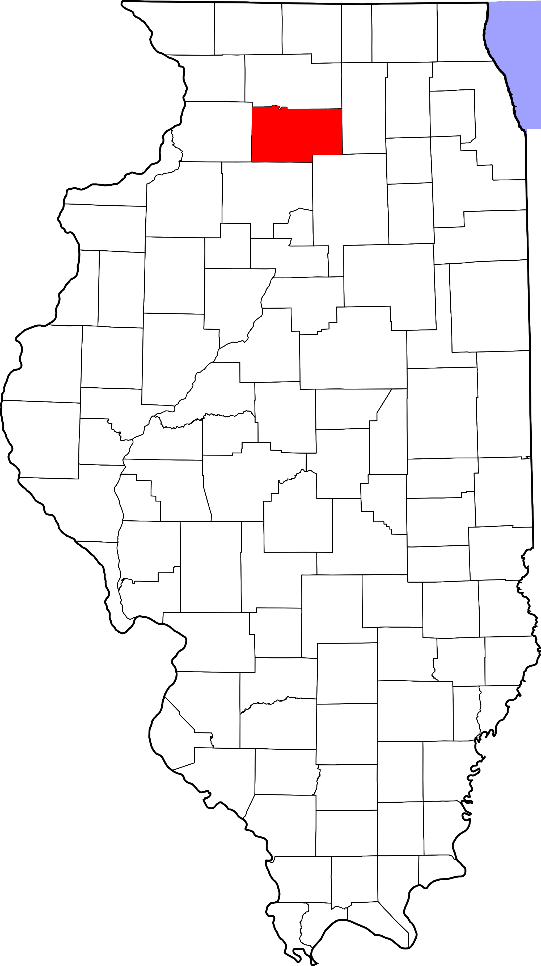
A. Child Maltreatment

Lee County (Rural)
During 2018, there were 118 substantiated cases of child maltreatment (which includes reports of physical and other abuse, sexual abuse, neglect, and risk of harm) in Lee County. This number equates to a rate of 17.18 substantiated reports per 1,000 children in Illinois (which is higher than the state rate: 10.95 substantiated reports per 1,000 children).

These figures illustrate substantiated reports by child’s race and age. 47% of substantiated cases were among female children.

B. Youth Violence
No data or insufficient data for this county.

C. Juvenile Violent Offenses
In 2018, there were 4 youth admitted to short-term locked juvenile detention facilities in Lee County.
25% of detention admissions were for a violent offense (n = 1). This translates to a rate of 0.32 violent offenses per 1,000 youth ages 10-17 in Lee County, which is lower than the rate for the state of Illinois (1.83 violent offense admissions per 1,000 youth ages 10-17).

Black youth had the highest rate of violent offense admissions (8.4 violent offense admissions per 1,000 youth ages 10-17).

 | Rate per 1,000
Male | 0.6
Female | 0

Violent Arrests by Race & Sex (2018)
 | Rate per 1,000
Race/Ethnicity
African American | 7.35
Hispanic/Latinx | 1.93
Other | 0.65
White | 2.85
Sex
Female | 1.48
Male | 4.97
D. Adult Violent Offenses (Arrests)
In 2018, Lee County had a rate of 192.85 violent crimes per 100,000 residents in Illinois. This is lower than the state rate (395.75 violent crimes per 100,000 residents).

African American adults had the highest rates of arrests for violent crimes.

E. Adult Intimate Partner Violence and Sexual Violence
Lee County reported lower rates of domestic violence crimes and higher rates of sexual assault crimes in 2018 compared to the state rate.
 | Rate per 100,000 | State Rate per 100,000
Domestic Violence Crime Offense | 385.7 | 840.39
Sexual Assault | 73.1 | 44.83

F. Gun Violence: Firearm Death Rate
No data or insufficient data for this county.

G. Abuse Among Older Adults
In 2015, Lee County had a rate of 656.8 reports of abuse among older adults (per 100,000) which is higher than the state rate (465.10 reports per 100,000).

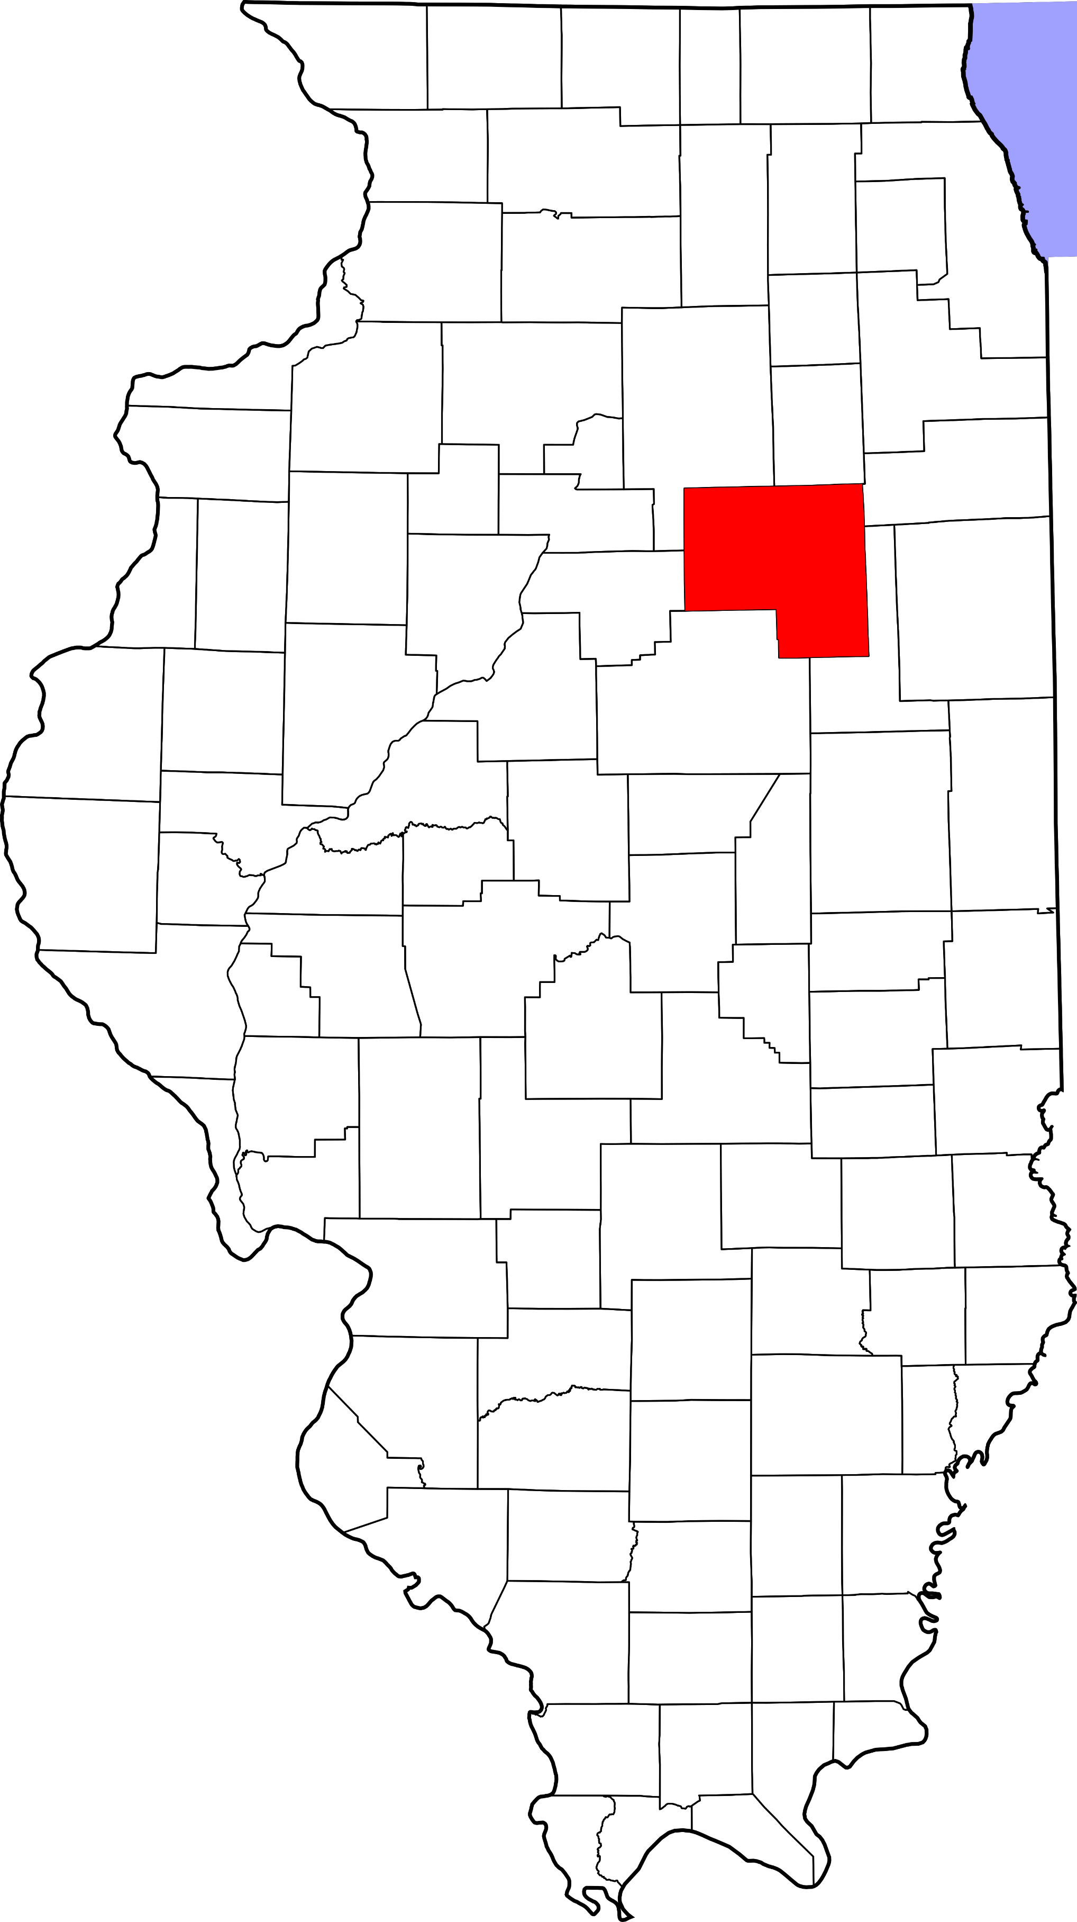
A. Child Maltreatment

Livingston County (Rural)
During 2018, there were 136 substantiated cases of child maltreatment (which includes reports of physical and other abuse, sexual abuse, neglect, and risk of harm) in Livingston County. This number equates to a rate of 17.34 substantiated reports per 1,000 children in Illinois (which is higher than the state rate: 10.95 substantiated reports per 1,000 children).

These figures illustrate substantiated reports by child’s race and age. 51% of substantiated cases were among female children.

B. Youth Violence
Youth in Livingston County reported higher rates of bullying, cyber bullying, physical fighting, and weapon carrying compared to the state average.

Youth reported lower levels of dating violence compared to the state average.

C. Juvenile Violent Offenses
In 2018, there were 22 youth admitted to short-term locked juvenile detention facilities in Livingston County. Approximately 41%of detention admissions were for a violent offense (n = 9). This translates to a rate of 2.46 violent offenses per 1,000 youth ages 10-17 in Livingston County, which is higher than the rate for the state of Illinois (1.83 violent offense admissions per 1,000 youth ages 10-17).

Hispanic youth had the highest rate of violent offense admissions.

 | Rate per 1,000
Male | 3.1
Female | 1.8

Juvenile Weapon-Related Offenses
Livingston County had 1 weapon-related offenses in 2018.

Violent Arrests by Race & Sex (2018)
 | Rate per 1,000
Race/Ethnicity
African American | 37.14
Hispanic/Latinx | 3.69
Other | 3.53
White | 3.56
Sex
Female | 2.03
Male | 8.70
D. Adult Violent Offenses (Arrests)
In 2018, Livingston County had a rate of 198.54 violent crimes per 100,000 residents in Illinois. This is lower than the state rate (395.75 violent crimes per 100,000 residents).

African American adults had the highest rates of arrests for violent crimes.

E. Adult Intimate Partner Violence and Sexual Violence
Livingston County reported lower rates of domestic violence and sexual assault crimes in 2018 compared to the state rate.
 | Rate per 100,000 | State Rate per 100,000
Domestic Violence Crime Offense | 248.9 | 840.39
Sexual Assault | 14 | 44.83

F. Gun Violence: Firearm Death Rate
No data or insufficient data for this county.

G. Abuse Among Older Adults
In 2015, Livingston County had a rate of 554 reports of abuse among older adults (per 100,000) which is higher than the state rate (465.10 reports per 100,000).
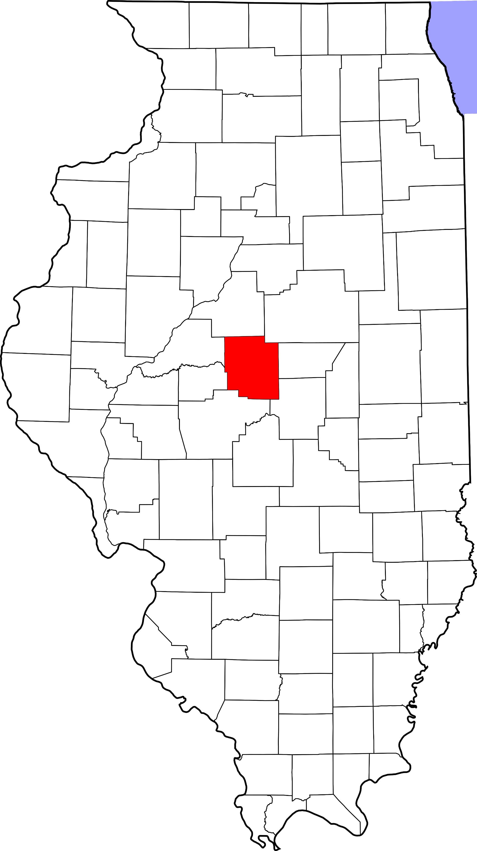
A. Child Maltreatment

Logan County (Rural)
During 2018, there were 163 substantiated cases of child maltreatment (which includes reports of physical and other abuse, sexual abuse, neglect, and risk of harm) in Logan County. This number equates to a rate of 28.90 substantiated reports per 1,000 children in Illinois (which is higher than the state rate: 10.95 substantiated reports per 1,000 children).

These figures illustrate substantiated reports by child’s race and age. 51% of substantiated cases were among female children.

B. Youth Violence
Youth in Logan County reported higher rates of bullying, cyber bullying, physical fighting, and weapon carrying compared to the state average.

Youth reported lower levels of dating violence compared to the state average.

C. Juvenile Violent Offenses
In 2018, there were 20 youth admitted to short-term locked juvenile detention facilities in Logan County. 25% of detention admissions were for a violent offense (n = 5). This translates to a rate of 1.92 violent offenses per 1,000 youth ages 10-17 in Logan County, which is higher than the rate for the state of Illinois (1.83 violent offense admissions per 1,000 youth ages 10-17).

White youth had a rate of 2 violent offense admissions per 1,000 youth ages 10-17.
 | Rate per 1,000
Male | 2.3
Female | 1.6

Violent Arrests by Race & Sex (2018)
 | Rate per 1,000
Race/Ethnicity
African American | 12.44
Hispanic/Latinx | 3.00
Other | 1.29
White | 4.50
Sex
Female | 3.06
Male | 7.61
D. Adult Violent Offenses (Arrests)
In 2018, Logan County had a rate of 210.89 violent crimes per 100,000 residents in Illinois. This is lower than the state rate (395.75 violent crimes per 100,000 residents).

African American adults had the highest rates of arrests for violent crimes.

E. Adult Intimate Partner Violence and Sexual Violence
Logan County reported lower rates of domestic violence and sexual assault crimes in 2018 compared to the state rate.
 | Rate per 100,000 | State Rate per 100,000
Domestic Violence Crime Offense | 449.4 | 840.39
Sexual Assault | 24.2 | 44.83

F. Gun Violence: Firearm Death Rate
No data or insufficient data for this county.

G. Abuse Among Older Adults
In 2015, Logan County had a rate of 508.9 reports of abuse among older adults (per 100,000) which is higher than the state rate (465.10 reports per 100,000).

A. Child Maltreatment

Macon County (Other Urban/Suburban)
During 2018, there were 707 substantiated cases of child maltreatment (which includes reports of physical and other abuse, sexual abuse, neglect, and risk of harm) in Macon County. This number equates to a rate of 29.76 substantiated reports per 1,000 children in Illinois (which is higher than the state rate: 10.95 substantiated reports per 1,000 children).

These figures illustrate substantiated reports by child’s race and age. 52% of substantiated cases were among female children.

B. Youth Violence
No data or insufficient data for this county.

C. Juvenile Violent Offenses
In 2018, there were 93 youth admitted to short-term locked juvenile detention facilities in Macon County. Approximately 11% of detention admissions were for a violent offense (n = 10). This translates to a rate of 0.97 violent offenses per 1,000 youth ages 10-17 in Macon County, which is lower than the rate for the state of Illinois (1.83 violent offense admissions per 1,000 youth ages 10-17).

Hispanic youth had the highest rate of violent offense admissions.

 | Rate per 1,000
Male | 1.3
Female | 0.6

Juvenile Weapon-Related Offenses
Macon county had 15 weapon-related offenses in 2018.

D. Adult Violent Offenses (Arrests)
Violent Arrests by Race & Sex (2018)
 | Rate per 1,000
Race/Ethnicity
African American | 36.95
Hispanic/Latinx | 1.69
Other | 0.49
White | 4.93
Sex
Female | 5.48
Male | 15.10
In 2018, Macon County had a rate of 388.69 violent crimes per 100,000 residents in Illinois. This is lower than the state rate (395.75 violent crimes per 100,000 residents).

African American adults had the highest rates of arrests for violent crimes.

E. Adult Intimate Partner Violence and Sexual Violence
Macon County reported higher rates of domestic violence and lower rates of sexual assault crimes in 2018 compared to the state rate.
 | Rate per 100,000 | State Rate per 100,000
Domestic Violence Crime Offense | 1521.3 | 840.39
Sexual Assault | 34.4 | 44.83

F. Gun Violence: Firearm Death Rate
No data or insufficient data for this county.

G. Abuse Among Older Adults
In 2015, Macon County had a rate of 573.7 reports of abuse among older adults (per 100,000) which is higher than the state rate (465.10 reports per 100,000).

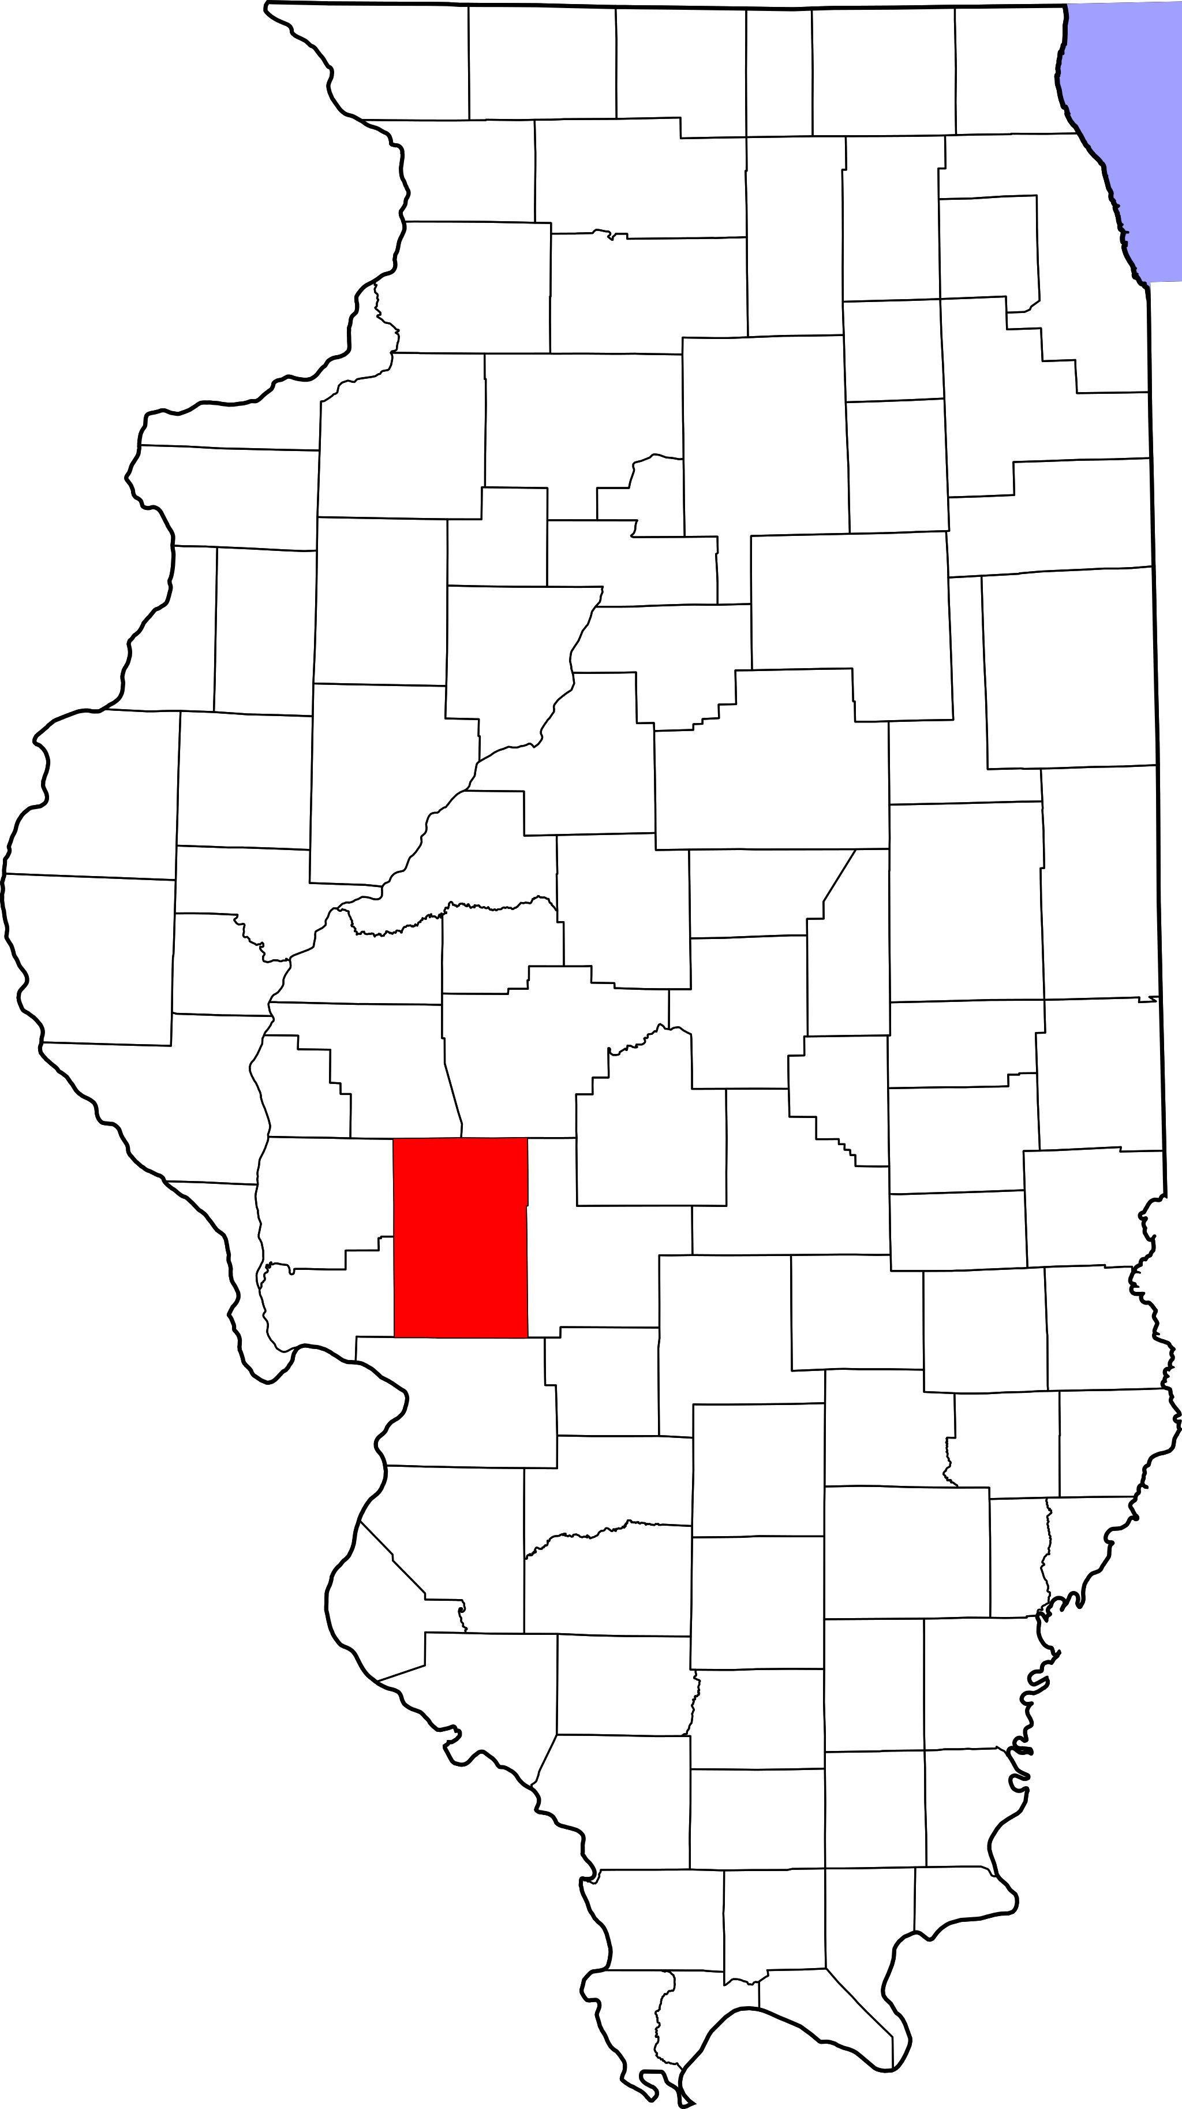
A. Child Maltreatment

Macoupin County (Other Urban/Suburban)
During 2018, there were 193 substantiated cases of child maltreatment (which includes reports of physical and other abuse, sexual abuse, neglect, and risk of harm) in Macoupin County. This number equates to a rate of 19.71 substantiated reports per 1,000 children in Illinois (which is higher than the state rate: 10.95 substantiated reports per 1,000 children).

These figures illustrate substantiated reports by child’s race and age. 51% of substantiated cases were among female children.

B. Youth Violence
Youth in Macoupin County reported higher rates of bullying, cyber-bullying and dating violence, physical fighting, and weapon carrying compared to the state average.

C. Juvenile Violent Offenses
In 2018, there were 17 youth admitted to short-term locked juvenile detention facilities in Macoupin County. Approximately 35% of detention admissions were for a violent offense (n = 6). This translates to a rate of 1.27 violent offenses per 1,000 youth ages 10-17 in Macoupin County, which is lower than the rate for the state of Illinois (1.83 violent offense admissions per 1,000 youth ages 10-17).

Black youth had the highest rate of violent offense admissions.

 | Rate per 1,000
Male | 2.4
Female | 0

D. Adult Violent Offenses (Arrests)
Violent Arrests by Race & Sex (2018)
 | Rate per 1,000
Race/Ethnicity
African American | 30.81
Hispanic/Latinx | -
Other | -
White | 3.82
Sex
Female | 1.95
Male | 6.15
In 2018, Macoupin County had a rate of 156.69 violent crimes per 100,000 residents in Illinois. This is lower than the state rate (395.75 violent crimes per 100,000 residents).

African American adults had the highest rates of arrests for violent crimes.

E. Adult Intimate Partner Violence and Sexual Violence
Macoupin County reported lower rates of domestic violence and sexual assault crimes in 2018 compared to the state rate.
 | Rate per 100,000 | State Rate per 100,000
Domestic Violence Crime Offense | 412.7 | 840.39
Sexual Assault | 24.3 | 44.83

F. Gun Violence: Firearm Death Rate
No data or insufficient data for this county.

G. Abuse Among Older Adults
In 2015, Macoupin County had a rate of 951.8 reports of abuse among older adults (per 100,000) which is higher than the state rate (465.10 reports per 100,000).
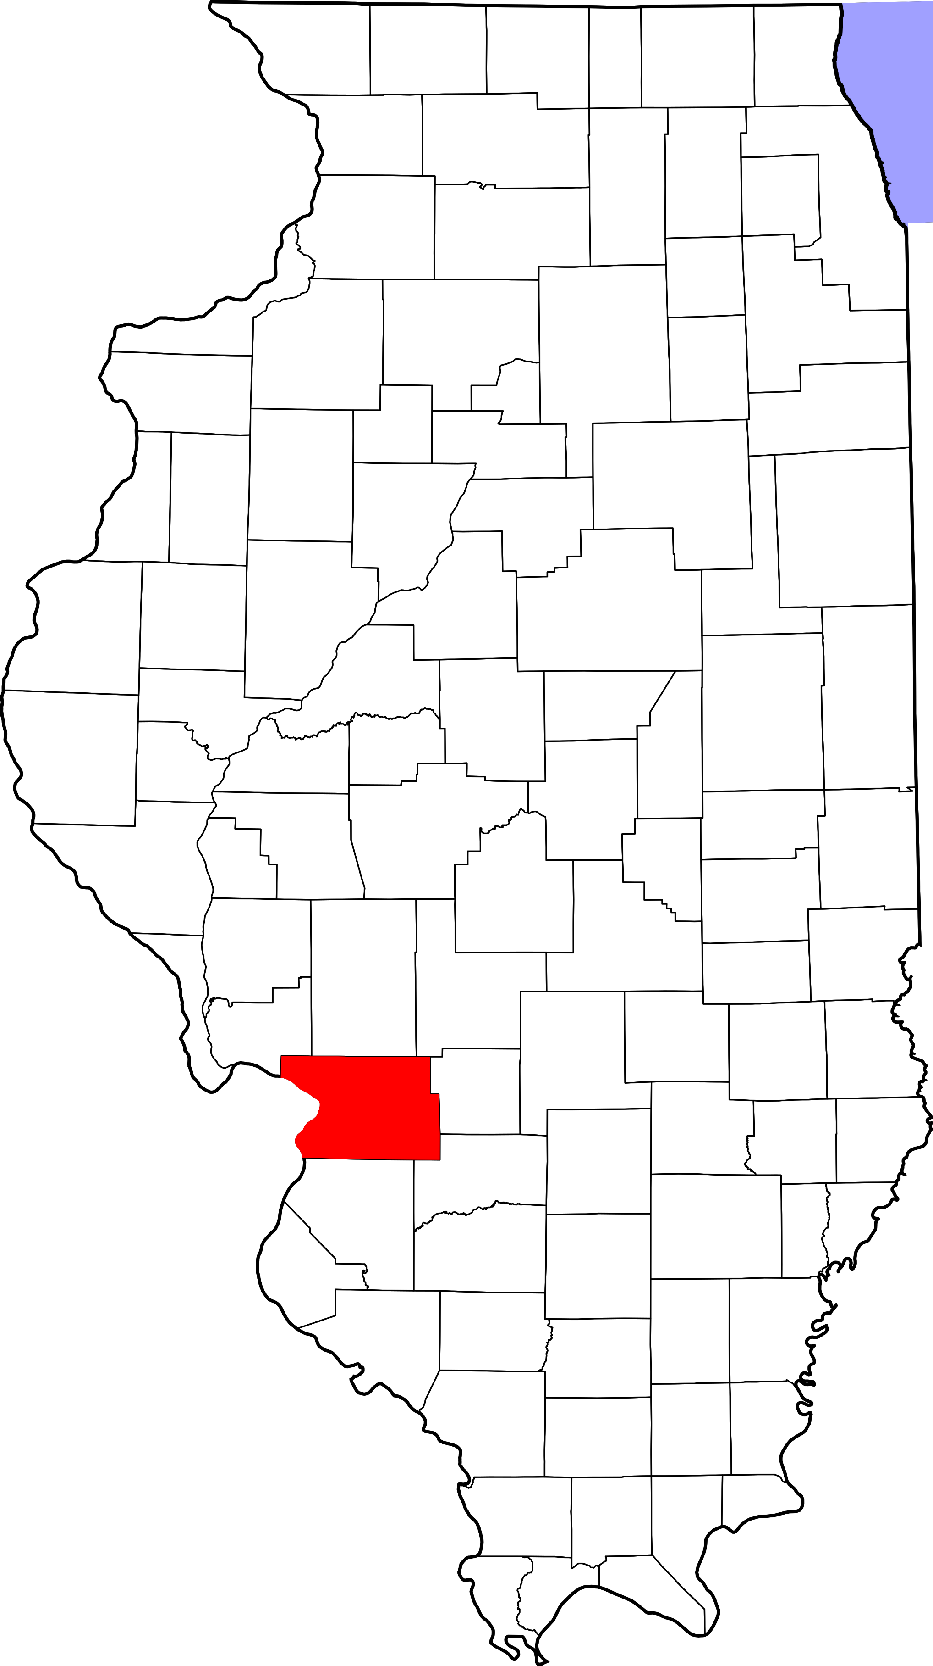
A. Child Maltreatment

Madison County (Other Urban/Suburban)
During 2018, there were 799 substantiated cases of child maltreatment (which includes reports of physical and other abuse, sexual abuse, neglect, and risk of harm) in Madison County. This number equates to a rate of 13.64 substantiated reports per 1,000 children in Illinois (which is higher than the state rate: 10.95 substantiated reports per 1,000 children).

These figures illustrate substantiated reports by child’s race and age. 51% of substantiated cases were among female children.

B. Youth Violence
Youth in Madison County reported higher rates of bullying, cyber bullying, dating violence, physical fighting, and weapon carrying compared to the state average.

C. Juvenile Violent Offenses
In 2018, there were 291 youth admitted to short-term locked juvenile detention facilities in Madison County. Approximately 23% of detention admissions were for a violent offense (n = 66). This translates to a rate of 2.49 violent offenses per 1,000 youth ages 10-17 in Effingham County, which is higher than the rate for the state of Illinois (1.83 violent offense admissions per 1,000 youth ages 10-17).

Black youth had the highest rate of violent offense admissions.

 | Rate per 1,000
Male | 3.0
Female | 1.9

Juvenile Weapon-Related Offenses
Madison county had 15 weapon-related offenses in 2018.

Violent Arrests by Race & Sex (2018)
 | Rate per 1,000
Race/Ethnicity
African American | 26.04
Hispanic/Latinx | 0.59
Other | 1.24
White | 4.53
Sex
Female | 2.57
Male | 11.17
D. Adult Violent Offenses (Arrests)
In 2018, Madison County had a rate of 299.48 violent crimes per 100,000 residents in Illinois. This is lower than the state rate (395.75 violent crimes per 100,000 residents).

African American adults had the highest rates of arrests for violent crimes.

E. Adult Intimate Partner Violence and Sexual Violence
Madison County reported lower rates of domestic violence and higher rates of sexual assault crimes in 2018 compared to the state rate.
 | Rate per 100,000 | State Rate per 100,000
Domestic Violence Crime Offense | 459.8 | 840.39
Sexual Assault | 56.3 | 44.83

F. Gun Violence: Firearm Death Rate
Madison County reported 11.7 deaths by a firearm (per 100,000 people), which is higher than the state rate (10.8 per 100,000 people).

G. Abuse Among Older Adults
In 2015, Madison County had a rate of 547.1 reports of abuse among older adults (per 100,000) which is higher than the state rate (465.10 reports per 100,000).
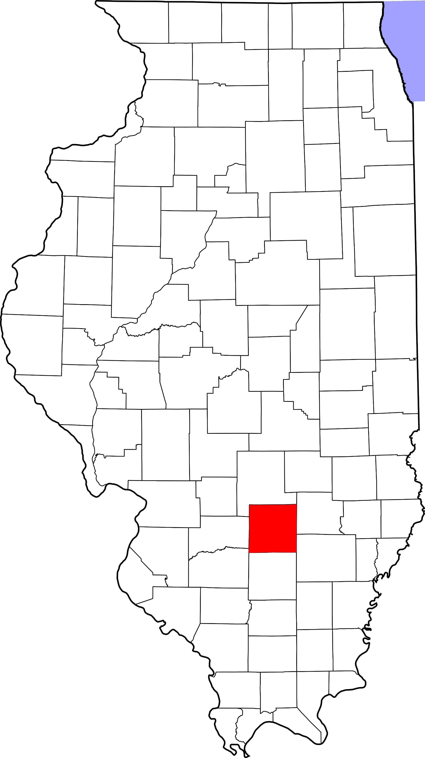
A. Child Maltreatment

Marion County (Rural)
During 2018, there were 242 substantiated cases of child maltreatment (which includes reports of physical and other abuse, sexual abuse, neglect, and risk of harm) in Marion County. This number equates to a rate of 27.70 substantiated reports per 1,000 children in Illinois (which is higher than the state rate: 10.95 substantiated reports per 1,000 children).

These figures illustrate substantiated reports by child’s race and age. 51% of substantiated cases were among female children.

B. Youth Violence
Youth in Marion County reported higher rates of bullying, cyber bullying, dating violence, physical fighting and weapon carrying compared to the state average.

C. Juvenile Violent Offenses
In 2018, there were 98 youth admitted to short-term locked juvenile detention facilities in Marion County. Approximately 23% of detention admissions were for a violent offense (n = 23). This translates to a rate of 5.92 violent offenses per 1,000 youth ages 10-17 in Marion County, which is higher than the rate for the state of Illinois (1.83 violent offense admissions per 1,000 youth ages 10-17).

Black youth had the highest rate of violent offense admissions.

 | Rate per 1,000
Male | 8.1
Female | 3.7

Juvenile Weapon-Related Offenses
Marion County had 4 weapon-related offenses in 2018.

D. Adult Violent Offenses (Arrests)
Violent Arrests by Race & Sex (2018)
 | Rate per 1,000
Race/Ethnicity
African American | 57.14
Hispanic/Latinx | -
Other | 0.67
White | 7.34
Sex
Female | 5.11
Male | 14.26
In 2018, Marion County had a rate of 552.90 violent crimes per 100,000 residents in Illinois. This is higher than the state rate (395.75 violent crimes per 100,000 residents).

African American adults had the highest rates of arrests for violent crimes.

E. Adult Intimate Partner Violence and Sexual Violence
Marion County reported lower rates of domestic violence and higher rates of sexual assault crimes in 2018 compared to the state rate.
 | Rate per 100,000 | State Rate per 100,000
Domestic Violence Crime Offense | 231.3 | 840.39
Sexual Assault | 127.6 | 44.83

F. Gun Violence: Firearm Death Rate
No data or insufficient data for this county.

G. Abuse Among Older Adults
In 2015, Marion County had a rate of 981.3 reports of abuse among older adults (per 100,000) which is higher than the state rate (465.10 reports per 100,000).

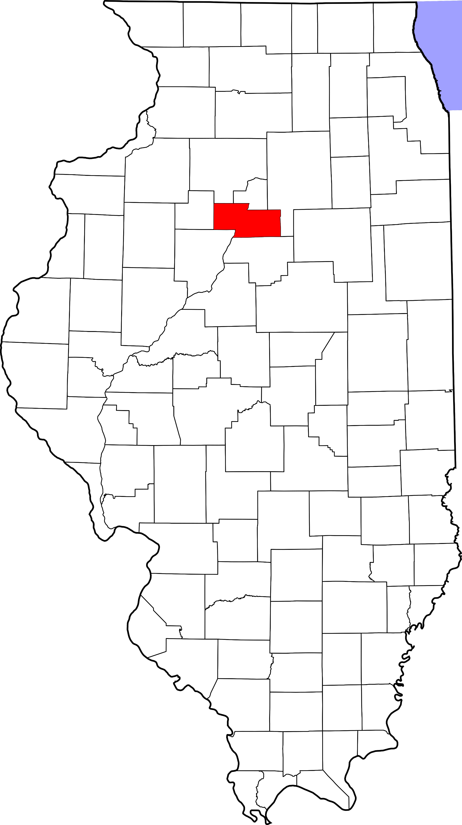
A. Child Maltreatment

Marshall County (Other Urban/Suburban)
During 2018, there were 24 substantiated cases of child maltreatment (which includes reports of physical and other abuse, sexual abuse, neglect, and risk of harm) in Marshall County. This number equates to a rate of 10.11 substantiated reports per 1,000 children in Illinois (which is lower than the state rate: 10.95 substantiated reports per 1,000 children).

These figures illustrate substantiated reports by child’s race and age. 50% of substantiated cases were among female children.

B. Youth Violence
Youth in Marshall County reported higher rates of dating violence, physical fighting, and weapon carrying compared to the state average.

Youth reported lower levels of bullying and cyber bullying compared to the state average.

C. Juvenile Violent Offenses
In 2018, there were 3 youth admitted to short-term locked juvenile detention facilities in Marshall County. None of these admissions were for a violent offense.

D. Adult Violent Offenses (Arrests)
Violent Arrests by Race & Sex (2018)
 | Rate per 1,000
Race/Ethnicity
African American | 61.22
Hispanic/Latinx | -
Other | -
White | 3.23
Sex
Female | 1.86
Male | 5.45
In 2018, Marshall County had a rate of 147.39 violent crimes per 100,000 residents in Illinois. This is lower than the state rate (395.75 violent crimes per 100,000 residents).

African American adults had the highest rates of arrests for violent crimes.

E. Adult Intimate Partner Violence and Sexual Violence
Marshall County reported lower rates of domestic violence and sexual assault crimes in 2018 compared to the state rate.
 | Rate per 100,000 | State Rate per 100,000
Domestic Violence Crime Offense | 268.8 | 840.39
Sexual Assault | 17.3 | 44.83

F. Gun Violence: Firearm Death Rate
No data or insufficient data for this county.

G. Abuse Among Older Adults
In 2015, Marshall County had a rate of 368.7 reports of abuse among older adults (per 100,000) which is lower than the state rate (465.10 reports per 100,000).

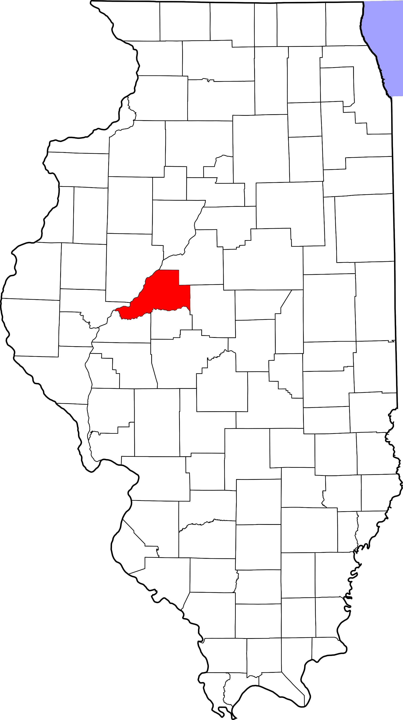
A. Child Maltreatment

Mason County (Rural)
During 2018, there were 91 substantiated cases of child maltreatment (which includes reports of physical and other abuse, sexual abuse, neglect, and risk of harm) in Mason County. This number equates to a rate of 31.87 substantiated reports per 1,000 children in Illinois (which is higher than the state rate: 10.95 substantiated reports per 1,000 children).

These figures illustrate substantiated reports by child’s race and age. 50% of substantiated cases were among female children.

B. Youth Violence
Youth in Mason County reported higher rates of bullying, cyber bullying and weapon carrying compared to the state average.

Youth reported similar levels of dating violence and physical fighting compared to the state average.

C. Juvenile Violent Offenses
In 2018, there were 8 youth admitted to short-term locked juvenile detention facilities in Mason County. 25% of detention admissions were for a violent offense (n = 2). This translates to a rate of 1.47 violent offenses per 1,000 youth ages 10-17 in Mason County, which is lower than the rate for the state of Illinois (1.83 violent offense admissions per 1,000 youth ages 10-17).

Black youth had the highest rate of violent offense admissions.

 | Rate per 1,000
Male | 1.5
Female | 1.4

Violent Arrests by Race & Sex (2018)
 | Rate per 1,000
Race/Ethnicity
African American | 23.08
Hispanic/Latinx | -
Other | 3.82
White | 5.30
Sex
Female | 2.74
Male | 8.77
D. Adult Violent Offenses (Arrests)
In 2018, Mason County had a rate of 390.71 violent crimes per 100,000 residents in Illinois. This is lower than the state rate (395.75 violent crimes per 100,000 residents).

African American adults had the highest rates of arrests for violent crimes.

E. Adult Intimate Partner Violence and Sexual Violence
Mason County reported lower rates of domestic violence and higher rates of sexual assault crimes in 2018 compared to the state rate.
 | Rate per 100,000 | State Rate per 100,000
Domestic Violence Crime Offense | 516 | 840.39
Sexual Assault | 162.2 | 44.83

F. Gun Violence: Firearm Death Rate
No data or insufficient data for this county.

G. Abuse Among Older Adults
In 2015, Mason County had a rate of 327.1 reports of abuse among older adults (per 100,000) which is lower than the state rate (465.10 reports per 100,000).
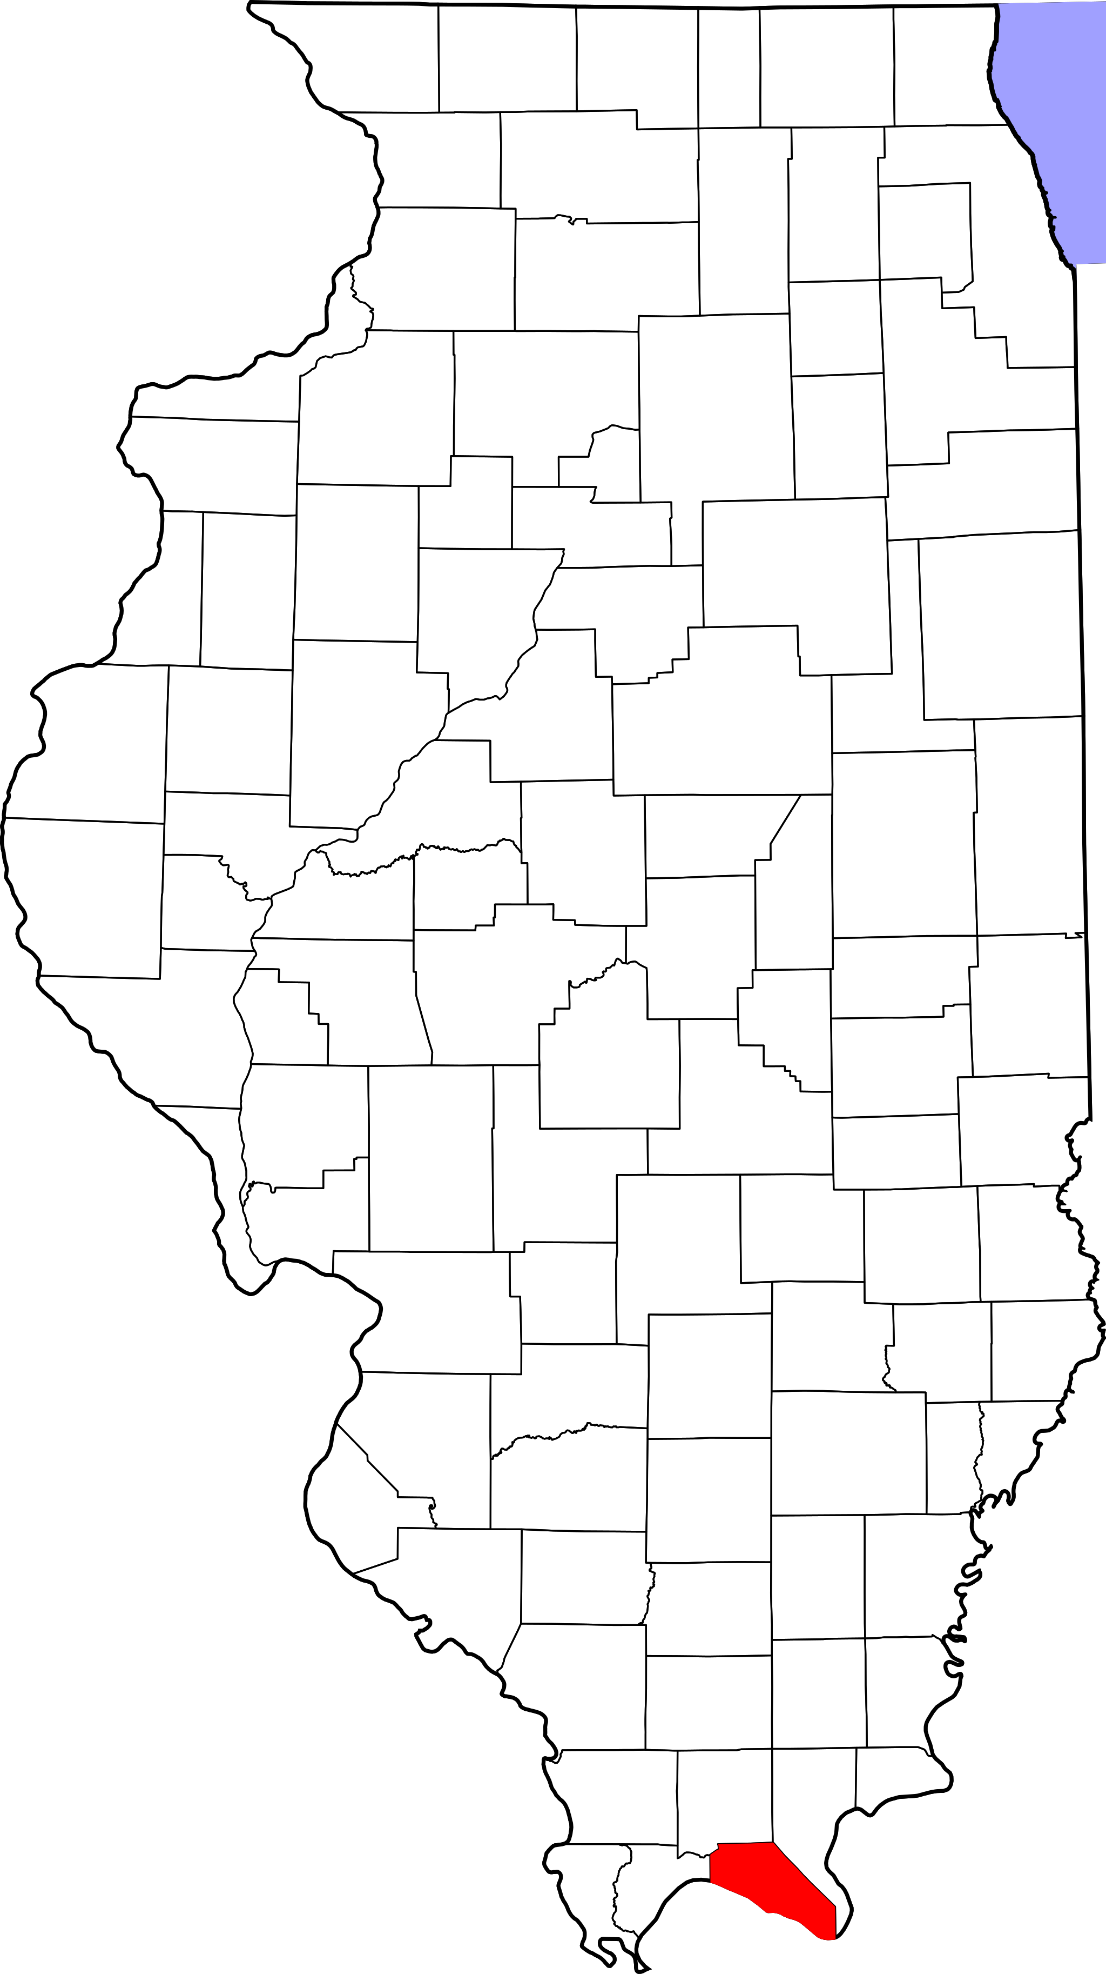
A. Child Maltreatment

Massac County (Rural)
During 2018, there were 49 substantiated cases of child maltreatment (which includes reports of physical and other abuse, sexual abuse, neglect, and risk of harm) in Massac County. This number equates to a rate of 15.31 substantiated reports per 1,000 children in Illinois (which is higher than the state rate: 10.95 substantiated reports per 1,000 children).

These figures illustrate substantiated reports by child’s race and age. 53% of substantiated cases were among female children.

B. Youth Violence
No data or insufficient data for this county.

C. Juvenile Violent Offenses
In 2018, there were 11 youth admitted to short-term locked juvenile detention facilities in Massac County. None of these admissions were for a violent offense.

D. Adult Violent Offenses (Arrests)
Violent Arrests by Race & Sex (2018)
 | Rate per 1,000
Race/Ethnicity
African American | 7.77
Hispanic/Latinx | -
Other | 4.98
White | 5.10
Sex
Female | 2.10
Male | 8.83
In 2018, Massac County had a rate of 312.50 violent crimes per 100,000 residents in Illinois. This is lower than the state rate (395.75 violent crimes per 100,000 residents).

African American adults had the highest rates of arrests for violent crimes.

E. Adult Intimate Partner Violence and Sexual Violence
Massac County reported higher rates of domestic violence and sexual assault crimes in 2018 compared to the state rate.
 | Rate per 100,000 | State Rate per 100,000
Domestic Violence Crime Offense | 852.3 | 840.39
Sexual Assault | 49.7 | 44.83

F. Gun Violence: Firearm Death Rate
No data or insufficient data for this county.

G. Abuse Among Older Adults
In 2015, Massac County had a rate of 805.8 reports of abuse among older adults (per 100,000) which is higher than the state rate (465.10 reports per 100,000).

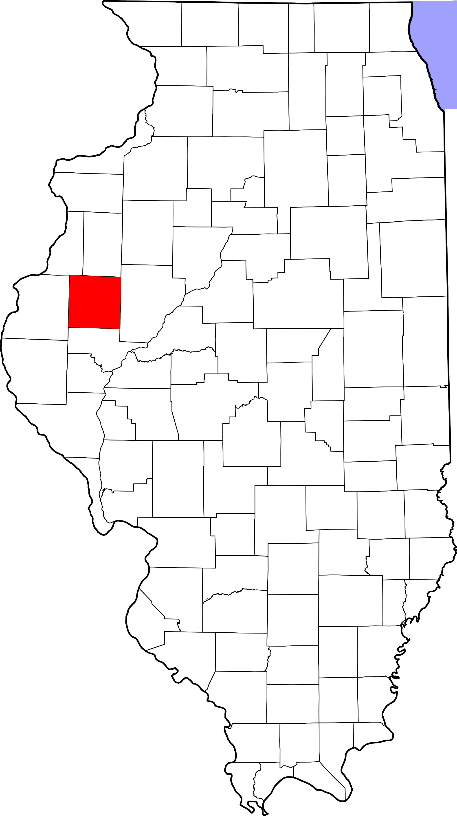
A. Child Maltreatment

McDonough County (Rural)
During 2018, there were 124 substantiated cases of child maltreatment (which includes reports of physical and other abuse, sexual abuse, neglect, and risk of harm) in McDonough County. This number equates to a rate of 24.12 substantiated reports per 1,000 children in Illinois (which is higher than the state rate: 10.95 substantiated reports per 1,000 children).

These figures illustrate substantiated reports by child’s race and age. 51% of substantiated cases were among female children.

B. Youth Violence
Youth in McDonough County reported higher rates of bullying, cyber bullying, dating violence and weapon carrying compared to the state average.

Youth reported lower level of physical fighting compared to the state average.

C. Juvenile Violent Offenses
In 2018, there were 26 youth admitted to short-term locked juvenile detention facilities in McDonough County. Approximately 12% of detention admissions were for a violent offense (n = 3). This translates to a rate of 1.26 violent offenses per 1,000 youth ages 10-17 in McDonough County, which is lower than the rate for the state of Illinois (1.83 violent offense admissions per 1,000 youth ages 10-17).

Black youth had the highest rate of violent offense admissions.

 | Rate per 1,000
Male | 1.7
Female | 0.9

Violent Arrests by Race & Sex (2018)
 | Rate per 1,000
Race/Ethnicity
African American | 33.61
Hispanic/Latinx | 2.40
Other | 0.65
White | 3.44
Sex
Female | 2.21
Male | 7.80
D. Adult Violent Offenses (Arrests)
In 2018, McDonough County had a rate of 257.05 violent crimes per 100,000 residents in Illinois. This is lower than the state rate (395.75 violent crimes per 100,000 residents).

African American adults had the highest rates of arrests for violent crimes.

E. Adult Intimate Partner Violence and Sexual Violence
McDonough County reported lower rates of domestic violence and higher rates of sexual assault crimes in 2018 compared to the state rate.
 | Rate per 100,000 | State Rate per 100,000
Domestic Violence Crime Offense | 527.5 | 840.39
Sexual Assault | 96.8 | 44.83

F. Gun Violence: Firearm Death Rate
No data or insufficient data for this county.

G. Abuse Among Older Adults
In 2015, McDonough County had a rate of 594.2 reports of abuse among older adults (per 100,000) which is higher than the state rate (465.10 reports per 100,000).
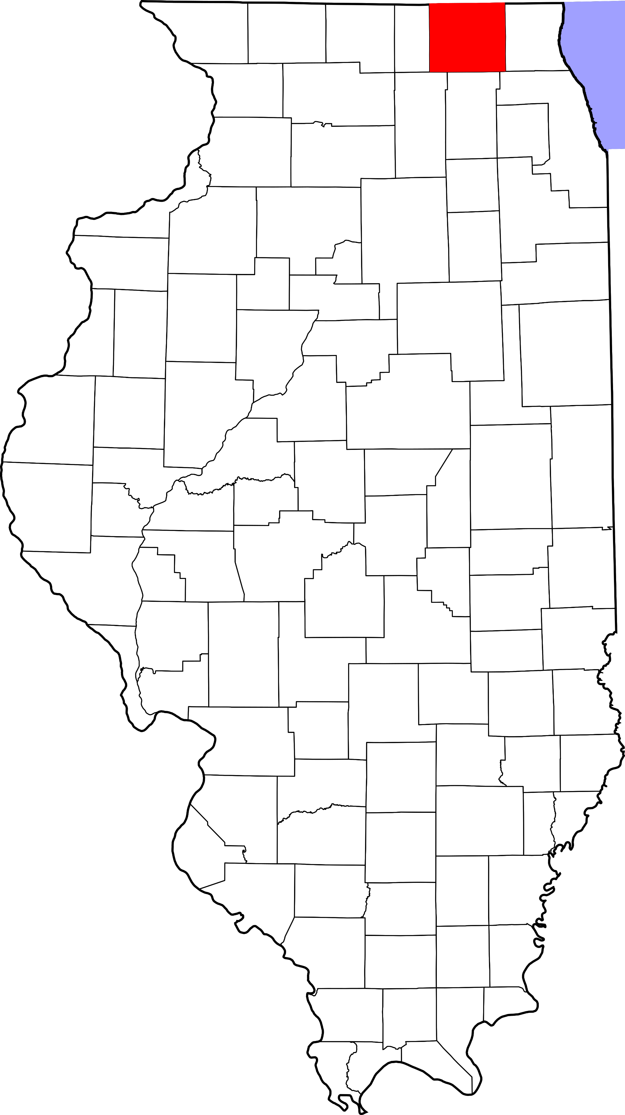
A. Child Maltreatment

McHenry County (Suburban Chicago)
During 2018, there were 646 substantiated cases of child maltreatment (which includes reports of physical and other abuse, sexual abuse, neglect, and risk of harm) in McHenry County. This number equates to a rate of 8.68 substantiated reports per 1,000 children in Illinois (which is lower than the state rate: 10.95 substantiated reports per 1,000 children).

These figures illustrate substantiated reports by child’s race and age. 50% of substantiated cases were among female children.

B. Youth Violence
Youth in McHenry County reported higher rates of bullying, cyber bullying, and dating violence compared to the state average.

Youth reported lower levels of physical fighting and similar levels of weapon carrying compared to the state average.

C. Juvenile Violent Offenses
In 2018, there were 90 youth admitted to short-term locked juvenile detention facilities in McHenry County. 20% of detention admissions were for a violent offense (n = 18). This translates to a rate of 0.50 violent offenses per 1,000 youth ages 10-17 in McHenry County, which is lower than the rate for the state of Illinois (1.83 violent offense admissions per 1,000 youth ages 10-17).

Black youth had the highest rate of violent offense admissions.

 | Rate per 1,000
Male | 0.6
Female | 0.3

Juvenile Weapon-Related Offenses
McHenry County had 4 weapon-related offenses in 2018.

Violent Arrests by Race & Sex (2018)
 | Rate per 1,000
Race/Ethnicity
African American | 14.98
Hispanic/Latinx | 2.98
Other | 0.53
White | 2.43
Sex
Female | 1.38
Male | 4.60
D. Adult Violent Offenses (Arrests)
In 2018, McHenry County had a rate of 108.24 violent crimes per 100,000 residents in Illinois. This is lower than the state rate (395.75 violent crimes per 100,000 residents).

African American adults had the highest rates of arrests for violent crimes.

E. Adult Intimate Partner Violence and Sexual Violence
McHenry County reported lower rates of domestic violence and sexual assault crimes in 2018 compared to the state rate.
 | Rate per 100,000 | State Rate per 100,000
Domestic Violence Crime Offense | 330.6 | 840.39
Sexual Assault | 35 | 44.83

F. Gun Violence: Firearm Death Rate
No data or insufficient data for this county.

G. Abuse Among Older Adults
In 2015, McHenry County had a rate of 251.7 reports of abuse among older adults (per 100,000) which is lower than the state rate (465.10 reports per 100,000).
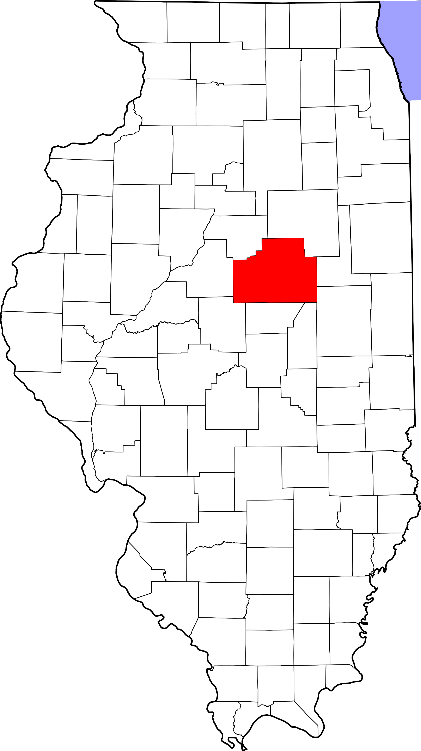
A. Child Maltreatment

McLean County (Other Urban/Suburban)
During 2018, there were 558 substantiated cases of child maltreatment (which includes reports of physical and other abuse, sexual abuse, neglect, and risk of harm) in McLean County. This number equates to a rate of 14.79 substantiated reports per 1,000 children in Illinois (which is higher than the state rate: 10.95 substantiated reports per 1,000 children).

These figures illustrate substantiated reports by child’s race and age. 51% of substantiated cases were among female children.

B. Youth Violence
Youth in McLean County reported higher rates of cyber bullying compared to the state average.

Youth reported lower levels of bullying, physical fighting and weapon carrying compared to the state average.

Youth reported similar levels of dating violence compared to the state average.

C. Juvenile Violent Offenses
In 2018, there were 119 youth admitted to short-term locked juvenile detention facilities in McLean County. Approximately 18% of detention admissions were for a violent offense (n = 21). This translates to a rate of 1.24 violent offenses per 1,000 youth ages 10-17 in McLean County, which is lower than the rate for the state of Illinois (1.83 violent offense admissions per 1,000 youth ages 10-17).

Hispanic youth had the highest rate of violent offense admissions.

 | Rate per 1,000
Male | 2.1
Female | 0.4

Juvenile Weapon-Related Offenses
Violent Arrests by Race & Sex (2018)
 | Rate per 1,000
Race/Ethnicity
African American | 22.57
Hispanic/Latinx | 4.32
Other | 0.40
White | 2.61
Sex
Female | 2.35
Male | 7.00
McLean county had 6 weapon-related offenses in 2018.

D. Adult Violent Offenses (Arrests)
In 2018, McLean County had a rate of 297.41 violent crimes per 100,000 residents in Illinois. This is lower than the state rate (395.75 violent crimes per 100,000 residents).

African American adults had the highest rates of arrests for violent crimes.

E. Adult Intimate Partner Violence and Sexual Violence
McLean County reported higher rates of domestic violence and sexual assault crimes in 2018 compared to the state rate.
 | Rate per 100,000 | State Rate per 100,000
Domestic Violence Crime Offense | 1169.4 | 840.39
Sexual Assault | 71.2 | 44.83

F. Gun Violence: Firearm Death Rate
No data or insufficient data for this county.

G. Abuse Among Older Adults
In 2015, McLean County had a rate of 679.3 reports of abuse among older adults (per 100,000) which is higher than the state rate (465.10 reports per 100,000).
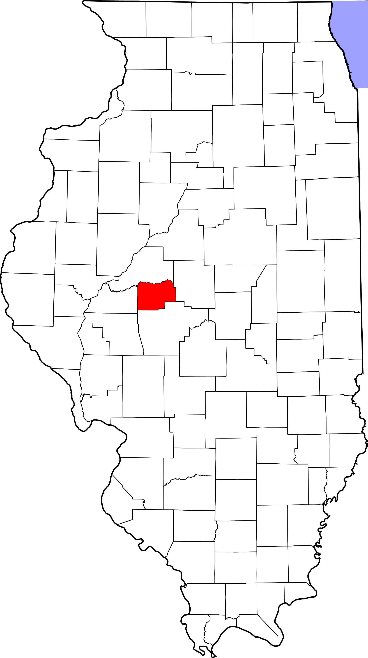
A. Child Maltreatment

Menard County (Other Urban/Suburban)
During 2018, there were 48 substantiated cases of child maltreatment (which includes reports of physical and other abuse, sexual abuse, neglect, and risk of harm) in Menard County. This number equates to a rate of 17.56 substantiated reports per 1,000 children in Illinois (which is higher than the state rate: 10.95 substantiated reports per 1,000 children).

These figures illustrate substantiated reports by child’s race and age. 51% of substantiated cases were among female children.

B. Youth Violence
Youth in Menard County reported higher rates of bullying, cyber bullying, physical fighting, and weapon carrying compared to the state average.

Youth reported lower levels of dating violence compared to the state average.

C. Juvenile Violent Offenses
In 2018, there was 1 youth admitted to short-term locked juvenile detention facilities in Menard County. It was not for a violent offense.

D. Adult Violent Offenses (Arrests)
Violent Arrests by Race & Sex (2018)
 | Rate per 1,000
Race/Ethnicity
African American | -
Hispanic/Latinx | -
Other | -
White | 3.25
Sex
Female | 1.58
Male | 4.80
In 2018, Menard County had a rate of 65.10 violent crimes per 100,000 residents in Illinois. This is lower than the state rate (395.75 violent crimes per 100,000 residents).

E. Adult Intimate Partner Violence and Sexual Violence
Menard County reported lower rates of domestic violence and sexual assault crimes in 2018 compared to the state rate.
 | Rate per 100,000 | State Rate per 100,000
Domestic Violence Crime Offense | 122.1 | 840.39
Sexual Assault | 16.3 | 44.83

F. Gun Violence: Firearm Death Rate
No data or insufficient data for this county.

G. Abuse Among Older Adults
In 2015, Menard County had a rate of 384.9 reports of abuse among older adults (per 100,000) which is lower than the state rate (465.10 reports per 100,000).

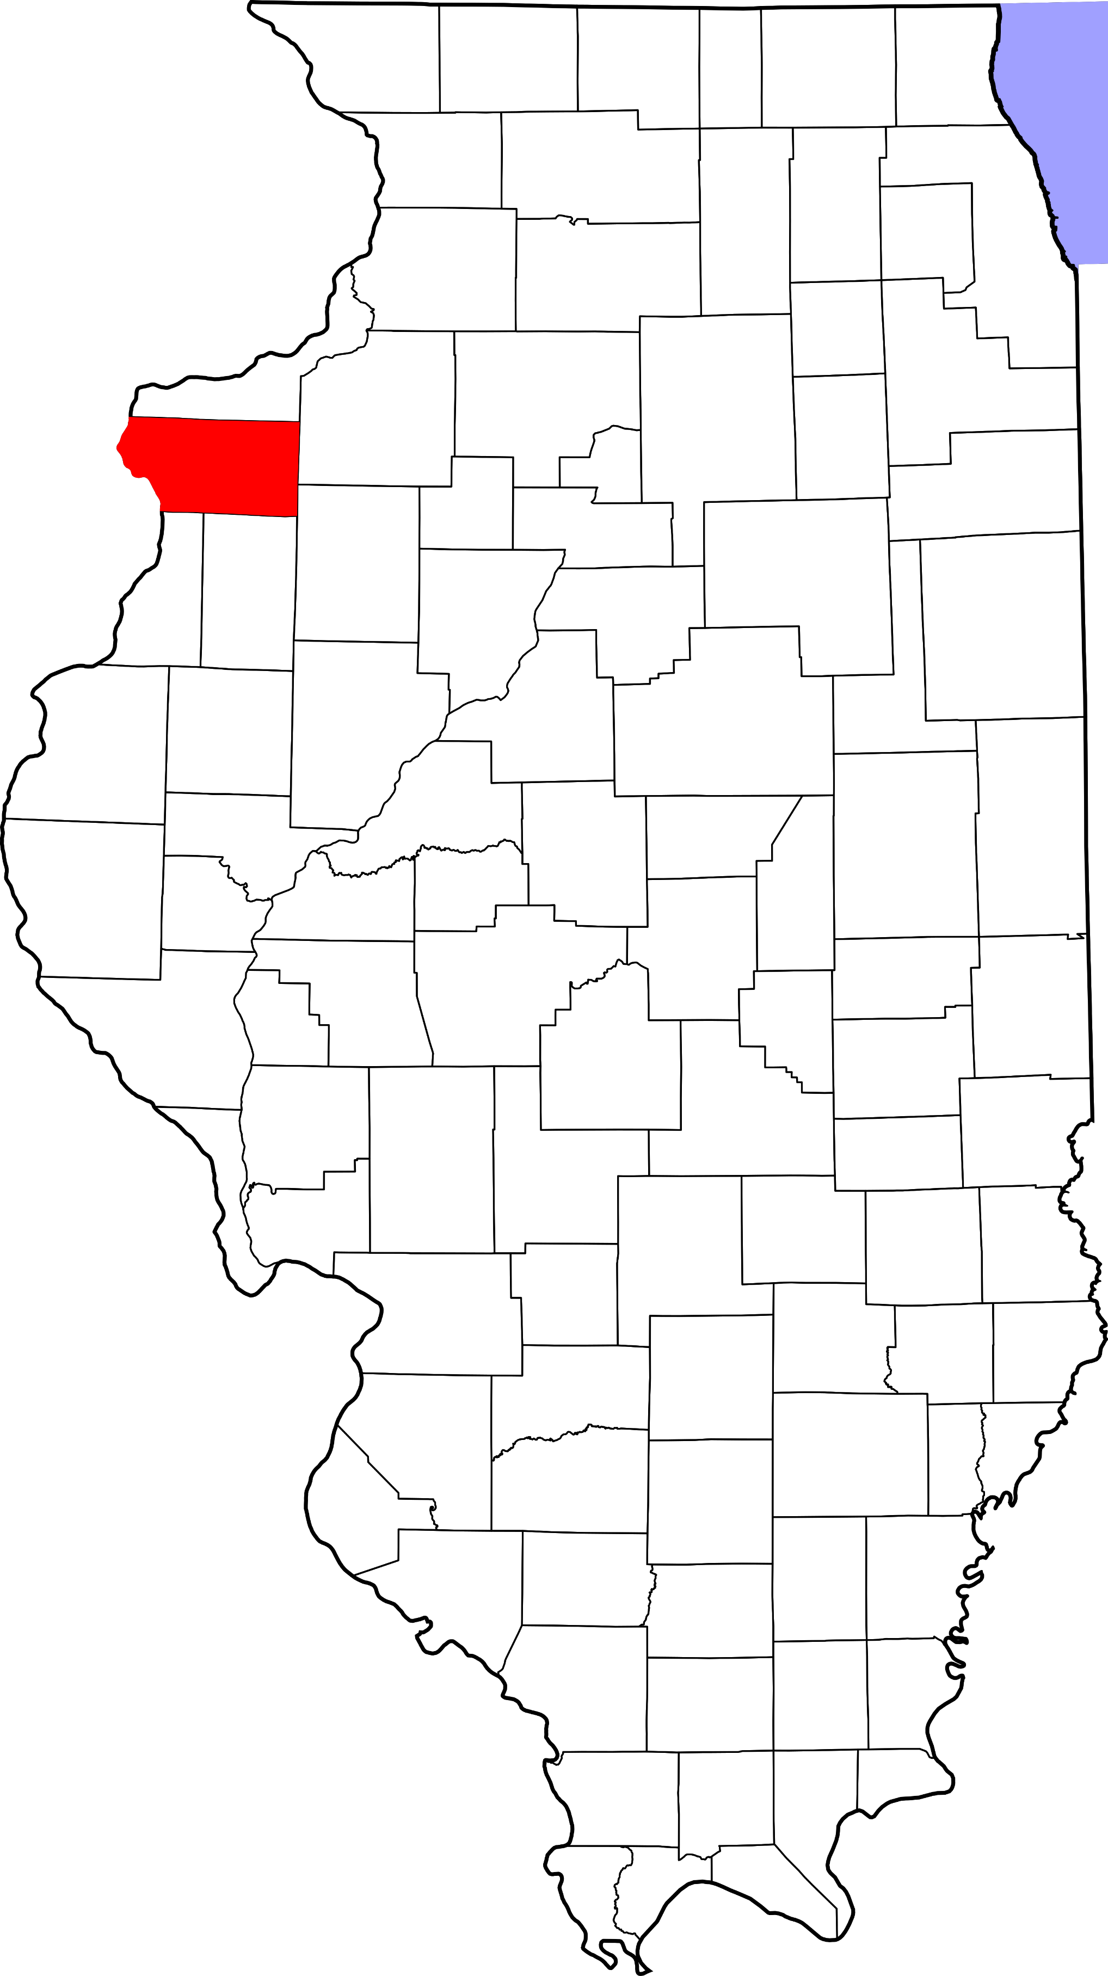
A. Child Maltreatment

Mercer County (Other Urban/Suburban)
During 2018, there were 48 substantiated cases of child maltreatment (which includes reports of physical and other abuse, sexual abuse, neglect, and risk of harm) in Mercer County. This number equates to a rate of 14.13 substantiated reports per 1,000 children in Illinois (which is higher than the state rate: 10.95 substantiated reports per 1,000 children).

These figures illustrate substantiated reports by child’s race and age. 50% of substantiated cases were among female children.

B. Youth Violence
No data or insufficient data for this county.

C. Juvenile Violent Offenses
In 2018, there were 17 youth admitted to short-term locked juvenile detention facilities in Mercer County. Approximately 12% of detention admissions were for a violent offense (n = 2). This translates to a rate of 1.20 violent offenses per 1,000 youth ages 10-17 in Mercer County, which is lower than the rate for the state of Illinois (1.83 violent offense admissions per 1,000 youth ages 10-17).

Hispanic youth had the highest rate of violent offense admissions.

 | Rate per 1,000
Male | 2.4
Female | 0
Juvenile Weapon-Related Offenses
Mercer county had 2 weapon-related offenses in 2018.

D. Adult Violent Offenses (Arrests)
No data or insufficient data for this county.

E. Adult Intimate Partner Violence and Sexual Violence
No data or insufficient data for this county.

F. Gun Violence: Firearm Death Rate
No data or insufficient data for this county.

G. Abuse Among Older Adults
In 2015, Mercer County had a rate of 410.6 reports of abuse among older adults (per 100,000) which is lower than the state rate (465.10 reports per 100,000).

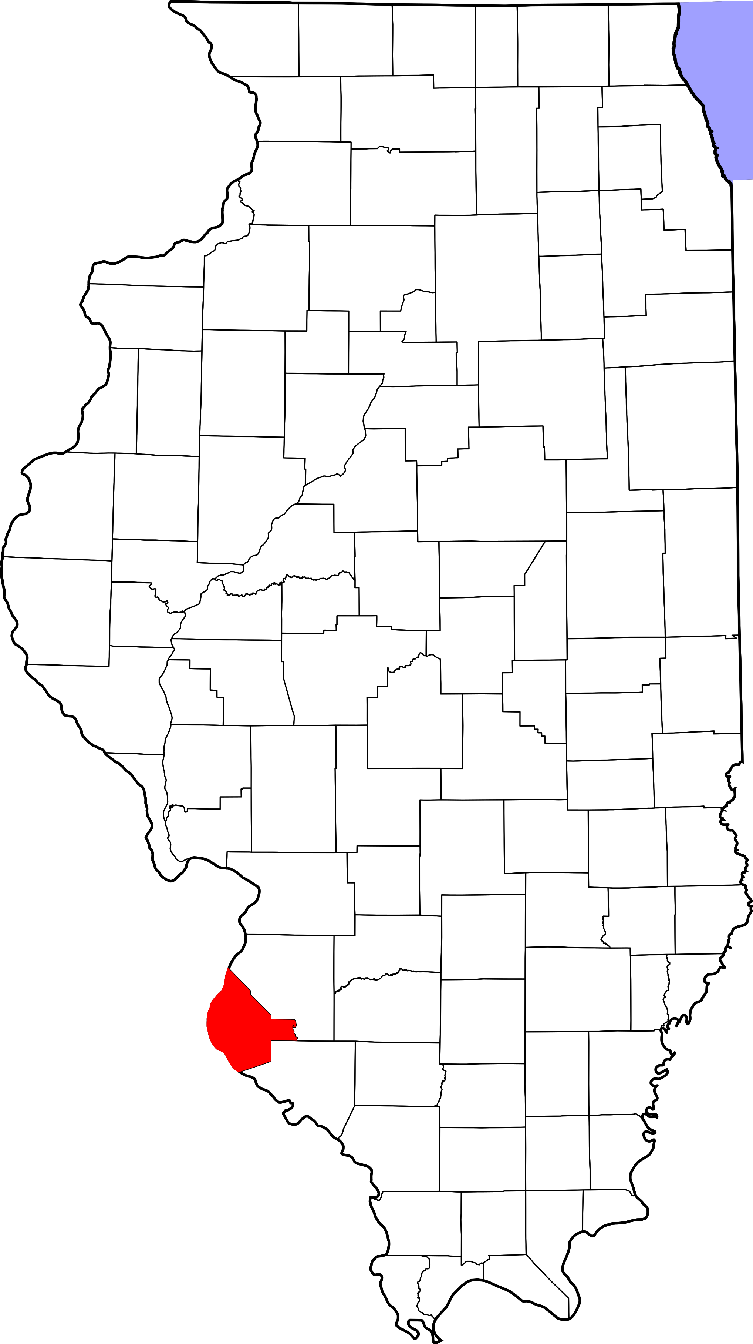
A. Child Maltreatment

Monroe County (Other Urban/Suburban)
During 2018, there were 46 substantiated cases of child maltreatment (which includes reports of physical and other abuse, sexual abuse, neglect, and risk of harm) in Monroe County. This number equates to a rate of 6.01 substantiated reports per 1,000 children in Illinois (which is lower than the state rate: 10.95 substantiated reports per 1,000 children).

These figures illustrate substantiated reports by child’s race and age. 51% of substantiated cases were among female children.

B. Youth Violence
Youth in Monroe County reported higher rates of bullying and weapon carrying compared to the state average.

Youth reported lower levels of dating violence and physical fighting compared to the state average.

Youth reported similar levels of cyber-bullying compared to the state average.
C. Juvenile Violent Offenses
In 2018, there were 4 youth admitted to short-term locked juvenile detention facilities in Monroe County. 25% of detention admissions were for a violent offense (n = 1). This translates to a rate of 0.28 violent offenses per 1,000 youth ages 10-17 in Monroe County, which is lower than the rate for the state of Illinois (1.83 violent offense admissions per 1,000 youth ages 10-17).

White youth had a rate of 0.3 violent offense admissions per 1,000 youth ages 10-17.
 | Rate per 1,000
Male | 0.5
Female | 0

Juvenile Weapon-Related Offenses
Monroe County had 1 weapon-related offenses in 2018.

Violent Arrests by Race & Sex (2018)
 | Rate per 1,000
Race/Ethnicity
African American | -
Hispanic/Latinx | -
Other | 1.45
White | 1.60
Sex
Female | 0.81
Male | 2.64
D. Adult Violent Offenses (Arrests)
In 2018, Monroe County had a rate of 75.72 violent crimes per 100,000 residents in Illinois. This is lower than the state rate (395.75 violent crimes per 100,000 residents).

E. Adult Intimate Partner Violence and Sexual Violence
Monroe County reported lower rates of domestic violence and sexual assault crimes in 2018 compared to the state rate.
 | Rate per 100,000 | State Rate per 100,000
Domestic Violence Crime Offense | 131.1 | 840.39
Sexual Assault | 26.2 | 44.83

F. Gun Violence: Firearm Death Rate
No data or insufficient data for this county.

G. Abuse Among Older Adults
In 2015, Monroe County had a rate of 168.8 reports of abuse among older adults (per 100,000) which is lower than the state rate (465.10 reports per 100,000).

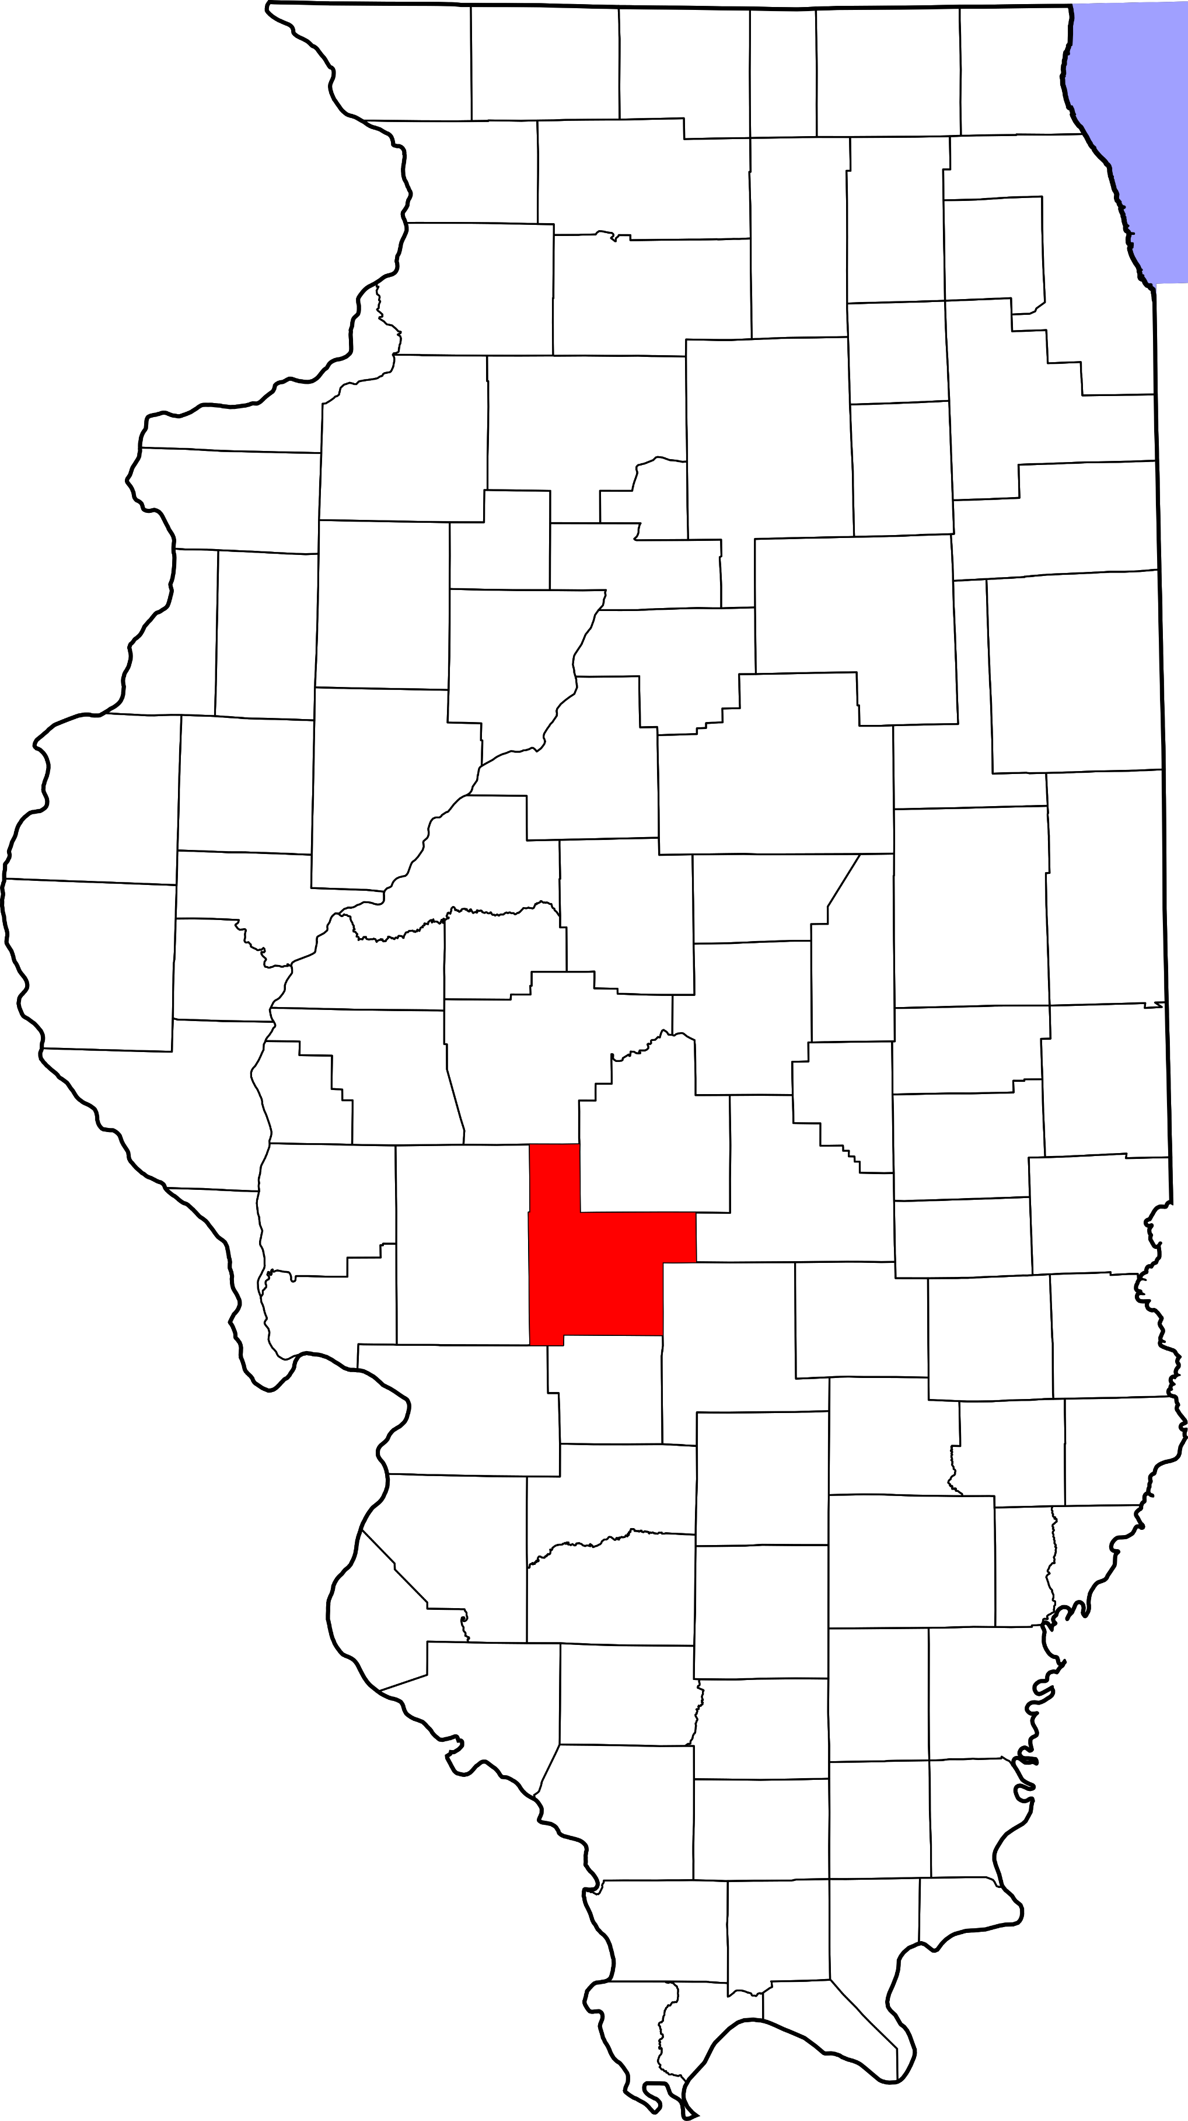
A. Child Maltreatment

Montgomery County (Rural)
During 2018, there were 103 substantiated cases of child maltreatment (which includes reports of physical and other abuse, sexual abuse, neglect, and risk of harm) in Montgomery County. This number equates to a rate of 17.89 substantiated reports per 1,000 children in Illinois (which is higher than the state rate: 10.95 substantiated reports per 1,000 children).

These figures illustrate substantiated reports by child’s race and age. 48% of substantiated cases were among female children.

B. Youth Violence
Youth in Montgomery County reported higher rates of bullying, cyber bullying, physical fighting, and weapon carrying compared to the state average.

Youth reported lower levels of dating violence compared to the state average.

C. Juvenile Violent Offenses
In 2018, there were 18 youth admitted to short-term locked juvenile detention facilities in Montgomery County. Approximately 11% of detention admissions were for a violent offense (n = 2). This translates to a rate of 0.74 violent offenses per 1,000 youth ages 10-17 in Montgomery County, which is lower than the rate for the state of Illinois (1.83 violent offense admissions per 1,000 youth ages 10-17).

White youth had a rate of 0.8 violent offense admissions per 1,000 youth ages 10-17).
 | Rate per 1,000
Male | 0.7
Female | 0.8

Juvenile Weapon-Related Offenses
Montgomery County had 1 weapon-related offenses in 2018.

Violent Arrests by Race & Sex (2018)
 | Rate per 1,000
Race/Ethnicity
African American | 1.37
Hispanic/Latinx | -
Other | 8.39
White | 4.21
Sex
Female | 2.38
Male | 6.14
D. Adult Violent Offenses (Arrests)
In 2018, Montgomery County had a rate of 220.27 violent crimes per 100,000 residents in Illinois. This is lower than the state rate (395.75 violent crimes per 100,000 residents).

Adults with “other” race/ethnicity had the highest rates of arrests for violent crimes.

E. Adult Intimate Partner Violence and Sexual Violence
Montgomery County reported lower rates of domestic violence and higher rates of sexual assault crimes in 2018 compared to the state rate.
 | Rate per 100,000 | State Rate per 100,000
Domestic Violence Crime Offense | 335.7 | 840.39
Sexual Assault | 45.5 | 44.83

F. Gun Violence: Firearm Death Rate
No data or insufficient data for this county.

G. Abuse Among Older Adults
In 2015, Montgomery County had a rate of 201.8 reports of abuse among older adults (per 100,000) which is lower than the state rate (465.10 reports per 100,000).

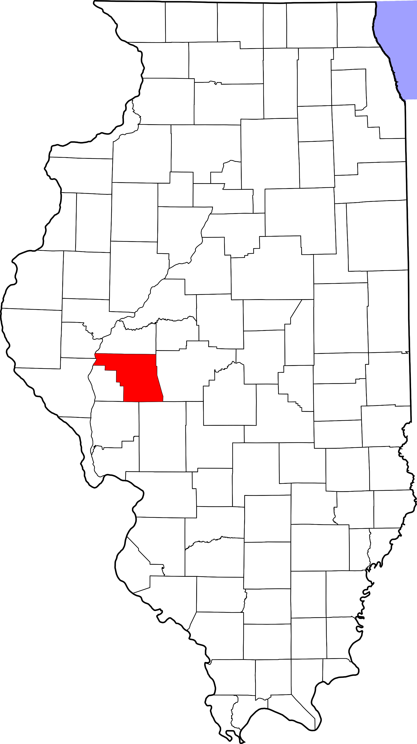
A. Child Maltreatment

Morgan County (Rural)
During 2018, there were 187 substantiated cases of child maltreatment (which includes reports of physical and other abuse, sexual abuse, neglect, and risk of harm) in Morgan County. This number equates to a rate of 28.46 substantiated reports per 1,000 children in Illinois (which is higher than the state rate: 10.95 substantiated reports per 1,000 children).

These figures illustrate substantiated reports by child’s race and age. 50% of substantiated cases were among female children.

B. Youth Violence
Youth in Morgan County reported higher rates of bullying, cyber bullying, physical fighting, and weapon carrying compared to the state average.

Youth reported slightly lower levels of dating violence compared to the state average.

C. Juvenile Violent Offenses
In 2018, there were 14 youth admitted to short-term locked juvenile detention facilities in Morgan County. Approximately 21% of detention admissions were for a violent offense (n = 3). This translates to a rate of 0.99 violent offenses per 1,000 youth ages 10-17 in Morgan County, which is lower than the rate for the state of Illinois (1.83 violent offense admissions per 1,000 youth ages 10-17).

Black youth had the highest rate of violent offense admissions.

 | Rate per 1,000
Male | 1.9
Female | 0

Juvenile Weapon-Related Offenses
Morgan County had 1 weapon-related offenses in 2018.

Violent Arrests by Race & Sex (2018)
 | Rate per 1,000
Race/Ethnicity
African American | 42.21
Hispanic/Latinx | 4.90
Other | 4.06
White | 5.92
Sex
Female | 5.25
Male | 12.20
D. Adult Violent Offenses (Arrests)
In 2018, Morgan County had a rate of 273.72 violent crimes per 100,000 residents in Illinois. This is lower than the state rate (395.75 violent crimes per 100,000 residents).

African American adults had the highest rates of arrests for violent crimes.

E. Adult Intimate Partner Violence and Sexual Violence
Morgan County reported lower rates of domestic violence and higher rates of sexual assault crimes in 2018 compared to the state rate.
 | Rate per 100,000 | State Rate per 100,000
Domestic Violence Crime Offense | 444.4 | 840.39
Sexual Assault | 67.7 | 44.83

F. Gun Violence: Firearm Death Rate
No data or insufficient data for this county.

G. Abuse Among Older Adults
In 2015, Morgan County had a rate of 540.7 reports of abuse among older adults (per 100,000) which is higher than the state rate (465.10 reports per 100,000).
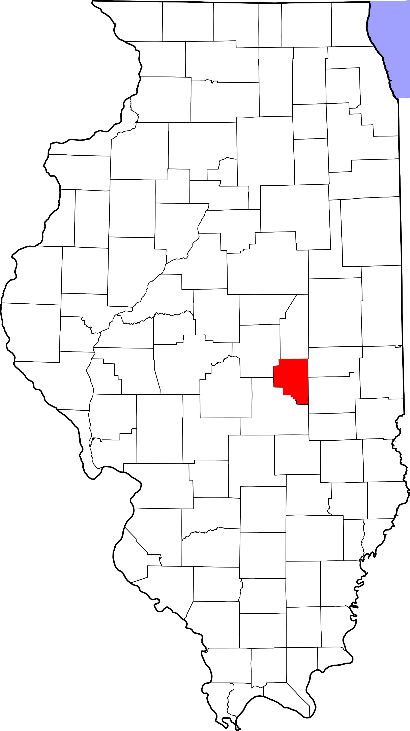
A. Child Maltreatment

Moultrie County (Rural)
During 2018, there were 56 substantiated cases of child maltreatment (which includes reports of physical and other abuse, sexual abuse, neglect, and risk of harm) in Moultrie County. This number equates to a rate of 15.03 substantiated reports per 1,000 children in Illinois (which is higher than the state rate: 10.95 substantiated reports per 1,000 children).

These figures illustrate substantiated reports by child’s race and age. 51% of substantiated cases were among female children.

B. Youth Violence
Youth in Moultrie County reported higher rates of bullying, cyber bullying, dating violence, physical fighting, and weapon carrying compared to the state average.

C. Juvenile Violent Offenses
In 2018, there were 4 youth admitted to short-term locked juvenile detention facilities in Moultrie County. 75.00% of detention admissions were for a violent offense (N = 3). This translates to a rate of 1.70 violent offenses per 1,000 youth ages 10-17 in Moultrie County, which is lower than the rate for the state of Illinois (1.83 violent offense admissions per 1,000 youth ages 10-17).

White youth had a rate of 1.7 violent offense admissions per 1,000 youth ages 10-17.
 | Rate per 1,000
Male | 0
Female | 3.5

D. Adult Violent Offenses (Arrests)
In 2018, Moultrie County had a rate of 346.54 violent crimes per 100,000 residents in Illinois. This is lower than the state rate (395.75 violent crimes per 100,000 residents).

E. Adult Intimate Partner Violence and Sexual Violence
Moultrie County reported lower rates of domestic violence and sexual assault crimes in 2018 compared to the state rate.
 | Rate per 100,000 | State Rate per 100,000
Domestic Violence Crime Offense | 122.3 | 840.39
Sexual Assault | 27.2 | 44.83

F. Gun Violence: Firearm Death Rate
No data or insufficient data for this county.

G. Abuse Among Older Adults
In 2015, Moultrie County had a rate of 279.7 reports of abuse among older adults (per 100,000) which is lower than the state rate (465.10 reports per 100,000).

A. Child Maltreatment

Ogle County (Rural)
During 2018, there were 108 substantiated cases of child maltreatment (which includes reports of physical and other abuse, sexual abuse, neglect, and risk of harm) in Ogle County. This number equates to a rate of 9.22 substantiated reports per 1,000 children in Illinois (which is lower than the state rate: 10.95 substantiated reports per 1,000 children).

These figures illustrate substantiated reports by child’s race and age. 50% of substantiated cases were among female children.

B. Youth Violence
Youth in Ogle County reported higher rates of bullying, cyber bullying, dating violence, physical fighting, and weapon carrying compared to the state average.

C. Juvenile Violent Offenses
In 2018, there were 16 youth admitted to short-term locked juvenile detention facilities in Ogle County. 25% of detention admissions were for a violent offense (n = 4). This translates to a rate of 0.72 violent offenses per 1,000 youth ages 10-17 in Ogle County, which is lower than the rate for the state of Illinois (1.83 violent offense admissions per 1,000 youth ages 10-17).

White youth had a rate of 0.6 violent offense admissions per 1,000 youth ages 10-17/
 | Rate per 1,000
Male | 1.1
Female | 0.4

Juvenile Weapon-Related Offenses
Ogle county had 4 weapon-related offenses in 2018.

D. Adult Violent Offenses (Arrests)
Violent Arrests by Race & Sex (2018)
 | Rate per 1,000
Race/Ethnicity
African American | 31.94
Hispanic/Latinx | 0.78
Other | 0.40
White | 3.81
Sex
Female | 2.33
Male | 5.90
In 2018, Ogle County had a rate of 49.09 violent crimes per 100,000 residents in Illinois. This is lower than the state rate (395.75 violent crimes per 100,000 residents).

African American adults had the highest rates of arrests for violent crimes.

E. Adult Intimate Partner Violence and Sexual Violence
Ogle County reported lower rates of domestic violence and sexual assault crimes in 2018 compared to the state rate.
 | Rate per 100,000 | State Rate per 100,000
Domestic Violence Crime Offense | 129.6 | 840.39
Sexual Assault | 9.8 | 44.83

F. Gun Violence: Firearm Death Rate
No data or insufficient data for this county.

G. Abuse Among Older Adults
In 2015, Ogle County had a rate of 534.5 reports of abuse among older adults (per 100,000) which is higher than the state rate (465.10 reports per 100,000).

A. Child Maltreatment

Peoria County (Other Urban/Suburban)
During 2018, there were 1,025 substantiated cases of child maltreatment (which includes reports of physical and other abuse, sexual abuse, neglect, and risk of harm) in Peoria County. This number equates to a rate of 23.36 substantiated reports per 1,000 children in Illinois (which is higher than the state rate: 10.95 substantiated reports per 1,000 children).

These figures illustrate substantiated reports by child’s race and age. 52% of substantiated cases were among female children.

B. Youth Violence
Youth in Peoria County reported higher rates of bullying, cyber bullying, physical fighting, and weapon carrying compared to the state average.

Youth reported similar levels of dating violence compared to the state average.

C. Juvenile Violent Offenses
In 2018, there were 481 youth admitted to short-term locked juvenile detention facilities in Peoria County. Approximately 51% of detention admissions were for a violent offense (N = 243). This translates to a rate of 13.12 violent offenses per 1,000 youth ages 10-17 in Peoria County, which is lower than the rate for the state of Illinois (1.83 violent offense admissions per 1,000 youth ages 10-17).

Black youth had the highest rate of violent offense admissions.

 | Rate per 1,000
Male | 14.3
Female | 11.9

Juvenile Weapon-Related Offenses
Peoria County had 4 weapon-related offenses in 2018.

Violent Arrests by Race & Sex (2018)
 | Rate per 1,000
Race/Ethnicity
African American | 41.79
Hispanic/Latinx | 0.12
Other | 3.19
White | 6.11
Sex
Female | 7.04
Male | 19.92
D. Adult Violent Offenses (Arrests)
In 2018, Peoria County had a rate of 565.27 violent crimes per 100,000 residents in Illinois. This is higher than the state rate (395.75 violent crimes per 100,000 residents).

African American adults had the highest rates of arrests for violent crimes.

E. Adult Intimate Partner Violence and Sexual Violence
Peoria County reported higher rates of domestic violence and sexual assault crimes in 2018 compared to the state rate.
 | Rate per 100,000 | State Rate per 100,000
Domestic Violence Crime Offense | 1646 | 840.39
Sexual Assault | 58.7 | 44.83

F. Gun Violence: Firearm Death Rate
Peoria County reported higher rates of deaths by firearms than the state rate.

 | Rate per 100,000 | State Rate per 100,000
Homicide by Firearm | - | 6.2
Suicide by Firearm | - | 4.5
Total: Death by Firearm | 14.4 | 10.8

G. Abuse Among Older Adults
In 2015, Peoria County had a rate of 719.7 reports of abuse among older adults (per 100,000) which is higher than the state rate (465.10 reports per 100,000).

A. Child Maltreatment

Perry County (Rural)
During 2018, there were 58 substantiated cases of child maltreatment (which includes reports of physical and other abuse, sexual abuse, neglect, and risk of harm) in Perry County. This number equates to a rate of 14.22 substantiated reports per 1,000 children in Illinois (which is higher than the state rate: 10.95 substantiated reports per 1,000 children).

These figures illustrate substantiated reports by child’s race and age. 45% of substantiated cases were among female children.

B. Youth Violence
No data or insufficient data for this county.

C. Juvenile Violent Offenses
In 2018, there were 38 youth admitted to short-term locked juvenile detention facilities in Perry County. Approximately 5% of detention admissions were for a violent offense (n = 2). This translates to a rate of 1.00 violent offenses per 1,000 youth ages 10-17 in Perry County, which is lower than the rate for the state of Illinois (1.83 violent offense admissions per 1,000 youth ages 10-17).

White youth had a rate of 1.1 violent offense admissions per 1,000 youth ages 10-17.
 | Rate per 1,000
Male | 1.9
Female | 0

Violent Arrests by Race & Sex (2018)
 | Rate per 1,000
Race/Ethnicity
African American | 3.13
Hispanic/Latinx | 3.04
Other | 1.68
White | 2.76
Sex
Female | 1.77
Male | 4.16
D. Adult Violent Offenses (Arrests)
In 2018, Perry County had a rate of 136.96 violent crimes per 100,000 residents in Illinois. This is lower than the state rate (395.75 violent crimes per 100,000 residents).

African American adults had the highest rates of arrests for violent crimes.

E. Adult Intimate Partner Violence and Sexual Violence
Perry County reported lower rates of domestic violence and sexual assault crimes in 2018 compared to the state rate.
 | Rate per 100,000 | State Rate per 100,000
Domestic Violence Crime Offense | 387.3 | 840.39
Sexual Assault | 9.4 | 44.83

F. Gun Violence: Firearm Death Rate
No data or insufficient data for this county.

G. Abuse Among Older Adults
In 2015, Perry County had a rate of 910.3 reports of abuse among older adults (per 100,000) which is higher than the state rate (465.10 reports per 100,000).

A. Child Maltreatment

Piatt County (Other Urban/Suburban)
During 2018, there were 69 substantiated cases of child maltreatment (which includes reports of physical and other abuse, sexual abuse, neglect, and risk of harm) in Piatt County. This number equates to a rate of 18.64 substantiated reports per 1,000 children in Illinois (which is higher than the state rate: 10.95 substantiated reports per 1,000 children).

These figures illustrate substantiated reports by child’s race and age. 51% of substantiated cases were among female children.

B. Youth Violence
Youth in Piatt County reported higher rates of bullying, cyber bullying, dating violence and weapon carrying compared to the state average.

Youth reported similar levels of physical fighting compared to the state average.

C. Juvenile Violent Offenses
In 2018, there were 15 youth admitted to short-term locked juvenile detention facilities in Piatt County.
Approximately 13% of detention admissions were for a violent offense (n = 2). This translates to a rate of 1.15 violent offenses per 1,000 youth ages 10-17 in Piatt County, which is lower than the rate for the state of Illinois (1.83 violent offense admissions per 1,000 youth ages 10-17).

White youth had a rate of 1.2 violent offense admissions per 1,000 youth ages 10-17.
 | Rate per 1,000
Male | 1.1
Female | 1.2

D. Adult Violent Offenses (Arrests)
In 2018, Piatt County had a rate of 213.47 violent crimes per 100,000 residents in Illinois. This is lower than the state rate (395.75 violent crimes per 100,000 residents).

E. Adult Intimate Partner Violence and Sexual Violence
Piatt County reported lower rates of domestic violence and sexual assault crimes in 2018 compared to the state rate.
 | Rate per 100,000 | State Rate per 100,000
Domestic Violence Crime Offense | 548.9 | 840.39
Sexual Assault | 24.4 | 44.83

F. Gun Violence: Firearm Death Rate
No data or insufficient data for this county.

G. Abuse Among Older Adults
In 2015, Piatt County had a rate of 241.1 reports of abuse among older adults (per 100,000) which is lower than the state rate (465.10 reports per 100,000).

A. Child Maltreatment

Pike County (Rural)
During 2018, there were 65 substantiated cases of child maltreatment (which includes reports of physical and other abuse, sexual abuse, neglect, and risk of harm) in Pike County. This number equates to a rate of 18.34 substantiated reports per 1,000 children in Illinois (which is higher than the state rate: 10.95 substantiated reports per 1,000 children).

These figures illustrate substantiated reports by child’s race and age. 50% of substantiated cases were among female children.

B. Youth Violence
No data or insufficient data for this county.

C. Juvenile Violent Offenses
In 2018, there were 10 youth admitted to short-term locked juvenile detention facilities in Pike County.
10% of detention admissions were for a violent offense (n = 1). This translates to a rate of 0.62 violent offenses per 1,000 youth ages 10-17 in Pike County, which is lower than the rate for the state of Illinois (1.83 violent offense admissions per 1,000 youth ages 10-17).

White youth had a rate of 0.6 violent offense admissions per 1,000 youth ages 10-17.
 | Rate per 1,000
Male | 1.2
Female | 0

Violent Arrests by Race & Sex (2018)
 | Rate per 1,000
Race/Ethnicity
African American | 12.35
Hispanic/Latinx | 5.13
Other | -
White | 3.41
Sex
Female | 1.64
Male | 5.89
D. Adult Violent Offenses (Arrests)
In 2018, Pike County had a rate of 108.90 violent crimes per 100,000 residents in Illinois. This is lower than the state rate (395.75 violent crimes per 100,000 residents).

African American adults had the highest rates of arrests for violent crimes.

E. Adult Intimate Partner Violence and Sexual Violence
Pike County reported lower rates of domestic violence and sexual assault crimes in 2018 compared to the state rate.
 | Rate per 100,000 | State Rate per 100,000
Domestic Violence Crime Offense | 19.2 | 840.39
Sexual Assault | 32 | 44.83

F. Gun Violence: Firearm Death Rate
No data or insufficient data for this county.

G. Abuse Among Older Adults
In 2015, Pike County had a rate of 439.5 reports of abuse among older adults (per 100,000) which is lower than the state rate (465.10 reports per 100,000).

A. Child Maltreatment

Pope County (Rural)
During 2018, there were 9 substantiated cases of child maltreatment (which includes reports of physical and other abuse, sexual abuse, neglect, and risk of harm) in Pope County. This number equates to a rate of 14.80 substantiated reports per 1,000 children in Illinois (which is higher than the state rate: 10.95 substantiated reports per 1,000 children).

These figures illustrate substantiated reports by child’s race and age. 50% of substantiated cases were among female children.

B. Youth Violence
No data or insufficient data for this county.

C. Juvenile Violent Offenses
In 2018, there were 2 youth admitted to short-term locked juvenile detention facilities in Pope County. Neither of these admissions were for violent offenses.

D. Adult Violent Offenses (Arrests)
No data or insufficient data for this county.

E. Adult Intimate Partner Violence and Sexual Violence
No data or insufficient data for this county.

F. Gun Violence: Firearm Death Rate
No data or insufficient data for this county.

G. Abuse Among Older Adults
In 2015, Pope County had a rate of 478.1 reports of abuse among older adults (per 100,000) which is higher than the state rate (465.10 reports per 100,000).
A. Child Maltreatment

Pulaski County (Rural)
During 2018, there were 30 substantiated cases of child maltreatment (which includes reports of physical and other abuse, sexual abuse, neglect, and risk of harm) in Pulaski County. This number equates to a rate of 24.86 substantiated reports per 1,000 children in Illinois (which is higher than the state rate: 10.95 substantiated reports per 1,000 children).

These figures illustrate substantiated reports by child’s race and age. 51% of substantiated cases were among female children.

B. Youth Violence
Youth in Pulaski County reported higher rates of bullying, cyber bullying, dating violence, physical fighting and weapon carrying compared to the state average.

C. Juvenile Violent Offenses
In 2018, there were 4 youth admitted to short-term locked juvenile detention facilities in Pulaski County. 75% of detention admissions were for a violent offense (n = 3). This translates to a rate of 5.38 violent offenses per 1,000 youth ages 10-17 in Pulaski County, which is higher than the rate for the state of Illinois (1.83 violent offense admissions per 1,000 youth ages 10-17).

Black youth had the highest rate of violent offense admissions.

 | Rate per 1,000
Male | 7.4
Female | 3.5

D. Adult Violent Offenses (Arrests)
No data or insufficient data for this county.

E. Adult Intimate Partner Violence and Sexual Violence
No data or insufficient data for this county.

F. Gun Violence: Firearm Death Rate
No data or insufficient data for this county.

G. Abuse Among Older Adults
In 2015, Pulaski County had a rate of 557.6 reports of abuse among older adults (per 100,000) which is higher than the state rate (465.10 reports per 100,000).

A. Child Maltreatment

Putnam County (Rural)
During 2018, there were 6 substantiated cases of child maltreatment (which includes reports of physical and other abuse, sexual abuse, neglect, and risk of harm) in Putnam County. This number equates to a rate of 5.27 substantiated reports per 1,000 children in Illinois (which is lower than the state rate: 10.95 substantiated reports per 1,000 children).

These figures illustrate substantiated reports by child’s race and age. 50% of substantiated cases were among female children.

B. Youth Violence
No data or insufficient data for this county.

C. Juvenile Violent Offenses
In 2018, there were 1 youth admitted to short-term locked juvenile detention facilities in Putnam County. It was not for a violent offense.

D. Adult Violent Offenses (Arrests)
In 2018, Putnam County had a rate of 17.42 violent crimes per 100,000 residents in Illinois. This is lower than the state rate (395.75 violent crimes per 100,000 residents).

E. Adult Intimate Partner Violence and Sexual Violence
Putnam County reported lower rates of domestic violence crimes in 2018 compared to the state rate.
 | Rate per 100,000 | State Rate per 100,000
Domestic Violence Crime Offense | 331 | 840.39

F. Gun Violence: Firearm Death Rate
No data or insufficient data for this county.

G. Abuse Among Older Adults
In 2015, Putnam County had a rate of 293.6 reports of abuse among older adults (per 100,000) which is lower than the state rate (465.10 reports per 100,000).

A. Child Maltreatment

Randolph County (Rural)
During 2018, there were 143 substantiated cases of child maltreatment (which includes reports of physical and other abuse, sexual abuse, neglect, and risk of harm) in Randolph County. This number equates to a rate of 22.62 substantiated reports per 1,000 children in Illinois (which is higher than the state rate: 10.95 substantiated reports per 1,000 children).

These figures illustrate substantiated reports by child’s race and age. 50% of substantiated cases were among female children.

B. Youth Violence
Youth in Randolph County reported higher rates of bullying, cyber bullying, dating violence, physical fighting and weapon carrying compared to the state average.

C. Juvenile Violent Offenses
In 2018, there were 17 youth admitted to short-term locked juvenile detention facilities in Randolph County. Approximately 59% of detention admissions were for a violent offense (n = 10). This translates to a rate of 3.52 violent offenses per 1,000 youth ages 10-17 in Randolph County, which is higher than the rate for the state of Illinois (1.83 violent offense admissions per 1,000 youth ages 10-17).

Black youth had the highest rate of violent offense admissions.

 | Rate per 1,000
Male | 4.7
Female | 2.2

Violent Arrests by Race & Sex (2018)
 | Rate per 1,000
Race/Ethnicity
African American | 5.44
Hispanic/Latinx | 3.01
Other | 1.07
White | 4.52
Sex
Female | 2.62
Male | 6.99

D. Adult Violent Offenses (Arrests)
In 2018, Randolph County had a rate of 65.41 violent crimes per 100,000 residents in Illinois. This is lower than the state rate (395.75 violent crimes per 100,000 residents).

African American adults had the highest rates of arrests for violent crimes.

E. Adult Intimate Partner Violence and Sexual Violence
Randolph County reported lower rates of domestic violence and sexual assault crimes in 2018 compared to the state rate.
 | Rate per 100,000 | State Rate per 100,000
Domestic Violence Crime Offense | 59.2 | 840.39
Sexual Assault | 9.3 | 44.83

F. Gun Violence: Firearm Death Rate
No data or insufficient data for this county.

G. Abuse Among Older Adults
In 2015, Randolph County had a rate of 542.2 reports of abuse among older adults (per 100,000) which is higher than the state rate (465.10 reports per 100,000).
A. Child Maltreatment

Richland County (Rural)
During 2018, there were 137 substantiated cases of child maltreatment (which includes reports of physical and other abuse, sexual abuse, neglect, and risk of harm) in Richland County. This number equates to a rate of 37.93 substantiated reports per 1,000 children in Illinois (which is higher than the state rate: 10.95 substantiated reports per 1,000 children).

These figures illustrate substantiated reports by child’s race and age. 51% of substantiated cases were among female children.

B. Youth Violence
No data or insufficient data for this county.

C. Juvenile Violent Offenses
In 2018, there were 11 youth admitted to short-term locked juvenile detention facilities in Richland County. Approximately 18% of detention admissions were for a violent offense (n = 2). This translates to a rate of 1.24 violent offenses per 1,000 youth ages 10-17 in Richland County, which is lower than the rate for the state of Illinois (1.83 violent offense admissions per 1,000 youth ages 10-17).

White youth had a rate of 1.3 violent offense admissions per 1,000 youth ages 10-17.
 | Rate per 1,000
Male | 2.4
Female | 0

Violent Arrests by Race & Sex (2018)
 | Rate per 1,000
Race/Ethnicity
African American | 42.55
Hispanic/Latinx | 3.79
Other | -
White | 6.27
Sex
Female | 3.34
Male | 10.12
D. Adult Violent Offenses (Arrests)
In 2018, Richland County had a rate of 380.64 violent crimes per 100,000 residents in Illinois. This is lower than the state rate (395.75 violent crimes per 100,000 residents).

African American adults had the highest rates of arrests for violent crimes.

E. Adult Intimate Partner Violence and Sexual Violence
Richland County reported higher rates of domestic violence and sexual assault crimes in 2018 compared to the state rate.
 | Rate per 100,000 | State Rate per 100,000
Domestic Violence Crime Offense | 1541.6 | 840.39
Sexual Assault | 88.8 | 44.83

F. Gun Violence: Firearm Death Rate
No data or insufficient data for this county.

G. Abuse Among Older Adults
In 2015, Richland County had a rate of 1549.1 reports of abuse among older adults (per 100,000) which is higher than the state rate (465.10 reports per 100,000).

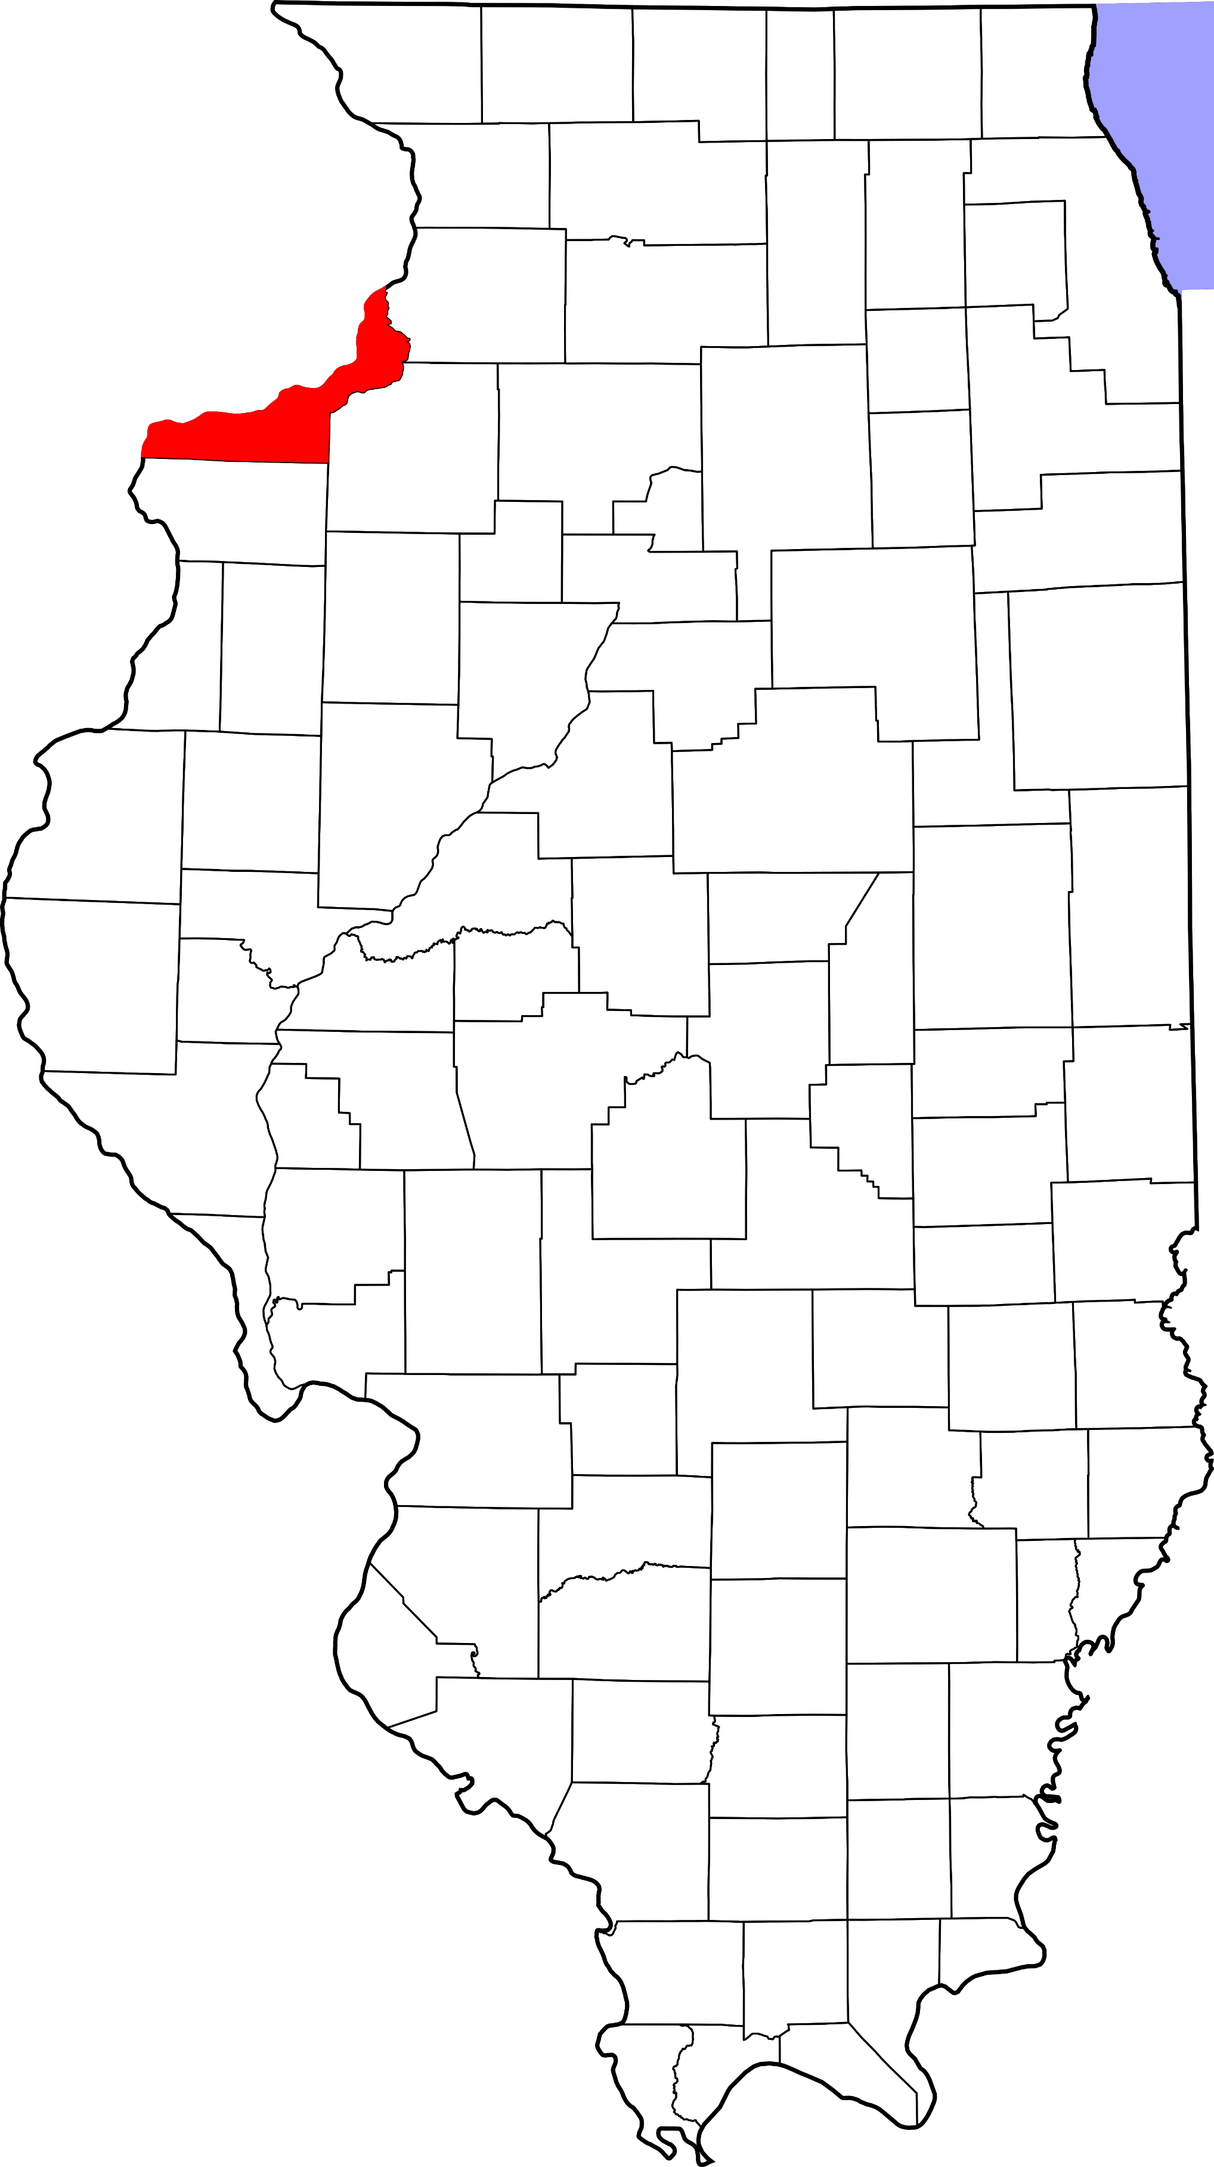
A. Child Maltreatment

Rock Island County (Other Urban/Suburban)
During 2018, there were 655 substantiated cases of child maltreatment (which includes reports of physical and other abuse, sexual abuse, neglect, and risk of harm) in Rock Island County. This number equates to a rate of 20.14 substantiated reports per 1,000 children in Illinois (which is higher than the state rate: 10.95 substantiated reports per 1,000 children).

These figures illustrate substantiated reports by child’s race and age. 51% of substantiated cases were among female children.

B. Youth Violence
Youth in Rock Island County reported higher rates of bullying, cyber bullying, dating violence, physical fighting and weapon carrying compared to the state average.

C. Juvenile Violent Offenses
In 2018, there were 182 youth admitted to short-term locked juvenile detention facilities in Rock Island County. Approximately 22% of detention admissions were for a violent offense (n =40). This translates to a rate of 2.84 violent offenses per 1,000 youth ages 10-17 in Rock Island County, which is higher than the rate for the state of Illinois (1.83 violent offense admissions per 1,000 youth ages 10-17).

Black youth had the highest rate of violent offense admissions.

 | Rate per 1,000
Male | 3.9
Female | 1.8

Juvenile Weapon-Related Offenses
Rock Island county had 11 weapon-related offenses in 2018.

Violent Arrests by Race & Sex (2018)
 | Rate per 1,000
Race/Ethnicity
African American | 21.92
Hispanic/Latinx | 3.85
Other | 0.23
White | 4.22
Sex
Female | 3.33
Male | 9.46
D. Adult Violent Offenses (Arrests)
In 2018, Rock Island County had a rate of 372.19 violent crimes per 100,000 residents in Illinois. This is lower than the state rate (395.75 violent crimes per 100,000 residents).

African American adults had the highest rates of arrests for violent crimes.

E. Adult Intimate Partner Violence and Sexual Violence
Rock Island County reported lower rates of domestic violence and higher rates of sexual assault crimes in 2018 compared to the state rate.
 | Rate per 100,000 | State Rate per 100,000
Domestic Violence Crime Offense | 453.7 | 840.39
Sexual Assault | 46 | 44.83

F. Gun Violence: Firearm Death Rate
No data or insufficient data for this county.

G. Abuse Among Older Adults
In 2015, Rock Island County had a rate of 765.6 reports of abuse among older adults (per 100,000) which is higher than the state rate (465.10 reports per 100,000).

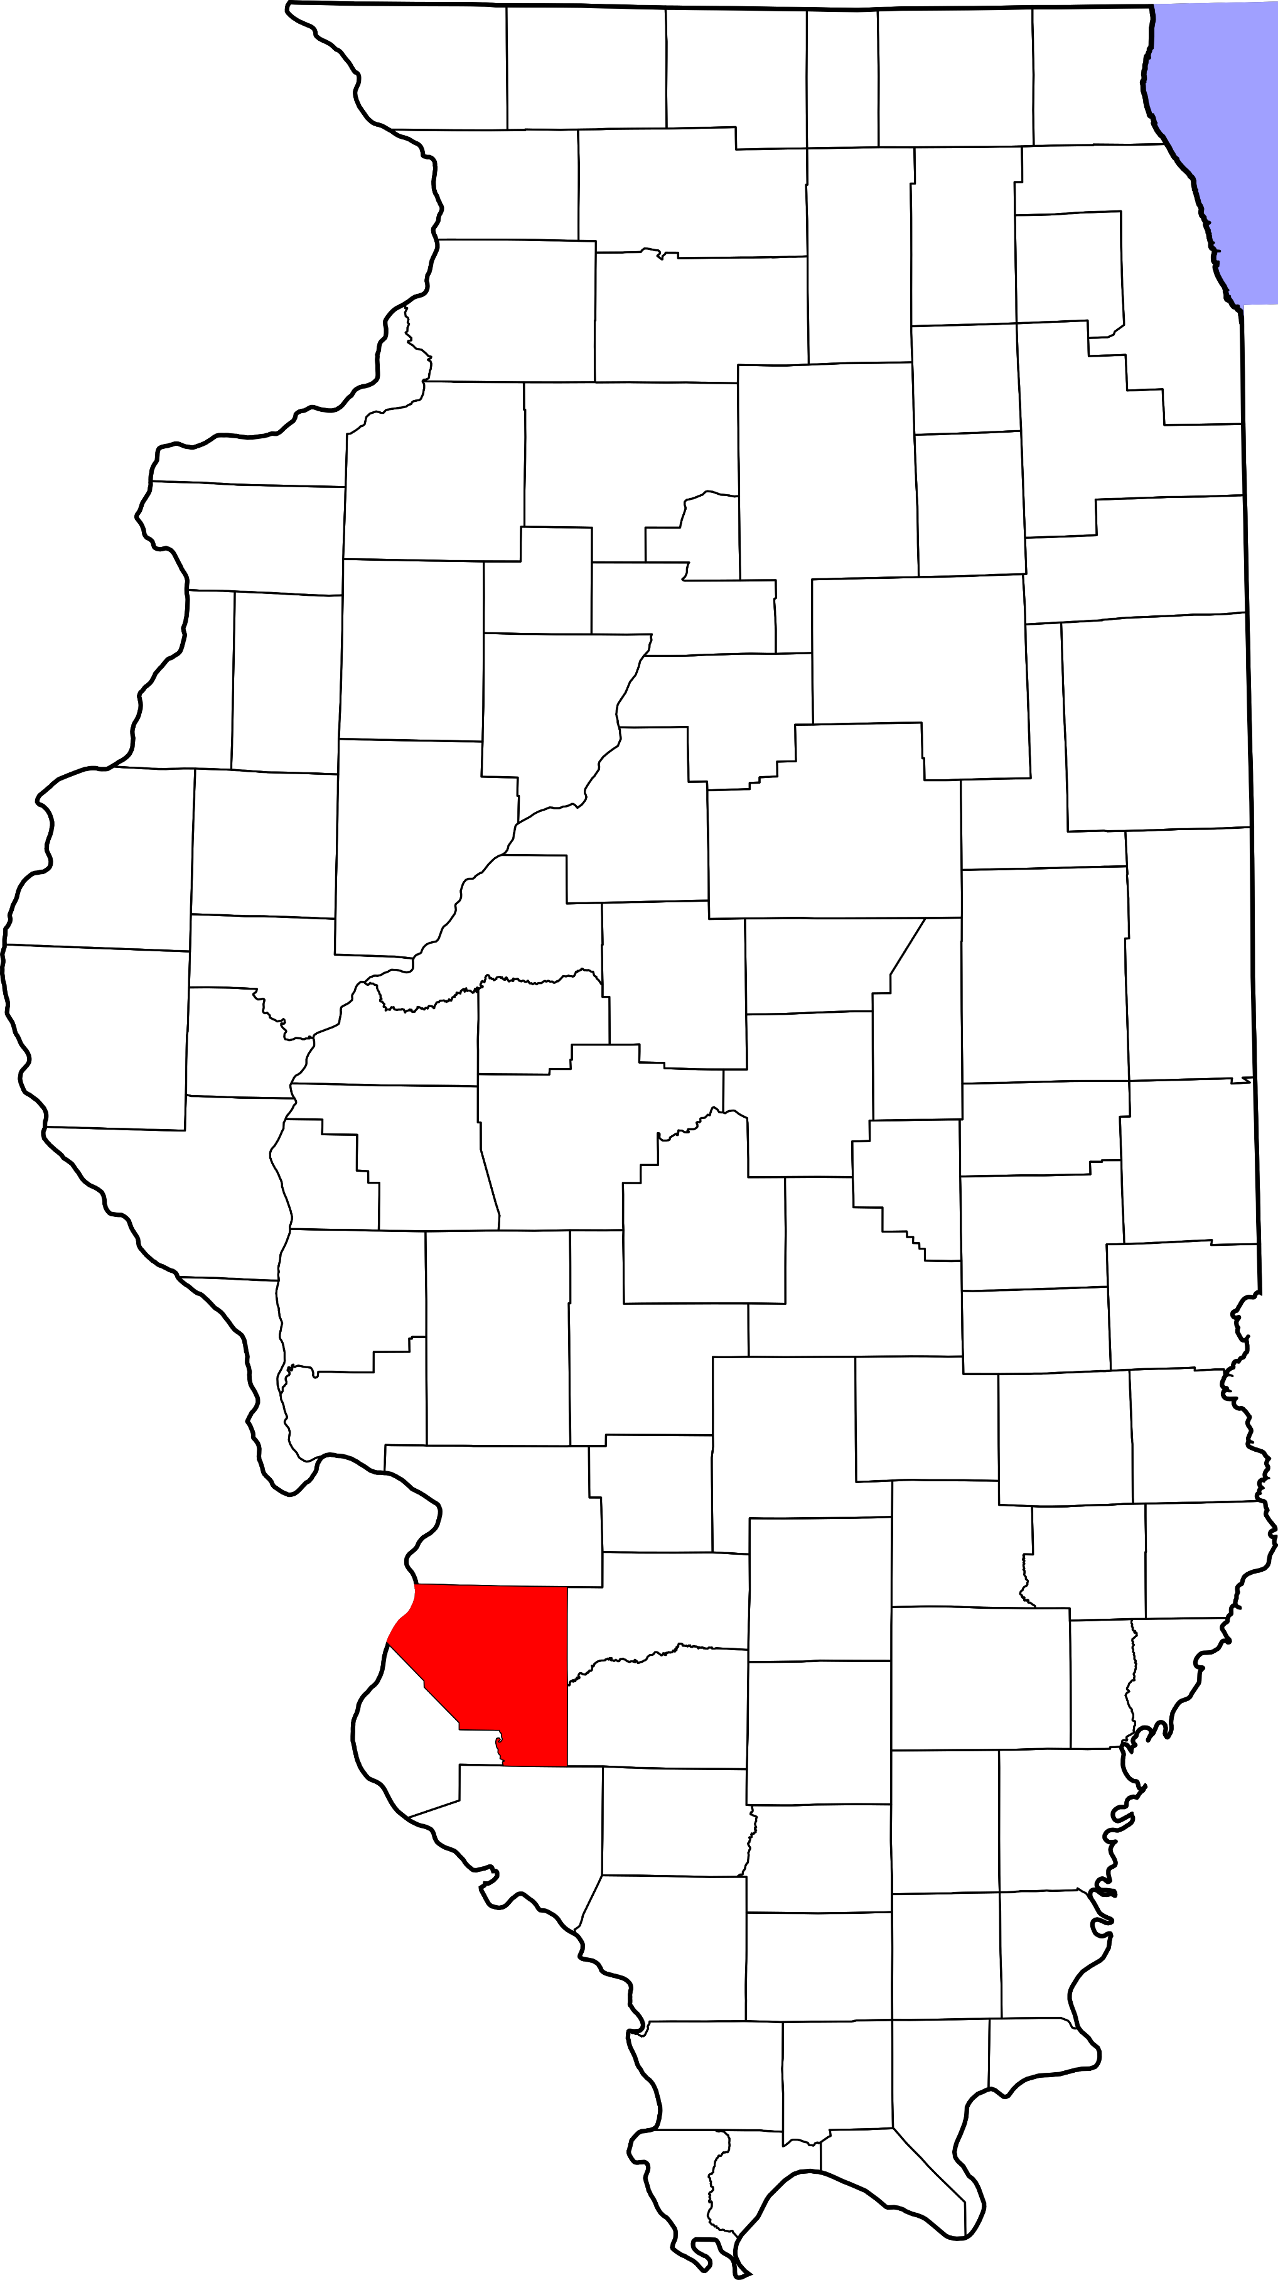
A. Child Maltreatment

St. Clair County (Other Urban/Suburban)
During 2018, there were 968 substantiated cases of child maltreatment (which includes reports of physical and other abuse, sexual abuse, neglect, and risk of harm) in St. Clair County. This number equates to a rate of 15.50 substantiated reports per 1,000 children in Illinois (which is higher than the state rate: 10.95 substantiated reports per 1,000 children).

These figures illustrate substantiated reports by child’s race and age. 52% of substantiated cases were among female children.

B. Youth Violence
Youth in St. Clair County reported higher rates of bullying, cyber bullying, dating violence, physical fighting and weapon carrying compared to the state average.

C. Juvenile Violent Offenses
In 2018, there were 340 youth admitted to short-term locked juvenile detention facilities in St. Clair County. Approximately 25% of detention admissions were for a violent offense (n = 86). This translates to a rate of 3.09 violent offenses per 1,000 youth ages 10-17 in St. Clair County, which is higher than the rate for the state of Illinois (1.83 violent offense admissions per 1,000 youth ages 10-17).

Black youth had the highest rate of violent offense admissions.

 | Rate per 1,000
Male | 4.1
Female | 2.0

Juvenile Weapon-Related Offenses
St. Clair County had 22 weapon-related offenses in 2018.

Violent Arrests by Race & Sex (2018)
 | Rate per 1,000
Race/Ethnicity
African American | 7.25
Hispanic/Latinx | 1.24
Other | 0.59
White | 2.28
Sex
Female | 1.49
Male | 6.48
D. Adult Violent Offenses (Arrests)
In 2018, St. Clair County had a rate of 392.25 violent crimes per 100,000 residents in Illinois. This is lower than the state rate (395.75 violent crimes per 100,000 residents).

African American adults had the highest rates of arrests for violent crimes.

E. Adult Intimate Partner Violence and Sexual Violence
St. Clair County reported lower rates of domestic violence and higher rates of sexual assault crimes in 2018 compared to the state rate.
 | Rate per 100,000 | State Rate per 100,000
Domestic Violence Crime Offense | 285 | 840.39
Sexual Assault | 64 | 44.83

F. Gun Violence: Firearm Death Rate
St. Clair County reported higher rates of homicides, suicides, and deaths by firearms than the state rate.

 | Rate per 100,000 | State Rate per 100,000
Homicide by Firearm | 12.6 | 6.2
Suicide by Firearm | 8.0 | 4.5
Total: Death by Firearm | 21.5 | 10.8

G. Abuse Among Older Adults
In 2015, St. Clair County had a rate of 568 reports of abuse among older adults (per 100,000) which is higher than the state rate (465.10 reports per 100,000).

A. Child Maltreatment

Saline County (Rural)
During 2018, there were 127 substantiated cases of child maltreatment (which includes reports of physical and other abuse, sexual abuse, neglect, and risk of harm) in Saline County. This number equates to a rate of 24.10 substantiated reports per 1,000 children in Illinois (which is higher than the state rate: 10.95 substantiated reports per 1,000 children).

These figures illustrate substantiated reports by child’s race and age. 51% of substantiated cases were among female children.

B. Youth Violence
Youth in Saline County reported higher rates of bullying, cyber bullying, dating violence, physical fighting and weapon carrying compared to the state average.

C. Juvenile Violent Offenses
In 2018, there were 31 youth admitted to short-term locked juvenile detention facilities in Saline County. Approximately 19% of detention admissions were for a violent offense (n = 6). This translates to a rate of 2.56 violent offenses per 1,000 youth ages 10-17 in Saline County, which is higher than the rate for the state of Illinois (1.83 violent offense admissions per 1,000 youth ages 10-17).

White youth had a rate of 3 violent offense admissions per 1,000 youth ages 10-17.
 | Rate per 1,000
Male | 4.6
Female | 0

Juvenile Weapon-Related Offenses
Saline County had 1 weapon-related offenses in 2018.

Violent Arrests by Race & Sex (2018)
 | Rate per 1,000
Race/Ethnicity
African American | 33.67
Hispanic/Latinx | -
Other | 4.70
White | 6.98
Sex
Female | 3.91
Male | 12.87
D. Adult Violent Offenses (Arrests)
In 2018, Saline County had a rate of 384.84 violent crimes per 100,000 residents in Illinois. This is lower than the state rate (395.75 violent crimes per 100,000 residents).

African American adults had the highest rates of arrests for violent crimes.

E. Adult Intimate Partner Violence and Sexual Violence
Saline County reported lower rates of domestic violence and sexual assault crimes in 2018 compared to the state rate.
 | Rate per 100,000 | State Rate per 100,000
Domestic Violence Crime Offense | 326.3 | 840.39
Sexual Assault | 29.3 | 44.83

F. Gun Violence: Firearm Death Rate
No data or insufficient data for this county.

G. Abuse Among Older Adults
In 2015, Saline County had a rate of 1232.8 reports of abuse among older adults (per 100,000) which is higher than the state rate (465.10 reports per 100,000).

A. Child Maltreatment

Sangamon County (Other Urban/Suburban)
During 2018, there were 1,054 substantiated cases of child maltreatment (which includes reports of physical and other abuse, sexual abuse, neglect, and risk of harm) in Sangamon County. This number equates to a rate of 23.62 substantiated reports per 1,000 children in Illinois (which is higher than the state rate: 10.95 substantiated reports per 1,000 children).

These figures illustrate substantiated reports by child’s race and age. 52% of substantiated cases were among female children.

B. Youth Violence
Youth in Sangamon County reported higher rates of bullying, cyber bullying, physical fighting and weapon carrying compared to the state average.

Youth reported slightly higher levels of dating violence compared to the state average.

C. Juvenile Violent Offenses
In 2018, there were 378 youth admitted to short-term locked juvenile detention facilities in Sangamon County. Approximately 29% of detention admissions were for a violent offense (n = 109). This translates to a rate of 5.33 violent offenses per 1,000 youth ages 10-17 in Sangamon County, which is higher than the rate for the state of Illinois (1.83 violent offense admissions per 1,000 youth ages 10-17).

Black youth had the highest rate of violent offense admissions.

 | Rate per 1,000
Male | 7.2
Female | 3.4

Juvenile Weapon-Related Offenses
Sangamon County had 17 weapon-related offenses in 2018.

Violent Arrests by Race & Sex (2018)
 | Rate per 1,000
Race/Ethnicity
African American | 39.94
Hispanic/Latinx | 0.22
Other | 3.88
White | 5.78
Sex
Female | 6.77
Male | 15.69
D. Adult Violent Offenses (Arrests)
In 2018, Sangamon County had a rate of 624.01 violent crimes per 100,000 residents in Illinois. This is lower than the state rate (395.75 violent crimes per 100,000 residents).

African American adults had the highest rates of arrests for violent crimes.

E. Adult Intimate Partner Violence and Sexual Violence
Sangamon County reported higher rates of domestic violence and sexual assault crimes in 2018 compared to the state rate.
 | Rate per 100,000 | State Rate per 100,000
Domestic Violence Crime Offense | 2377.8 | 840.39
Sexual Assault | 64.5 | 44.83

F. Gun Violence: Firearm Death Rate
Sangamon County reported 10.2 deaths by a firearm (per 100,000 people), which is slightly lower than the state rate (10.8 per 100,000 people).

G. Abuse Among Older Adults
In 2015, Sangamon County had a rate of 636.1 reports of abuse among older adults (per 100,000) which is higher than the state rate (465.10 reports per 100,000).
A. Child Maltreatment

Schuyler County (Rural)
During 2018, there were 25 substantiated cases of child maltreatment (which includes reports of physical and other abuse, sexual abuse, neglect, and risk of harm) in Schuyler County. This number equates to a rate of 18.59 substantiated reports per 1,000 children in Illinois (which is higher than the state rate: 10.95 substantiated reports per 1,000 children).

These figures illustrate substantiated reports by child’s race and age. 50% of substantiated cases were among female children.

B. Youth Violence
No data or insufficient data for this county.

C. Juvenile Violent Offenses
No data or insufficient data for this county.

D. Adult Violent Offenses (Arrests)
In 2018, Schuyler County had a rate of 130.30 violent crimes per 100,000 residents in Illinois. This is lower than the state rate (395.75 violent crimes per 100,000 residents).

E. Adult Intimate Partner Violence and Sexual Violence
Schuyler County reported lower rates of domestic violence and sexual assault crimes in 2018 compared to the state rate.
 | Rate per 100,000 | State Rate per 100,000
Domestic Violence Crime Offense | 231.6 | 840.39
Sexual Assault | 43.4 | 44.83

F. Gun Violence: Firearm Death Rate
No data or insufficient data for this county.

G. Abuse Among Older Adults
In 2015, Schuyler County had a rate of 249.4 reports of abuse among older adults (per 100,000) which is lower than the state rate (465.10 reports per 100,000).

A. Child Maltreatment

Scott County (Rural)
During 2018, there were 10 substantiated cases of child maltreatment (which includes reports of physical and other abuse, sexual abuse, neglect, and risk of harm) in Scott County. This number equates to a rate of 8.85 substantiated reports per 1,000 children in Illinois (which is lower than the state rate: 10.95 substantiated reports per 1,000 children).

These figures illustrate substantiated reports by child’s race and age. 51% of substantiated cases were among female children.

B. Youth Violence
No data or insufficient data for this county.

C. Juvenile Violent Offenses
No data or insufficient data for this county.

D. Adult Violent Offenses (Arrests)
In 2018, Scott County had a rate of 40.60 violent crimes per 100,000 residents in Illinois. This is lower than the state rate (395.75 violent crimes per 100,000 residents).

E. Adult Intimate Partner Violence and Sexual Violence
Scott County reported lower rates of domestic violence and sexual assault crimes in 2018 compared to the state rate.
 | Rate per 100,000 | State Rate per 100,000
Domestic Violence Crime Offense | 81.2 | 840.39
Sexual Assault | 20.3 | 44.83

F. Gun Violence: Firearm Death Rate
No data or insufficient data for this county.

G. Abuse Among Older Adults
In 2015, Scott County had a rate of 153.1 reports of abuse among older adults (per 100,000) which is lower than the state rate (465.10 reports per 100,000).

A. Child Maltreatment

Shelby County (Rural)
During 2018, there were 89 substantiated cases of child maltreatment (which includes reports of physical and other abuse, sexual abuse, neglect, and risk of harm) in Shelby County. This number equates to a rate of 19.06 substantiated reports per 1,000 children in Illinois (which is higher than the state rate: 10.95 substantiated reports per 1,000 children).

These figures illustrate substantiated reports by child’s race and age. 51% of substantiated cases were among female children.

B. Youth Violence
Youth in Shelby County reported higher rates of bullying, cyber bullying, dating violence, physical fighting and weapon carrying compared to the state average.

C. Juvenile Violent Offenses
In 2018, there were 10 youth admitted to short-term locked juvenile detention facilities in Shelby County. 20% of detention admissions were for a violent offense (n = 2). This translates to a rate of 0.92 violent offenses per 1,000 youth ages 10-17 in Shelby County, which is lower than the rate for the state of Illinois (1.83 violent offense admissions per 1,000 youth ages 10-17).

White youth had a rate of 0.9 violent offense admissions per 1,000 youth ages 10-17.
 | Rate per 1,000
Male | 1.8
Female | 0

Juvenile Weapon-Related Offenses
Shelby County had 1 weapon-related offenses in 2018.

Violent Arrests by Race & Sex (2018)
 | Rate per 1,000
Race/Ethnicity
African American | 4.93
Hispanic/Latinx | 4.42
Other | 5.88
White | 3.03
Sex
Female | 1.99
Male | 4.91
D. Adult Violent Offenses (Arrests)
In 2018, Shelby County had a rate of 36.80 violent crimes per 100,000 residents in Illinois. This is lower than the state rate (395.75 violent crimes per 100,000 residents).

Adults with “other” race/ethnicity had the highest rates of arrests for violent crimes.

E. Adult Intimate Partner Violence and Sexual Violence
Shelby County reported lower rates of domestic violence and sexual assault crimes in 2018 compared to the state rate.
 | Rate per 100,000 | State Rate per 100,000
Domestic Violence Crime Offense | 9.2 | 840.39
Sexual Assault | 36.8 | 44.83

F. Gun Violence: Firearm Death Rate
No data or insufficient data for this county.

G. Abuse Among Older Adults
In 2015, Shelby County had a rate of 226.6 reports of abuse among older adults (per 100,000) which is lower than the state rate (465.10 reports per 100,000).

A. Child Maltreatment

Stark County (Other Urban/Suburban)
During 2018, there were 8 substantiated cases of child maltreatment (which includes reports of physical and other abuse, sexual abuse, neglect, and risk of harm) in Stark County. This number equates to a rate of 6.67 substantiated reports per 1,000 children in Illinois (which is lower than the state rate: 10.95 substantiated reports per 1,000 children).

These figures illustrate substantiated reports by child’s race and age. 51% of substantiated cases were among female children.

B. Youth Violence
No data or insufficient data for this county.

C. Juvenile Violent Offenses
In 2018, there were 6 youth admitted to short-term locked juvenile detention facilities in Stark County.
Approximately 17% of detention admissions were for a violent offense (n = 1). This translates to a rate of 1.80 violent offenses per 1,000 youth ages 10-17 in Stark County, which is lower than the rate for the state of Illinois (1.83 violent offense admissions per 1,000 youth ages 10-17).

White youth had a rate of 1.9 violent offense admissions per 1,000 youth ages 10-17).
 | Rate per 1,000
Male | 0
Female | 3.7

D. Adult Violent Offenses (Arrests)
In 2018, Stark County had a rate of 165.84 violent crimes per 100,000 residents in Illinois. This is lower than the state rate (395.75 violent crimes per 100,000 residents).

E. Adult Intimate Partner Violence and Sexual Violence
Stark County reported lower rates of domestic violence and sexual assault crimes in 2018 compared to the state rate.
 | Rate per 100,000 | State Rate per 100,000
Domestic Violence Crime Offense | 73.7 | 840.39
Sexual Assault | 18.4 | 44.83

F. Gun Violence: Firearm Death Rate
No data or insufficient data for this county.

G. Abuse Among Older Adults
In 2015, Stark County had a rate of 377.4 reports of abuse among older adults (per 100,000) which is lower than the state rate (465.10 reports per 100,000).

A. Child Maltreatment

Stephenson County (Rural)
During 2018, there were 243 substantiated cases of child maltreatment (which includes reports of physical and other abuse, sexual abuse, neglect, and risk of harm) in Stephenson County. This number equates to a rate of 24.74 substantiated reports per 1,000 children in Illinois (which is higher than the state rate: 10.95 substantiated reports per 1,000 children).

These figures illustrate substantiated reports by child’s race and age. 52% of substantiated cases were among female children.

B. Youth Violence
Youth in Stephenson County reported higher rates of bullying, cyber bullying and dating violence, physical fighting, and weapon carrying compared to the state average.

C. Juvenile Violent Offenses
In 2018, there were 41 youth admitted to short-term locked juvenile detention facilities in Stephenson County. Approximately 27% of detention admissions were for a violent offense (n = 11). This translates to a rate of 2.43 violent offenses per 1,000 youth ages 10-17 in Stephenson County, which is lower than the rate for the state of Illinois (1.83 violent offense admissions per 1,000 youth ages 10-17).

Black youth had the highest rate of violent offense admissions.

 | Rate per 1,000
Male | 3.5
Female | 1.4

Juvenile Weapon-Related Offenses
Stephenson County had 7 weapon-related offenses in 2018.

Violent Arrests by Race & Sex (2018)
 | Rate per 1,000
Race/Ethnicity
African American | 28.19
Hispanic/Latinx | 0.58
Other | 1.57
White | 2.87
Sex
Female | 2.60
Male | 8.51
D. Adult Violent Offenses (Arrests)
In 2018, Stephenson County had a rate of 138.54 violent crimes per 100,000 residents in Illinois. This is lower than the state rate (395.75 violent crimes per 100,000 residents).

African American adults had the highest rates of arrests for violent crimes.

E. Adult Intimate Partner Violence and Sexual Violence
Stephenson County reported higher rates of domestic violence and sexual assault crimes in 2018 compared to the state rate.
 | Rate per 100,000 | State Rate per 100,000
Domestic Violence Crime Offense | 1293.8 | 840.39
Sexual Assault | 64.8 | 44.83

F. Gun Violence: Firearm Death Rate
No data or insufficient data for this county.

G. Abuse Among Older Adults
In 2015, Stephenson County had a rate of 441.9 reports of abuse among older adults (per 100,000) which is lower than the state rate (465.10 reports per 100,000).
A. Child Maltreatment

Tazewell County (Other Urban/Suburban)
During 2018, there were 473 substantiated cases of child maltreatment (which includes reports of physical and other abuse, sexual abuse, neglect, and risk of harm) in Tazewell County. This number equates to a rate of 15.42 substantiated reports per 1,000 children in Illinois (which is higher than the state rate: 10.95 substantiated reports per 1,000 children).

These figures illustrate substantiated reports by child’s race and age. 51% of substantiated cases were among female children.

B. Youth Violence
Youth in Tazewell County reported higher rates of bullying, cyber bullying, dating violence, physical fighting, and weapon carrying compared to the state average.

C. Juvenile Violent Offenses
In 2018, there were 96 youth admitted to short-term locked juvenile detention facilities in Tazewell County. 25.% of detention admissions were for a violent offense (n = 24). This translates to a rate of 1.71 violent offenses per 1,000 youth ages 10-17 in Tazewell County, which is lower than the rate for the state of Illinois (1.83 violent offense admissions per 1,000 youth ages 10-17).

Black youth had the highest rate of violent offense admissions.

 | Rate per 1,000
Male | 2.8
Female | 0.6

Juvenile Weapon-Related Offenses
Tazewell County had 8 weapon-related offenses in 2018.

Violent Arrests by Race & Sex (2018)
 | Rate per 1,000
Race/Ethnicity
African American | 41.79
Hispanic/Latinx | 0.99
Other | 1.55
White | 5.13
Sex
Female | 2.80
Male | 9.27
D. Adult Violent Offenses (Arrests)
In 2018, Tazewell County had a rate of 239.56 violent crimes per 100,000 residents in Illinois. This is lower than the state rate (395.75 violent crimes per 100,000 residents).

African American adults had the highest rates of arrests for violent crimes.

E. Adult Intimate Partner Violence and Sexual Violence
Tazewell County reported lower rates of domestic violence and higher rates of sexual assault crimes in 2018 compared to the state rate.
 | Rate per 100,000 | State Rate per 100,000
Domestic Violence Crime Offense | 742.9 | 840.39
Sexual Assault | 67.3 | 44.83

F. Gun Violence: Firearm Death Rate
No data or insufficient data for this county.

G. Abuse Among Older Adults
In 2015, Tazewell County had a rate of 486.8 reports of abuse among older adults (per 100,000) which is higher than the state rate (465.10 reports per 100,000).

A. Child Maltreatment

Union County (Rural)
During 2018, there were 146 substantiated cases of child maltreatment (which includes reports of physical and other abuse, sexual abuse, neglect, and risk of harm) in Union County. This number equates to a rate of 40.87 substantiated reports per 1,000 children in Illinois (which is higher than the state rate: 10.95 substantiated reports per 1,000 children).

These figures illustrate substantiated reports by child’s race and age. 50% of substantiated cases were among female children.

B. Youth Violence
Youth in Union County reported higher rates of bullying, cyber bullying, dating violence, physical fighting and weapon carrying compared to the state average.

C. Juvenile Violent Offenses
In 2018, there were 6 youth admitted to short-term locked juvenile detention facilities in Union County.
Approximately 33% of detention admissions were for a violent offense (n = 2). This translates to a rate of 1.14 violent offenses per 1,000 youth ages 10-17 in Union County, which is lower than the rate for the state of Illinois (1.83 violent offense admissions per 1,000 youth ages 10-17).

Black youth had the highest rate of violent offense admissions.

 | Rate per 1,000
Male | 2.2
Female | 0

D. Adult Violent Offenses (Arrests)
Violent Arrests by Race & Sex (2018)
 | Rate per 1,000
Race/Ethnicity
African American | 8.44
Hispanic/Latinx | 1.14
Other | -
White | 5.09
Sex
Female | 2.46
Male | 8.61
In 2018, Union County had a rate of 219.70 violent crimes per 100,000 residents in Illinois. This is lower than the state rate (395.75 violent crimes per 100,000 residents).

African American adults had the highest rates of arrests for violent crimes.

E. Adult Intimate Partner Violence and Sexual Violence
Union County reported lower rates of domestic violence and higher rates of sexual assault crimes in 2018 compared to the state rate.
 | Rate per 100,000 | State Rate per 100,000
Domestic Violence Crime Offense | 225.6 | 840.39
Sexual Assault | 47.5 | 44.83

F. Gun Violence: Firearm Death Rate
No data or insufficient data for this county.

G. Abuse Among Older Adults
In 2015, Union County had a rate of 856.2 reports of abuse among older adults (per 100,000) which is higher than the state rate (465.10 reports per 100,000).
A. Child Maltreatment

Vermilion County (Other Urban/Suburban)
During 2018, there were 454 substantiated cases of child maltreatment (which includes reports of physical and other abuse, sexual abuse, neglect, and risk of harm) in Vermilion County. This number equates to a rate of 24.30 substantiated reports per 1,000 children in Illinois (which is higher than the state rate: 10.95 substantiated reports per 1,000 children).

These figures illustrate substantiated reports by child’s race and age. 50% of substantiated cases were among female children.

B. Youth Violence
Youth in Vermilion County reported higher rates of bullying, cyber bullying, dating violence, physical fighting and weapon carrying compared to the state average.

C. Juvenile Violent Offenses
In 2018, there were 156 youth admitted to short-term locked juvenile detention facilities in Vermilion County. Approximately 43% of detention admissions were for a violent offense (n = 67). This translates to a rate of 8.24 violent offenses per 1,000 youth ages 10-17 in Vermilion County, which is higher than the rate for the state of Illinois (1.83 violent offense admissions per 1,000 youth ages 10-17).

Black youth had the highest rate of violent offense admissions.

 | Rate per 1,000
Male | 10.4
Female | 5.9

Juvenile Weapon-Related Offenses
Vermilion County had 20 weapon-related offenses in 2018.

Violent Arrests by Race & Sex (2018)
 | Rate per 1,000
Race/Ethnicity
African American | 34.08
Hispanic/Latinx | -
Other | -
White | 6.90
Sex
Female | 6.57
Male | 16.04
D. Adult Violent Offenses (Arrests)
In 2018, Vermilion County had a rate of 933.52 violent crimes per 100,000 residents in Illinois. This is higher than the state rate (395.75 violent crimes per 100,000 residents).

African American adults had the highest rates of arrests for violent crimes.

E. Adult Intimate Partner Violence and Sexual Violence
Vermilion County reported higher rates of domestic violence and sexual assault crimes in 2018 compared to the state rate.
 | Rate per 100,000 | State Rate per 100,000
Domestic Violence Crime Offense | 1193.9 | 840.39
Sexual Assault | 121.1 | 44.83

F. Gun Violence: Firearm Death Rate
Vermilion County reported 27.3 deaths by a firearm (per 100,000 people), which is higher than the state rate (10.8 per 100,000 people).

G. Abuse Among Older Adults
In 2015, Vermilion County had a rate of 1557.3 reports of abuse among older adults (per 100,000) which is higher than the state rate (465.10 reports per 100,000).
A. Child Maltreatment

Wabash County (Rural)
During 2018, there were 76 substantiated cases of child maltreatment (which includes reports of physical and other abuse, sexual abuse, neglect, and risk of harm) in Wabash County. This number equates to a rate of 29.64 substantiated reports per 1,000 children in Illinois (which is higher than the state rate: 10.95 substantiated reports per 1,000 children).

These figures illustrate substantiated reports by child’s race and age. 50% of substantiated cases were among female children.

B. Youth Violence
No data or insufficient data for this county.

C. Juvenile Violent Offenses
In 2018, there were 3 youth admitted to short-term locked juvenile detention facilities in Wabash County. None of these admissions were for a violent offense.

D. Adult Violent Offenses (Arrests)
Violent Arrests by Race & Sex (2018)
 | Rate per 1,000
Race/Ethnicity
African American | 32.26
Hispanic/Latinx | -
Other | 2.88
White | 6.20
Sex
Female | 2.88
Male | 10.41
In 2018, Wabash County had a rate of 147.20 violent crimes per 100,000 residents in Illinois. This is lower than the state rate (395.75 violent crimes per 100,000 residents).

African American adults had the highest rates of arrests for violent crimes.

E. Adult Intimate Partner Violence and Sexual Violence
Wabash County reported lower rates of domestic violence crimes in 2018 compared to the state rate.

 | Rate per 100,000 | State Rate per 100,000
Domestic Violence Crime Offense | 26 | 840.39

F. Gun Violence: Firearm Death Rate
No data or insufficient data for this county.

G. Abuse Among Older Adults
In 2015, Wabash County had a rate of 910.6 reports of abuse among older adults (per 100,000) which is higher than the state rate (465.10 reports per 100,000).

A. Child Maltreatment

Warren County (Rural)
During 2018, there were 65 substantiated cases of child maltreatment (which includes reports of physical and other abuse, sexual abuse, neglect, and risk of harm) in Warren County. This number equates to a rate of 16.77 substantiated reports per 1,000 children in Illinois (which is higher than the state rate: 10.95 substantiated reports per 1,000 children).

These figures illustrate substantiated reports by child’s race and age. 52% of substantiated cases were among female children.

B. Youth Violence
Youth in Warren County reported higher rates of bullying, cyber bullying, dating violence, physical fighting, and weapon carrying compared to the state average.

C. Juvenile Violent Offenses
In 2018, there were 15 youth admitted to short-term locked juvenile detention facilities in Warren County. Approximately 33% of detention admissions were for a violent offense (n = 5). This translates to a rate of 2.96 violent offenses per 1,000 youth ages 10-17 in Warren County, which is higher than the rate for the state of Illinois (1.83 violent offense admissions per 1,000 youth ages 10-17).

Black youth had the highest rate of violent offense admissions.

 | Rate per 1,000
Male | 4.8
Female | 1.2

D. Adult Violent Offenses (Arrests)
Violent Arrests by Race & Sex (2018)
 | Rate per 1,000
Race/Ethnicity
African American | 24.28
Hispanic/Latinx | 3.07
Other | -
White | 3.08
Sex
Female | 2.11
Male | 6.46
In 2018, Warren County had a rate of 182.01 violent crimes per 100,000 residents in Illinois. This is lower than the state rate (395.75 violent crimes per 100,000 residents).

African American adults had the highest rates of arrests for violent crimes.

E. Adult Intimate Partner Violence and Sexual Violence
Warren County reported higher rates of domestic violence and lower rates of sexual assault crimes in 2018 compared to the state rate.
 | Rate per 100,000 | State Rate per 100,000
Domestic Violence Crime Offense | 2413.1 | 840.39
Sexual Assault | 5.9 | 44.83

F. Gun Violence: Firearm Death Rate
No data or insufficient data for this county.

G. Abuse Among Older Adults
In 2015, Warren County had a rate of 319.3 reports of abuse among older adults (per 100,000) which is lower than the state rate (465.10 reports per 100,000).
A. Child Maltreatment

Washington County (Rural)
During 2018, there were 61 substantiated cases of child maltreatment (which includes reports of physical and other abuse, sexual abuse, neglect, and risk of harm) in Washington County. This number equates to a rate of 19.94 substantiated reports per 1,000 children in Illinois (which is higher than the state rate: 10.95 substantiated reports per 1,000 children).

These figures illustrate substantiated reports by child’s race and age. 50% of substantiated cases were among female children.

B. Youth Violence
No data or insufficient data for this county.

C. Juvenile Violent Offenses
In 2018, there were 9 youth admitted to short-term locked juvenile detention facilities in Washington County. Approximately 44% of detention admissions were for a violent offense (n = 4). This translates to a rate of 2.82 violent offenses per 1,000 youth ages 10-17 in Washington County, which is higher than the rate for the state of Illinois (1.83 violent offense admissions per 1,000 youth ages 10-17).

Black youth had the highest rate of violent offense admissions.

 | Rate per 1,000
Male | 4.2
Female | 1.4

D. Adult Violent Offenses (Arrests)
Violent Arrests by Race & Sex (2018)
 | Rate per 1,000
Race/Ethnicity
African American | 102.56
Hispanic/Latinx | -
Other | 5.63
White | 2.48
Sex
Female | 1.84
Male | 5.21
In 2018, Washington County had a rate of 178.64 violent crimes per 100,000 residents in Illinois. This is lower than the state rate (395.75 violent crimes per 100,000 residents).

African American adults had the highest rates of arrests for violent crimes.

E. Adult Intimate Partner Violence and Sexual Violence
Washington County reported lower rates of domestic violence and sexual assault crimes in 2018 compared to the state rate.
 | Rate per 100,000 | State Rate per 100,000
Domestic Violence Crime Offense | 85.7 | 840.39

F. Gun Violence: Firearm Death Rate
No data or insufficient data for this county.

G. Abuse Among Older Adults
In 2015, Washington County had a rate of 272.6 reports of abuse among older adults (per 100,000) which is lower than the state rate (465.10 reports per 100,000).

A. Child Maltreatment

Wayne County (Rural)
During 2018, there were 91 substantiated cases of child maltreatment (which includes reports of physical and other abuse, sexual abuse, neglect, and risk of harm) in Wayne County. This number equates to a rate of 24.27 substantiated reports per 1,000 children in Illinois (which is higher than the state rate: 10.95 substantiated reports per 1,000 children).

These figures illustrate substantiated reports by child’s race and age. 50% of substantiated cases were among female children.

B. Youth Violence
No data or insufficient data for this county.

C. Juvenile Violent Offenses
In 2018, there were 11 youth admitted to short-term locked juvenile detention facilities in Wayne County. None of these admissions were for a violent offense.

Juvenile Weapon-Related Offenses
Wayne County had 1 weapon-related offense in 2018.

D. Adult Violent Offenses (Arrests)
In 2018, Wayne County had a rate of 128.58 violent crimes per 100,000 residents in Illinois. This is lower than the state rate (395.75 violent crimes per 100,000 residents).

E. Adult Intimate Partner Violence and Sexual Violence
Wayne County reported lower rates of domestic violence and sexual assault crimes in 2018 compared to the state rate.
 | Rate per 100,000 | State Rate per 100,000
Domestic Violence Crime Offense | 214.3 | 840.39
Sexual Assault | 30.6 | 44.83

F. Gun Violence: Firearm Death Rate
No data or insufficient data for this county.

G. Abuse Among Older Adults
In 2015, Wayne County had a rate of 759.6 reports of abuse among older adults (per 100,000) which is higher than the state rate (465.10 reports per 100,000).

A. Child Maltreatment

White County (Rural)
During 2018, there were 60 substantiated cases of child maltreatment (which includes reports of physical and other abuse, sexual abuse, neglect, and risk of harm) in White County. This number equates to a rate of 19.40 substantiated reports per 1,000 children in Illinois (which is higher than the state rate: 10.95 substantiated reports per 1,000 children).

These figures illustrate substantiated reports by child’s race and age. 50d% of substantiated cases were among female children.

B. Youth Violence
Youth in White County reported higher rates of bullying, cyber bullying, dating violence, physical fighting, and weapon carrying compared to the state average.

C. Juvenile Violent Offenses
In 2018, there were 6 youth admitted to short-term locked juvenile detention facilities in White County.
Approximately 33% of detention admissions were for a violent offense (n = 2). This translates to a rate of 1.50 violent offenses per 1,000 youth ages 10-17 in White County, which is lower than the rate for the state of Illinois (1.83 violent offense admissions per 1,000 youth ages 10-17).

White youth had a rate of 1.5 violent offense admissions per 1,000 youth ages 10-17.
 | Rate per 1,000
Male | 1.5
Female | 1.5

Violent Arrests by Race & Sex (2018)
 | Rate per 1,000
Race/Ethnicity
African American | 49.50
Hispanic/Latinx | 5.05
Other | -
White | 4.66
Sex
Female | 2.38
Male | 9.01
D. Adult Violent Offenses (Arrests)
In 2018, White County had a rate of 278.08 violent crimes per 100,000 residents in Illinois. This is lower than the state rate (395.75 violent crimes per 100,000 residents).

African American adults had the highest rates of arrests for violent crimes.

E. Adult Intimate Partner Violence and Sexual Violence
White County reported lower rates of domestic violence and sexual assault crimes in 2018 compared to the state rate.
 | Rate per 100,000 | State Rate per 100,000
Domestic Violence Crime Offense | 22 | 840.39
Sexual Assault | 29.3 | 44.83

F. Gun Violence: Firearm Death Rate
No data or insufficient data for this county.

G. Abuse Among Older Adults
In 2015, White County had a rate of 729 reports of abuse among older adults (per 100,000) which is higher than the state rate (465.10 reports per 100,000).

A. Child Maltreatment

Whiteside County (Rural)
During 2018, there were 262 substantiated cases of child maltreatment (which includes reports of physical and other abuse, sexual abuse, neglect, and risk of harm) in Whiteside County. This number equates to a rate of 20.78 substantiated reports per 1,000 children in Illinois (which is higher than the state rate: 10.95 substantiated reports per 1,000 children).

These figures illustrate substantiated reports by child’s race and age. 51% of substantiated cases were among female children.

B. Youth Violence
Youth in Whiteside County reported higher rates of bullying, cyber bullying, physical fighting, and weapon carrying compared to the state average.

Youth reported lower levels of dating violence compared to the state average.

C. Juvenile Violent Offenses
In 2018, there were 32 youth admitted to short-term locked juvenile detention facilities in Whiteside County. Approximately 19% of detention admissions were for a violent offense (n = 6). This translates to a rate of 1.04 violent offenses per 1,000 youth ages 10-17 in Whiteside County, which is lower than the rate for the state of Illinois (1.83 violent offense admissions per 1,000 youth ages 10-17).

White youth had the highest rate of violent offense admissions.

 | Rate per 1,000
Male | 2.0
Female | 0

D. Adult Violent Offenses (Arrests)
Violent Arrests by Race & Sex (2018)
 | Rate per 1,000
Race/Ethnicity
African American | 21.30
Hispanic/Latinx | 1.35
Other | -
White | 2.01
Sex
Female | 1.15
Male | 3.92
In 2018, Whiteside County had a rate of 165.39 violent crimes per 100,000 residents in Illinois. This is lower than the state rate (395.75 violent crimes per 100,000 residents).

African American adults had the highest rates of arrests for violent crimes.

E. Adult Intimate Partner Violence and Sexual Violence
Whiteside County reported lower rates of domestic violence and higher rates of sexual assault crimes in 2018 compared to the state rate.
 | Rate per 100,000 | State Rate per 100,000
Domestic Violence Crime Offense | 183.4 | 840.39
Sexual Assault | 70.1 | 44.83

F. Gun Violence: Firearm Death Rate
No data or insufficient data for this county.

G. Abuse Among Older Adults
In 2015, Whiteside County had a rate of 647.4 reports of abuse among older adults (per 100,000) which is higher than the state rate (465.10 reports per 100,000).
A. Child Maltreatment

Will County (Suburban Chicago)
During 2018, there were 954 substantiated cases of child maltreatment (which includes reports of physical and other abuse, sexual abuse, neglect, and risk of harm) in Will County. This number equates to a rate of 5.38 substantiated reports per 1,000 children in Illinois (which is lower than the state rate: 10.95 substantiated reports per 1,000 children).

These figures illustrate substantiated reports by child’s race and age. 50% of substantiated cases were among female children.

B. Youth Violence
Youth in Will County reported higher rates of physical fighting compared to the state average.

Youth reported lower levels of dating violence compared to the state average.

Youth reported similar levels of bullying, cyber-bullying and weapon carrying compared to the state average.
C. Juvenile Violent Offenses
In 2018, there were 375 youth admitted to short-term locked juvenile detention facilities in Will County. Approximately 34% of detention admissions were for a violent offense (n = 128). This translates to a rate of 1.49 violent offenses per 1,000 youth ages 10-17 in Will County, which is lower than the rate for the state of Illinois (1.83 violent offense admissions per 1,000 youth ages 10-17).

Black youth had the highest rate of violent offense admissions.

 | Rate per 1,000
Male | 2.1
Female | 0.9

Juvenile Weapon-Related Offenses
Will County had 32 weapon-related offenses in 2018.

Violent Arrests by Race & Sex (2018)
 | Rate per 1,000
Race/Ethnicity
African American | 8.31
Hispanic/Latinx | 0.71
Other | 0.48
White | 1.91
Sex
Female | 1.26
Male | 4.13
D. Adult Violent Offenses (Arrests)
In 2018, Will County had a rate of 154.56 violent crimes per 100,000 residents in Illinois. This is lower than the state rate (395.75 violent crimes per 100,000 residents).

African American adults had the highest rates of arrests for violent crimes.

E. Adult Intimate Partner Violence and Sexual Violence
Will County reported lower rates of domestic violence and sexual assault crimes in 2018 compared to the state rate.
 | Rate per 100,000 | State Rate per 100,000
Domestic Violence Crime Offense | 699.3 | 840.39
Sexual Assault | 27 | 44.83

F. Gun Violence: Firearm Death Rate
Will County reported lower rates of suicides and deaths by firearms than the state rate.

 | Rate per 100,000 | State Rate per 100,000
Homicide by Firearm | - | 6.2
Suicide by Firearm | 3.2 | 4.5
Total: Death by Firearm | 5.9 | 10.8

G. Abuse Among Older Adults
In 2015, Will County had a rate of 306.1 reports of abuse among older adults (per 100,000) which is lower than the state rate (465.10 reports per 100,000).

A. Child Maltreatment

Williamson County (Other Urban/Suburban)
During 2018, there were 365 substantiated cases of child maltreatment (which includes reports of physical and other abuse, sexual abuse, neglect, and risk of harm) in Williamson County. This number equates to a rate of 24.76 substantiated reports per 1,000 children in Illinois (which is higher than the state rate: 10.95 substantiated reports per 1,000 children).

These figures illustrate substantiated reports by child’s race and age. 50% of substantiated cases were among female children.

B. Youth Violence
Youth in Williamson County reported higher rates of bullying, cyber bullying, dating violence and weapon carrying compared to the state average.

Youth reported similar levels of physical fighting compared to the state average.

C. Juvenile Violent Offenses
In 2018, there were 9 youth admitted to short-term locked juvenile detention facilities in Williamson County. Approximately 11% of detention admissions were for a violent offense (n = 1). This translates to a rate of 0.15 violent offenses per 1,000 youth ages 10-17 in Williamson County, which is lower than the rate for the state of Illinois (1.83 violent offense admissions per 1,000 youth ages 10-17).

White youth had a rate of 0.2 violent offense admissions per 1,000 youth ages 10-17.
 | Rate per 1,000
Male | 0.3
Female | 0

Violent Arrests by Race & Sex (2018)
 | Rate per 1,000
Race/Ethnicity
African American | 36.58
Hispanic/Latinx | 4.00
Other | 0.67
White | 5.89
Sex
Female | 3.53
Male | 11.52
D. Adult Violent Offenses (Arrests)
In 2018, Williamson County had a rate of 89.48 violent crimes per 100,000 residents in Illinois. This is lower than the state rate (395.75 violent crimes per 100,000 residents).

African American adults had the highest rates of arrests for violent crimes.

E. Adult Intimate Partner Violence and Sexual Violence
Williamson County reported lower rates of domestic violence and sexual assault crimes in 2018 compared to the state rate.
 | Rate per 100,000 | State Rate per 100,000
Domestic Violence Crime Offense | 205.8 | 840.39
Sexual Assault | 31.3 | 44.83

F. Gun Violence: Firearm Death Rate
No data or insufficient data for this county.

G. Abuse Among Older Adults
In 2015, Williamson County had a rate of 1182.4 reports of abuse among older adults (per 100,000) which is higher than the state rate (465.10 reports per 100,000).

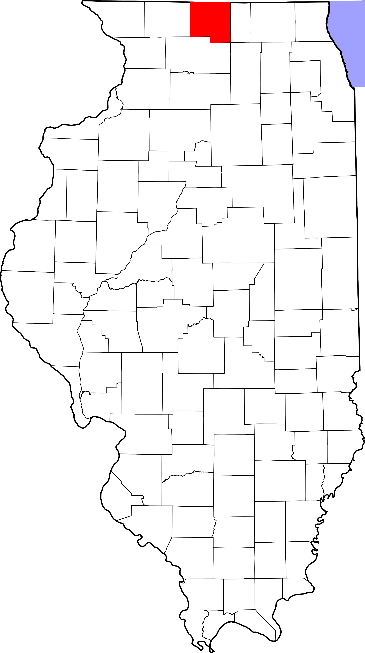
A. Child Maltreatment

Winnebago County (Other Urban/Suburban)
During 2018, there were 1,261 substantiated cases of child maltreatment (which includes reports of physical and other abuse, sexual abuse, neglect, and risk of harm) in Winnebago County. This number equates to a rate of 18.63 substantiated reports per 1,000 children in Illinois (which is higher than the state rate: 10.95 substantiated reports per 1,000 children).

These figures illustrate substantiated reports by child’s race and age. 51% of substantiated cases were among female children.

B. Youth Violence
Youth in Winnebago County reported higher rates of bullying, cyber bullying, dating violence, physical fighting and weapon carrying compared to the state average.

C. Juvenile Violent Offenses
In 2018, there were 525 youth admitted to short-term locked juvenile detention facilities in Winnebago County. Approximately 11% of detention admissions were for a violent offense (n = 59). This translates to a rate of 1.95 violent offenses per 1,000 youth ages 10-17 in Winnebago County, which is higher than the rate for the state of Illinois (1.83 violent offense admissions per 1,000 youth ages 10-17).

Black youth had the highest rate of violent offense admissions.
 | Rate per 1,000
Male | 3.2
Female | 0.6

Juvenile Weapon-Related Offenses
Winnebago county had 30 weapon-related offenses in 2018.

Violent Arrests by Race & Sex (2018)
 | Rate per 1,000
Race/Ethnicity
African American | 22.75
Hispanic/Latinx | 4.18
Other | 0.73
White | 3.09
Sex
Female | 3.19
Male | 9.63

D. Adult Violent Offenses (Arrests)
In 2018, Winnebago County had a rate of 839.55 violent crimes per 100,000 residents in Illinois. This is lower than the state rate (395.75 violent crimes per 100,000 residents).

African American adults had the highest rates of arrests for violent crimes.

E. Adult Intimate Partner Violence and Sexual Violence
Winnebago County reported higher rates of domestic violence and sexual assault crimes in 2018 compared to the state rate.
 | Rate per 100,000 | State Rate per 100,000
Domestic Violence Crime Offense | 1307.4 | 840.39
Sexual Assault | 81.3 | 44.83

F. Gun Violence: Firearm Death Rate
Winnebago County reported higher rates of homicides, suicides, and deaths by firearms than the state rate.

 | Rate per 100,000 | State Rate per 100,000
Homicide by Firearm | 8.8 | 6.2
Suicide by Firearm | 7.7 | 4.5
Total: Death by Firearm | 16.9 | 10.8

G. Abuse Among Older Adults
In 2015, Winnebago County had a rate of 683.5 reports of abuse among older adults (per 100,000) which is higher than the state rate (465.10 reports per 100,000).

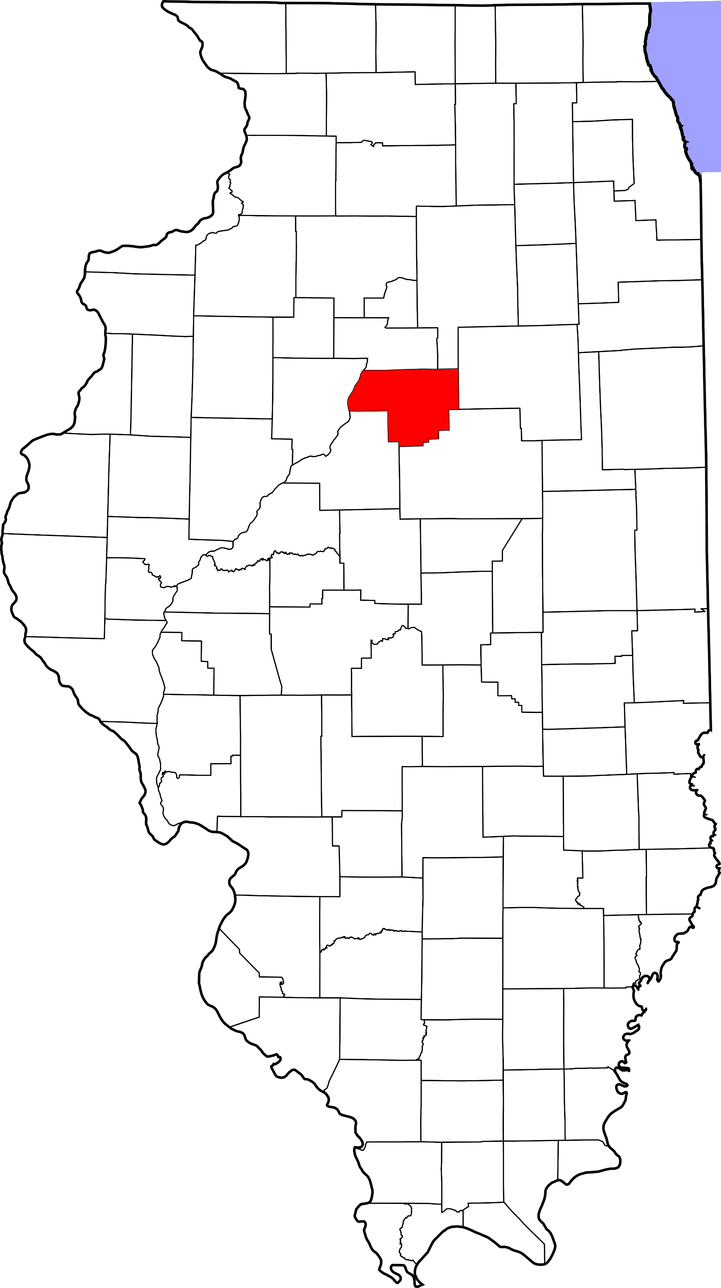
A. Child Maltreatment

Woodford County (Other Urban/Suburban)
During 2018, there were 84 substantiated cases of child maltreatment (which includes reports of physical and other abuse, sexual abuse, neglect, and risk of harm) in Woodford County. This number equates to a rate of 8.78 substantiated reports per 1,000 children in Illinois (which is lower than the state rate: 10.95 substantiated reports per 1,000 children).

These figures illustrate substantiated reports by child’s race and age. 50% of substantiated cases were among female children.

B. Youth Violence
Youth in Woodford County reported higher rates of weapon carrying compared to the state average.

Youth reported lower levels of physical fighting compared to the state average.

Youth reported slightly lower levels of bullying, cyber-bullying and dating violence compared to the state average.
C. Juvenile Violent Offenses
In 2018, there were 9 youth admitted to short-term locked juvenile detention facilities in Woodford County. Approximately 11% of detention admissions were for a violent offense (n = 1). This translates to a rate of 0.23 violent offenses per 1,000 youth ages 10-17 in Woodford County, which is lower than the rate for the state of Illinois (1.83 violent offense admissions per 1,000 youth ages 10-17).

White youth had a rate of 0.2 violent offense admissions per 1,000 youth ages 10-17).

 | Rate per 1,000
Male | 0.4
Female | 0

Violent Arrests by Race & Sex (2018)
 | Rate per 1,000
Race/Ethnicity
African American | 20.00
Hispanic/Latinx | 4.32
Other | -
White | 2.16
Sex
Female | 1.44
Male | 3.57
D. Adult Violent Offenses (Arrests)
In 2018, Woodford County had a rate of 44.20 violent crimes per 100,000 residents in Illinois. This is lower than the state rate (395.75 violent crimes per 100,000 residents).

African American adults had the highest rates of arrests for violent crimes.

E. Adult Intimate Partner Violence and Sexual Violence
Woodford County reported lower rates of domestic violence and sexual assault crimes in 2018 compared to the state rate.
 | Rate per 100,000 | State Rate per 100,000
Domestic Violence Crime Offense | 124.8 | 840.39
Sexual Assault | 10.4 | 44.83

F. Gun Violence: Firearm Death Rate
No data or insufficient data for this county.

G. Abuse Among Older Adults
In 2015, Woodford County had a rate of 244.1 reports of abuse among older adults (per 100,000) which is lower than the state rate (465.10 reports per 100,000).





